Equality Impact Assessment Form
Reference – Adults Discretionary Income– 2026-27

Department | Adult Social Care | Version no | 0.5
Assessed by | Imran Rathore | Date created | 03.09.24
Approved by | Jane Wood | Date approved | 25.11.24
Updated by | Bev Winter | Date updated | 12.05.25
Final approval | Jane Wood | Date signed off | 16.05.25

Section 1: What is being assessed?

1.1 Name of proposal to be assessed.

Proposed changes to the discretionary elements of the Adult Social Care Non-Residential Contribution Policy i.e. removal of 25% discretionary buffer above basic rate of income support.

1.2 Describe the proposal under assessment and what change it would result in if implemented.

1.2.1 Change Proposal – Removal of the 25% discretionary buffer
Adult Social Care is means tested and the charging regulations that are followed form part of the Care Act Statutory Guidance. For community services charging there is a national minimum income guarantee (MIG). Unlike most other Local Authorities (LA’s) in Yorkshire and Humberside, Bradford applies an additional discretionary buffer of 25% above the basic level of income support.
This proposal considers removing the additional 25% discretionary buffer to achieve higher income from charging to support the costs of ASC and to bring Bradford in line with other authorities. This will bring in an additional £5.610m of income in a financial year, based on the current cohort and their current financial assessment as at 12/05/25. This may change as care packages can change for a variety of reasons:
a service user is no longer receiving a service or following a care review and/or a financial assessment review,
the number of hours and their financial assessed contribution could change due to a change in their financial circumstances.

As of 5 February 2025, there were 3,837 people in receipt of Adult Social Care community services.

- 349 people paying the full cost of their care i.e. above £23,250 capital threshold and so will not be impacted unless their savings deplete.
- 1,047 not currently contributing but are likely to be drawn into making a contribution and so will be impacted.
- 2,441 who are currently contributing and will be impacted.
3,488 people are currently benefitting from the 25% discretionary buffer, a reduction of any scale will have an impact on people currently receiving a service as they will see an increase in the financial contribution, they are required to make towards the support they receive.

The Council has conducted a benchmarking survey via the National Association of Financial Assessment Officers (NAFAO). Of the 30 Councils who responded only 4 apply a discretionary buffer, with 3 of those considering removing or reducing it.

Following the consultation and the re run of the data as at 12/05/2025 3,941 people are in receipt of Adult Social Care community services.

- 364 people pay the full cost of their care i.e. above £23,250 capital threshold and so will not be impacted unless their savings deplete.
- 1,127 are not currently contributing but are likely to be drawn into making a contribution and so will be impacted.
- 2,450 who are currently contributing and will be impacted.

3,577 people are currently directly benefiting from the 25% discretionary buffer, a reduction of any scale will have an impact on these people as they will see an increase in the financial contribution they are required to make towards the support they receive.

1.2.2 Current approach on calculating charges:
If a person is deemed eligible for statutory social care services, a package of care may be put in place. In accordance with the Council’s policy on charging and contributions, a financial assessment is carried out to determine whether the client has the financial means to contribute to the cost of their care.

A person who receives care and support in their own home will need to pay their daily living costs such as rent, food and utilities, and must have enough money to meet these costs. Under the care and support statutory guidance their income must not be reduced below a specified level after charges have been deducted. This is known as the ‘Minimum Income Guarantee’ (MIG) and is designed to promote independence and social inclusion. The MIG amount has increased in line with inflation in recent years, and the MIG levels are confirmed through the “Social Care – Charging for Care and Support: Local Authority Circular” which Is issued in February. (See Appendix C for further information).

When calculating what someone should pay, the current approach (as per Care Act guidance) is to take into account 100% of their “net disposable income” (income less expenses and allowances).

The following table sets in more detail what is included as income and what is not included as income.

Table 1:
Income includes: | Income does not include
State Benefits, such as:  - State Retirement Pension  - Employment and Support Allowance  - Universal Credit  - Disability benefits  - Pension Credit  - Occupational and private pensions  - Any other income | - Earnings from employment  - Charitable income  - Winter fuel and cold weather payments  - Statutory sick pay, statutory adoption pay, and statutory maternity pay or allowance  - The mobility component of disability living allowance or personal independence payment  - The difference between the lower rate and higher rate of DLA/PIP – current disregard £35.90pw  - Tax credit  - Maintenance payments specifically relating to a child.  - War pensions  - Guaranteed income payments (GIPs) paid under the armed forces compensation scheme (AFCS)

When working out whether to charge for a service, the Council takes into account any expenses a person has because of a disability or frailty. This is known as disability related expenditure (DRE).

- If a person has more than £23,250 in savings or if they choose not to declare their finances to the Council, then they will be charged the full cost of their services.

- If the person has between £14,250 - £23.250 in savings, their maximum assessed contribution is inflated by £1 per week for every £250 up to the £23,250 threshold.

- If the person has savings below £14,250 then they would be financially assessed to contribute towards the cost of meeting their assessed social care needs up to a maximum weekly contribution that is based on their income but leaves the person with the government minimum income guarantee (MIG) or income support benefits, plus the LA’s 25% discretionary buffer.

Further deductions to the assessed maximum weekly contribution can be allowed if the person is in receipt of disability related benefits and has disability related expenditure (DRE) that they need to fund.

The charge is calculated based on the amount of service the person will receive (hrs/days etc) multiplied by the service fee rate, capped at the maximum the person’s financial assessment states they can afford to contribute. Anyone over £23,250 pays the actual/full cost of the service, which is the maximum charge. The LA will never charge the person more than the actual cost of the service.

We do not charge carers for support they may receive as a result of a statutory carers assessment.

1.3 Stage 1 Assessment:

Table 2:
Protected Characteristics: | Impact  Y/N
Age | Y
Disability | Y
Gender reassignment | N
Race | Y
Religion/Belief | Y
Pregnancy and maternity | N
Sexual Orientation | N
Sex | Y
Marriage and civil partnership | Y
Additional Consideration:
Low income/low wage | Y
Care Leavers | N
Stage 2: Full Equality Impact Assessment:
The full impact assessment process outlined below, will examine what the impact of the proposal is likely to be on protected groups, low-income groups, and care leavers.

- Will this proposal advance equality of opportunity for people who share a protected characteristic and/or foster good relations between people who share a protected characteristic and those that do not?
No

2.2 Will this proposal have a positive impact and help to eliminate discrimination and harassment against, or the victimisation of people who share a protected characteristic? If yes, please explain further.
No

2.3 Will this proposal potentially have a negative and/or disproportionate impact on people who share a protected characteristic? If yes, please explain further.
Yes, the increase in charges will have an impact on people currently receiving a service as they will see an increase in their financial contribution required towards the cost for the support they receive.

2.4 Please indicate the level of negative impact on each of the protected characteristics?

Table 3: (high (H), medium (M), low (L), no effect (N))
Protected Characteristics: | Impact  (H, M, L, N)
Age | H
Disability | H
Gender reassignment | N
Race | N
Religion/Belief | N
Pregnancy and maternity | N
Sexual Orientation | N
Sex | H
Marriage and civil partnership | N
Additional Consideration:
Low income/low wage | M
Care Leavers | N

The proposal takes account of national and local Frameworks and through setting maximum charges the ability to the current service users to pay the additional charges. A full Equalities Impact Assessment (EIA) has been undertaken on the proposal, which has highlighted that the proposal will potentially have a negative impact on all our current 3,941, in receipt of community care services and 3,577 of these to whom the 25% buffer currently applies.

Tables 4 and 5 below provide an updated breakdown of the services users by Age, Gender, and primary support reason as at 12th May 2025.

Table 4: Impact by Gender and Age Band.
Age Band | Female | Male | Unknown | Total
Under 20 | 42 | 73 |  | 115
21 - 25 | 109 | 181 |  | 290
26 - 30 | 109 | 136 |  | 245
31 - 40 | 185 | 221 |  | 406
41 - 50 | 181 | 191 | 1 | 373
51 - 60 | 219 | 238 |  | 457
61 - 70 | 234 | 272 |  | 506
71 - 80 | 326 | 223 |  | 549
81 - 90 | 469 | 212 |  | 681
91 - 100 | 247 | 62 |  | 309
100+ | 8 | 2 |  | 10
Grand Total | 2,129 | 1,811 | 1 | 3,941

Table 5a: Impact by Primary Support Reason and Age Band
Age Band | Learning Disabilities | Mental Health | Older People | Physical Disabilities | Unknown | Grand Total
Under 20 | 98 | 2 | 5 | 8 | 2 | 115
21 - 25 | 245 | 1 | 16 | 27 | 1 | 290
26 - 30 | 195 | 4 | 12 | 33 | 1 | 245
31 - 40 | 310 | 15 | 26 | 52 | 3 | 406
41 - 50 | 225 | 19 | 58 | 70 | 1 | 373
51 - 60 | 214 | 18 | 138 | 86 | 1 | 457
61 - 70 | 144 | 20 | 281 | 61 |  | 506
71 - 80 | 59 | 5 | 482 | 3 |  | 549
81 - 90 | 11 |  | 670 |  |  | 681
91 - 100 | 1 |  | 308 |  |  | 309
100+ |  |  | 10 |  |  | 10
Grand Total | 1,502 | 84 | 2,006 | 340 | 9 | 3,941

Table 5b: Impact by Primary Support Reason and Gender
Primary Support Reason by Gender
Primary Support Reason | Female | Male | Unknown | Grand Total
Learning Disabilities | 629 | 872 | 1 | 1,502
Mental Health | 36 | 48 |  | 84
Older People | 1,280 | 726 |  | 2,006
Physical Disabilities | 181 | 159 |  | 340
Unknown | 3 | 6 |  | 9
Grand Total | 2,129 | 1,811 | 1 | 3,941

Table 6 provides a case study on the following cohorts to help illustrate the scale of impact:

Table 6:
No | Person | Financial Impact of a 25% reduction
1. | A pensioner with no private income or savings with 7hrs of home support | In this scenario the person is likely to be financially assessed as not having to contribute towards their ASC support and therefore a reduction of the discretionary buffer will not impact on their assessed weekly contribution.
2. | A disabled, working age adult, with disability benefits and related premiums, with no private income or savings with 7hrs of home support. | In this scenario the person is likely to be financially assessed as having to pay £39.76 extra per week towards the cost of their ASC funded support.
3. | A pensioner with a large private pension and big savings with 7hrs of home support | In this scenario the person is likely to be financially assessed as having to pay £54.54 extra per week towards the cost of their ASC funded support.
4. | A pensioner receiving a disability benefit and Severe Disability Premium with 7hrs of home support. | In this scenario the person is likely to be financially assessed as having to pay £54.54 - £58.30 extra per week towards the cost of their ASC funded support.

Of the 3,941 people in receipt of community services:
- Of the 3,941 people currently in receipt of community services as at 12/05/25, 3,124 would see an increase in their contribution towards the cost of their care per week if the proposed change to remove 100% of the discretionary buffer was implemented from July 2025, subject to a new financial assessment, welfare benefit and disability related expenditure review for each person.

Of these:
- 1,364 will see an increase of between 0-£20 per week;
- 4 will see an increase of between £20-£40 per week;
- 6 will see an increase of between £40-£50 per week; and
- 1,750 will see an increase of over £50 per week with the highest increase being £51.28 per week.

Table 7: Number of People Impacted By Weekly Amount.
Increase Amount | Number of People | Percentage of total
£0 - £20 per week | 1,364 | 35%
£20 - £40 per week | 4 | Less than 1%
£40 - £50 per week | 6 | Less than 1%
>£50 per week | 1,750 | 44%

The remaining people will be better off (less than 1%), see no change (11%) or are full payers (9%)
Of the 3,941 people in receipt of community services:
- 3,124 will see an increase in their contribution towards the cost of their care.
- 364 are self-funders with capital above the £23,250 threshold and will not be impacted unless their capital falls below the threshold.
- 448 will see no change in the contribution there are required to make.
- 5 will see a decrease in their contribution.

The biggest cohort who will be impacted by these changes are set out in tables 8-11 below.
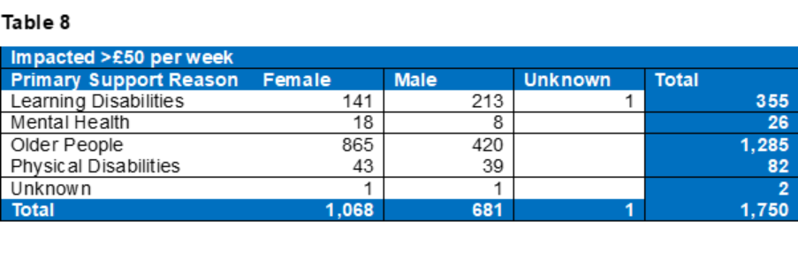
Table 9
Impacted £40 - £50 per week
Primary Support Reason | Female | Male | Unknown | Total
Learning Disabilities
Mental Health
Older People | 3 | 3 |  | 6
Physical Disabilities
Unknown
Total | 3 | 3 |  | 6

Table 10:
Impacted £20 - £40 per week
Primary Support Reason | Female | Male | Unknown | Total
Learning Disabilities | 1 |  |  | 1
Mental Health
Older People | 2 | 1 |  | 3
Physical Disabilities
Unknown
Total | 3 | 1 |  | 4

Table 11:
Impacted £0 - £20 per week
Primary Support Reason | Female | Male | Unknown | Total
Learning Disabilities | 393 | 524 |  | 917
Mental Health | 10 | 32 |  | 42
Older People | 120 | 114 |  | 234
Physical Disabilities | 87 | 80 |  | 167
Unknown |  | 4 |  | 4
Total | 610 | 754 |  | 1,364

- As a proportion of the Adult Social Care case load Older People make up the biggest group at 51% (2,006) of which 1,280 are female and 726 male.
- This is followed by people of working age with a Learning Disability at 38% (1,502) of which 629 are female, 872 are male and 1 is unknown.
- The majority 44% (1,750) will see an increase above £50 per week,73% (1,285) of those are Older People followed by 20% (355) people of working age with a Learning Disability.
- 35% of people will be impacted by an increase of £0-20 per week – 67% (917) of those are people of working age with a Learning Disability, followed by 17% (234) of Older People.
- For 20% of people there will be either no impact as they are deemed ‘full costers’ and already pay the full cost of their care, or they are people where there will be no change to their contribution. (812 people)
- 5 people where there is a change will be better off.

The tables 12, 13 and 14 below provide a breakdown of current services users by gender and ethnicity and indices of deprivation.

- More females (54%) are impacted and of these 53% are white, the next highest ethnicity impacted are Asian/Asian British at 25%.
- 46% are male and of these 55% are white, the next highest ethnicity impacted are Asian/Asian British at 23%.
Table 12:
Ethnicity by Gender | Female | Male | Unknown | Grand Total
Asian / Asian British | 546 | 420 |  | 966
Black / African / Caribbean / Black British | 39 | 34 |  | 73
Mixed / Multiple | 250 | 211 | 1 | 462
Other Ethnic Group | 78 | 48 |  | 126
Undeclared / Not known | 19 | 28 |  | 47
White | 1,126 | 999 |  | 2,125
Blank | 71 | 71 |  | 142
Grand Total | 2,129 | 1811 | 1 | 3,941

Table 13:
Indices of Deprivation | Ranking | Asian / Asian British | Black / African / Caribbean / Black British | Mixed / Multiple | Other Ethnic Group | White | Undeclared Not known | Blank | Grand Total
10% most deprived | 1 | 487 | 45 | 139 | 46 | 607 | 16 | 56 | 1,396
10-20% | 2 | 191 | 6 | 57 | 14 | 295 | 8 | 20 | 591
20-30% | 3 | 196 | 8 | 59 | 23 | 304 | 5 | 21 | 616
30-40% | 4 | 35 | 6 | 42 | 15 | 152 | 3 | 10 | 263
40-50% | 5 | 20 | 3 | 45 | 4 | 164 | 2 | 10 | 248
50-60% | 6 | 18 | 2 | 39 | 5 | 165 | 5 | 5 | 239
60-70% | 7 | 4 |  | 29 | 10 | 176 | 2 | 8 | 229
70-80% | 8 | 5 | 2 | 22 | 1 | 114 | 2 | 4 | 150
80-90% | 9 | 2 | 1 | 9 | 6 | 61 |  | 3 | 82
10% least deprived | 10 | 2 |  | 21 | 1 | 63 | 2 | 3 | 92
 | (blank) | 6 |  |  |  | 25 | 1 | 3 | 35
Grand Total |  | 966 | 73 | 462 | 126 | 2,125 | 47 | 142 | 3,941

- This shows that more of those impacted (35%) live in the 10% most deprived areas based on the seven indices of deprivation.
- Of those impacted and living in one of the 10% most deprived areas, 43% are White and 35% are Asian/Asian British

Table 14:
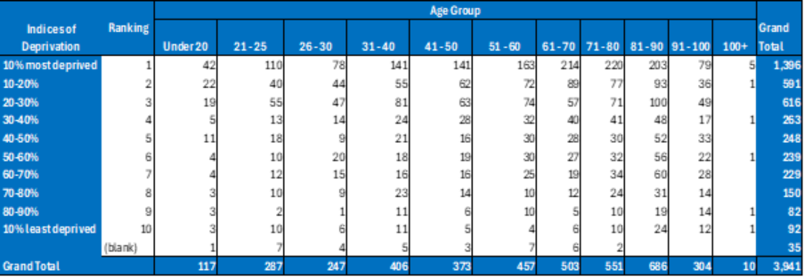

The EqIA has been reviewed and updated to take account of the feedback received from service users and to take account of other changes to income levels both within Council plans (e.g. safe and sound charges change) and impacts of national policy or budget.
Changes in the amount people need to pay for their social care services could potentially lead to a reduction in the anticipated income as some people may decide to stop their service and/or refuse to pay, in both these scenarios the council will continue to have a duty to meet assessed eligible needs.

2.5 How could the disproportionate negative impacts be mitigated or eliminated?

The Council has an appeals procedure which allows service users to dispute their financial assessment or want to reduce their care and support to a level that is affordable to them but does not meet their assessed adult social care needs.
The proposal will potentially have a negative impact on service users, and although it is not possible to entirely mitigate the impact of the increased charges there are number are actions that will be taken to support service users, which include.

- undertaking a detailed engagement and consultation exercise with current and future service users, which will aim to ensure that service users are aware of the changes and implications.

This will include:
- updating all relevant policy documents, guides, and web pages to ensure they articulate the new approach in a clear and concise manner and are available in large print, different languages and provide this information in an easy read accessible information format.
- writing to all current service users to inform them of the changes and the implications to them. The letter will include information about our local advocacy and welfare/benefits advise services and how they can access support.
- establishing a priority helpline that service users will be able to call for clarification about the changes and the impact on them.
- signposting service users to 3rd party approved financial and welfare advice services.

- We will listen to service users regarding the impact on them and we will mitigate through checking benefits and signposting to other relevant support. Correctly and thoroughly financially assessing, including correct application of Disability Related Expenditure.

- We will ensure that no:
- existing care plan will be altered without a care plan review and the approval of a social worker.
- alteration will be approved that does not ensure that the service users’ needs are met.
- services will be cut from any care plan based on the ability to pay or not.
- We will work with operational services to track the service use of the cohort of individuals impacted by the recommended changes to identify any trends in the reduction of service use and potential for any safeguarding issues.

- Where there are concerns over the welfare of an individual, existing safeguarding measures will apply.
Section 3: Dependencies from other proposals

3.1 Please consider which other services would need to know about your proposal and the impacts you have identified. Identify below which services you have consulted, and any consequent additional equality impacts that have been identified.

- The Local Integrated Care Board
- Voluntary and Community sector organisations.
- Providers

Discussions will take place with all key stakeholders as part of the consultation process to ensure their views are captured and considered as part of the decision-making process.
Section 4: What evidence have you used?

4.1 What evidence do you hold to back up this assessment?

We have undertaken benchmarking exercise with Local Authorities within England to understand the approach around the use of a buffer. While out of the 30 that responded to our benchmarking request four local authorities, are continuing with some form of buffer, three of these are considering removing or reducing that buffer.

From the data available via the following, we know that demand for ASC services will continue to increase in the coming years, so it is imperative that we can continue to provide support to service users in a sustainable and cost-effective way. If Bradford Council fails to maximise the income it receives towards the cost of ASC services, it may compromise the capacity and sustainability of provision. In a time when the Council is facing significant financially sustainability challenges and is in receipt of exceptional financial support via a capitalisation direction, this position is not tenable.

- Poppi and Pansi data

- ONS population projections.

- Carers feedback.

- Feedback from people who receive support or their carers/advocates.

4.2 Do you need further evidence?
We have undertaken a detailed consultation exercise with all stakeholders including current service users, their carers and families, and service user groups. We will also engage with the wider general public and other people in our system who may become chargeable in the future or because of the change. The approach we take on consultation will be varied and will use different channels including paper surveys, digital surveys and focus groups to enable all stakeholders to understand the implications while being able to share their feedback.
Section 5: Consultation Feedback

It is vitally important the proposal is consulted on with relevant protected groups and key partners to ensure the potential impact is understood.

5.1 Results from any previous consultations prior to the proposal development.
There was a targeted consultation in 2023 which impacted on a cohort of 600. This was focused on ensuring charges reflected the actual cost to the Council of adult social care. It was not focused on the removal of a discretionary buffer.

5.2 The departmental feedback you provided on the previous consultation (as at 5.1).
The mitigations we put in place for the 2023 consultation are those reflected in this proposal under paragraph 2.5.

5.3 Feedback from current consultation following the proposal development (e.g. following approval by Executive for budget consultation).
The feedback from the consultation is set out within Appendix H.

The key themes from the engagement sessions were:

- Inequity for those living at home: Families were very concerned about the financial impact, particularly where the person receiving care was living in the family home. Their view is there is an inequity in terms of housing related allowances for people living with their family rather than in their own accommodation, supported living or shared lives. This is because people living in the family home receive no concession i.e. no disregard in their financial assessment for a ‘board and lodging’ as a contribution towards the cost of the household

A person living independently in e.g. in Supported Living is likely to have their housing costs met via Housing Benefit, a Department of Work and Pensions benefit, administered by local councils. If the contribution towards the cost of assessed care and support needs for a person not living independently i.e. living with their family is unaffordable for the individual Bradford Council looks at each case on an individual basis. The expectation is that the expectation is the Minimum Income Guarantee amount is to cover food, clothes, utility bills, contents insurance and other personal expenses as set out in paragraph 2.7 for the person in receipt of care and support. The council will give consideration looking at utilities on request, where that individual’s requirement and consequently the bills exceed the national averages (using the National Association of Financial Assessment Officers guidance).

Bradford Council disregard’s Rent, Mortgage and Council Tax (as Housing Costs) from income before a calculation of the financial assessment contribution, where applicable and where the person in receipt of care is formally named on any such agreement.

With regards to rent/mortgage where the individual is not liable for rent/mortgage payments or if not named on the documentation Bradford Council would not normally make an allowance for rent/mortgage, unless in certain circumstances which would be dealt with via appeal. For example: where parents are paying rent/claiming housing benefit and have to pay the extra due to needing a property with an additional bedroom to accommodate a young adult, then this would be heard via an appeal alongside the supporting evidence.

The Minimum Income Guarantee amount, unless there is any specific Disability Related Expenditure, will be the income the individual is left with after they have made their contribution towards the cost of their care. If they are unable to afford their contribution based on their benefits which are to support their needs, they have the opportunity to appeal. We would encourage those service users who cannot afford there charge to contact us the Council’s ASC Contributions Team, to discuss how to appeal, what it entails and what evidence is required.

- Increase in Challenging Behaviours: People would need to reduce care or activities which would lead to more challenging behaviours for those with a Learning Disability or serve autism. This would place significant additional pressure on unpaid carers.

As set out in the point above Bradford Council will support people to ensure that the person in receipt of care’s services is affordable for them in line with their income and national guidance. Depending on their level of services and their individual financial assessment, reducing services may not result in a reduced charge. This is because the charge is a contribution towards the cost of the services based on affordability for the individual.

Examples:

- The charge for a person who has a maximum assessed contribution of £90 per week and is paying £90 per, where the cost of service is £202.24 per week for 8 hours of care at £25.28 per hour, who decides to reduce their hours will not change. This is because their maximum assessed contribution is less than the cost of the service. The charge would only reduce if the cost of the service was less than the maximum contribution.

- The charge for a person who has a maximum assessed contribution of £90 per week and is paying £90 per week, where the cost of service is £101.12 per week for 4 hours of care at £25.28 per hour, who decides to reduce to 3 hours would reduce to £75.84 per week. This is because the cost of the service is less than their maximum contribution. Bradford Council does not charge more than the cost of the service.
The only exception to these examples is when someone is on holiday or in hospital for a period of time. The service will not be expected to pay their contribution these times as their charges are based on actual service delivered.

- Carer Breakdown: family carers said they just could not cope any more with the financial impact and having to manage an increase challenging behaviours. They are unpaid and it is a false economy to do this. If they can no longer manage it will cost the council significantly more if they have to fund the care unpaid carers are providing.
The Council acknowledges the significant support provided by family carers and recognises the financial saving to the public purse that this represents.

In the first instance families should contact the Council to seek a social care review and a financial assessment review. The Council will work with families to ensure care needs are appropriately met and affordable in line with national guidance. The Council can provide support to carers in their caring role, including provision of respite care for the looked after person or individual support for the carer themselves. The Carers Resource Centre provides advice, guidance, health and wellbeing checks and access to one off grants for carers, on behalf of the Council and NHS in Bradford and District. In addition to seeking a social care review, the routine annual reviews undertaken by social care in Bradford and District will take account of the carer’s needs and the ongoing suitability of the support in place.

- Continuation of the Cost-of-Living Crisis: This is on top of the increase in prices for everything e.g. including water, utility bills, mobile phone charges council tax and ‘Safe and Sound’ contributions.

Bradford Council offers a range of council tax reductions for people on low income, benefits and where a member of the household has a disability and adaptations have been made to the property to e.g. accommodate If a member of your household has a permanent disability, you may qualify for a reduction if the property has an adaptation which meets the needs of a disability:
- an extra bathroom
- a special room, for example for physiotherapy
- space to allow wheelchair to be used indoors

Pensioners on the lowest incomes are entitled to a maximum reduction of 100% of their Council Tax liability via the Council Tax Reduction scheme.

There are also a number of discounts and exemptions that are particularly relevant to pensioners.

- Single person discount, 25% reduction in bill for those who are the only adult living in a property
- Properties adapted for a householder’s disability – Council tax reduced by a band (or 1/6th if property in band A)
- Severely Mentally Impaired, can be 100% reduction or 25% if live with one other adult
- Annex – if an annex is occupied by a relative a 50% discount can be applied. If the household living in the annex is over 65 or disabled a 100% discount can be granted
- Disability carer – 25% discount applies if caring for someone with a disability who is not a spouse, partner or the carer’s own child.

Full detail and the process to apply for a reduction can be found via this link; Other Council Tax discounts | Bradford Council

As set out under 2.15.1 a financial assessment disregards some property-related household expenses such rent, mortgage costs, and council tax where the individual in receipt of care is liable for this cost.

The MIG is to the amount the government states a person in receipt of care should be left with to fund their:
- food
- clothing
- energy bills
- water rates
- insurance
- leisure activities
- TV licence
- telephone and subscriptions for TV channels

In recent years the MIG has been increased in line with inflation.
For people that have a specific disability there are certain items we call Disability Related Expenditure we will deduct from a person’s income in their financial assessment before we calculate the contribution they can afford to make, in line with national guidance, towards the cost of their assessed care and support. This includes the cost of Safe and Sound services.

- Phased Introduction Requested: The council’s financial position is understood, it can no longer afford to subsidise, but we need time to make adjustments. A phased implementation would allow us to do this.
The recommendation of this report is to phase the removal of the discretionary buffer.

- Targeting the Vulnerable: Why are you targeting the most vulnerable you should be looking elsewhere to find savings.
Disability Related Expenditure (DRE) is the extra costs that arise as a result of a person having a disability, requiring them to spend money on goods and services because of an impairment or long-term health condition. The individual can talk to their Social Worker/Allocated Worker about this when they come to assess their needs; and they can record it in the individual’s assessment. Bradford Council will also need to complete a financial assessment, the individual should discuss any DRE and submit any evidence (such as receipts) they have. If they can demonstrate a higher level of DRE, it may bring down the amount that they are asked to contribute towards their care”

As part of the financial assessment a local authority is required to consider Disability Related Expenditure (DRE). The Council uses NAFAO (National Association of Financial Assessment Officers) guidance to support DRE exemptions. There are certain items of expenditure we will deduct from a person’s income in their financial assessment before we calculate the contribution they can afford to make, in line with national guidance, towards the cost of their assessed care and support.

Appendix I provides more detail on Disability Related Expenditure.

- The Council has got itself into this mess: this is self-inflicted, the council can always find money if they want to and perhaps, they shouldn’t be wasting money on things like the City of Culture.

The Council faces severe financial challenges, among the most significant in local government nationally, and the reasons for this have been described in previous Council Executive reports. A major part of the Council’s recovery strategy is to continue to deliver economic growth in the district. Bradford City of Culture has received a relatively small amount of funding from Bradford Council, but will bring a positive financial return to the district during this year and into the future.

- Done Deal: why are you consulting as it is a done deal.
As this proposed removal of the discretionary buffer would affect an identifiable cadre of people, there has been a duty to effectively consult with those people.

Under paragraph 10.2 of this report the council is proposing a change based on the feedback heard during the consultation process.

- Claiming of state benefits: ‘what is the point in claiming anything else the council will only take off me via and increased contribution towards the cost of my care.
This could mean a reduced level of income to Adult Social Care and a greater burden is placed on the council taxpayers of Bradford as it is funding what state benefits should fund.

- Concerns about the Welfare Reforms: as launched in Pathways to Work: Reforming Benefits and Support to Get Britain Working Green Paper.

Bradford Council anticipates if there are any implications from these proposed reforms, they will be reflected in the relevant annual Local Authority Social Care ‘charging for care and support’ circular and will be taken into account in adult social care charging

- We feel listened to: these sessions have been informative and useful, we feel we have been listened to.
Recommendation 10.2 demonstrates Bradford Council has listened to the feedback received during the consultation process.

5.4 Your departmental response to the feedback on the current consultation (as at 5.3) – include any changes made to the proposal as a result of the feedback.
A phased implementation of the proposed discretionary buffer in July
2025 and 50% in July 2026. This would provide those currently charged and in receipt of care, time to make adjustments to their living expenditure, so they are more able to manage the financial increase. Throughout the consultation there have been repeated requests to phase the removal of the discretionary buffer. People said they understand the challenges but feel the removal of the discretionary buffer all at once will lead to financial hardship and does not allow them time to re budget and make adjustments to their expenditure.

Any phasing would need to weigh up the significant additional costs to the council of undertaking new financial assessments during the period of phasing, the financial hardship this may cause and legal advice that to spread over a longer period may cause confusion people in relation to their charges and increase the risk of challenge.

The recommendation is that the phasing will be contained within a 12-month period following the new financial assessment, as such there should be no need for any additional new financial assessments. The business-as-usual process would be followed for anyone with a significant financial change over the period who would request a financial assessment review, or they receive a financial assessment review every 12 months.

If it is agreed the discretionary buffer should be removed, there will be a further communication to all of those impacted. This will set out the implementation process would include a new financial assessment, welfare benefit and disability related expenditure review for each person in receipt of non-residential services. This will ensure any new charge is affordable in line with national guidelines before any change to the contribution towards the cost of their care is made.

Appendix K - Postcode Analysis
The postcode analysis demonstrates, by the indices of deprivation on a constituency and ward basis, those people impacted by the recommended change.

The individual tables are broken down by constituency and ward.

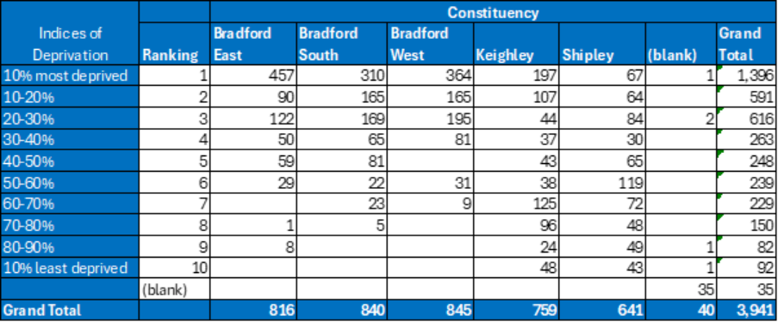

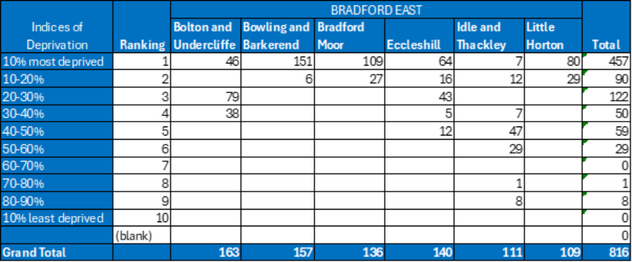

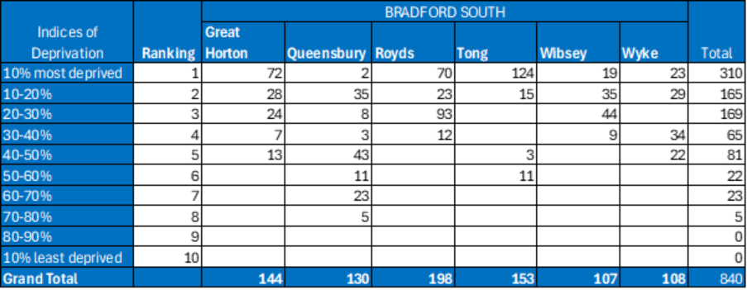
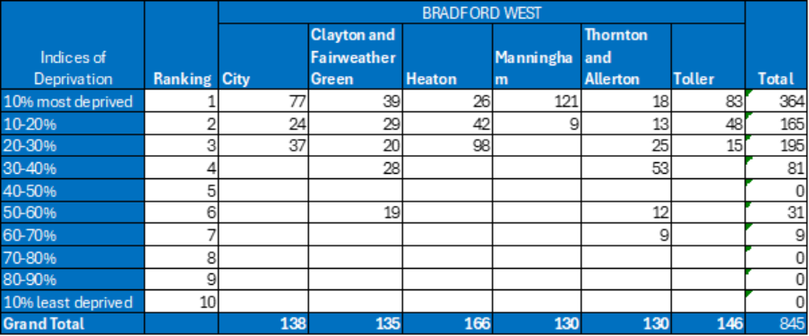

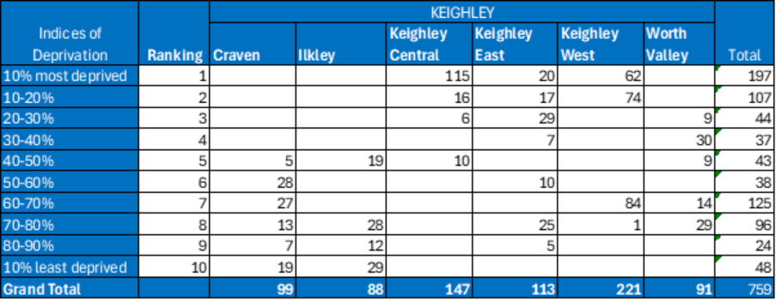
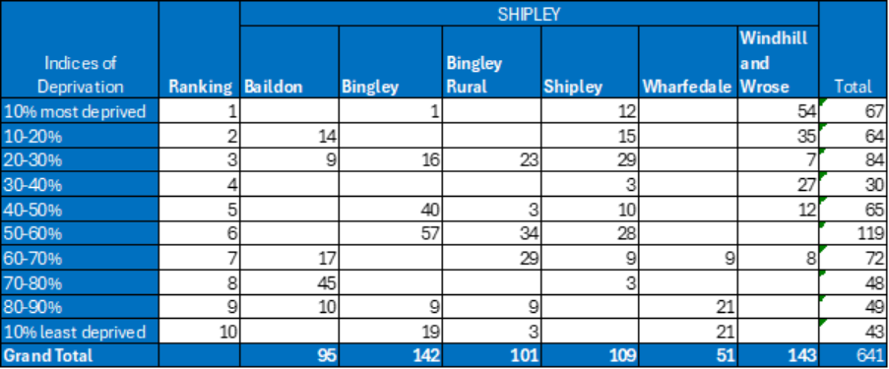

The following table shows the postcodes of those who responded the consultation questionnaire.
The main postcodes responding – BD22 (Keighley Wards) and BD6 (Wibsey Ward) were those in the 10, 20 and 30% most deprived postcodes as defined by the indices of deprivation.

