Equality Impact Assessment Form
Reference – Safe and Sound Improvement Programme– 2026-27

Department | Adult Social Care | Version no | 0.1
Assessed by | Imran Rathore | Date created | 15.07.24
Approved by | Rachael Meadows-Hambleton | Date approved | 08.08.24
Updated by |  | Date updated
Final approval | Rachael Meadows-Hambleton | Date signed off | 15.08.24

The Equality Act 2010 requires the Council to have due regard to the need to
- eliminate unlawful discrimination, harassment and victimisation;
- advance equality of opportunity between different groups; and
- foster good relations between different groups

Section 1: What is being assessed?

1.1 Name of the proposal to be assessed.

Safe and Sound improvement programme – this includes specific actions required to
- Meet the requirements of the Digital Switchover
- Increase the awareness and promote the service, both internally across the Council and externally with partners and residents to increase uptake
- Implement plans to maintain a sustainable service through the implementation of a varied charging model.

1.2 Describe the proposal under assessment and what change it would result in if implemented.

1.2.1 SERVICE OVERVIEW:
Safe and Sound is an existing service within Bradford Council, Adult Social Care Service. It is a combination of what was historically known as Careline and Telecare. It is a person-centered service supporting people to stay safe and independent in their own home.
The Safe and Sound Service operates in partnership with other health and social care organisations and emergency services, such as, West Yorkshire Ambulance Service and the Yorkshire Fire and Rescue Service, delivering a 24/7 emergency response to people’s homes.
Safe and Sound uses a variety of technology and support systems to help people of all ages to live safely and independently at home. The Service offers help 24 hours a day 365 days a year, giving people independence and freedom in their own home, whilst safe in the knowledge that if there is an accident or if you have a fall, help is available in the form of an emergency response.
Referrals are received from a range of sources and following the referral, the service undertakes an assessment with the person (and or their carers), to ensure the appropriate safety equipment and technology is issued to support independent living.

1.2.2 CHANGE RATIONALE:
In Bradford the population for 65-90+ is forecast to increase from 86,413 to 103,219 by 2033. The breakdown of this across 65+ age group is outlined below:
AGE GROUP | 2023 | 2024 | 2025 | 2026 | 2027 | 2028 | 2029 | 2030 | 2031 | 2032 | 2033 | % Change
65-69 | 25,303 | 25,698 | 26,411 | 26,862 | 27,337 | 27,614 | 28,163 | 28,459 | 28,641 | 28,901 | 29,087 | 14.96%
70-74 | 21,289 | 21,393 | 21,414 | 21,886 | 22,291 | 22,785 | 23,167 | 23,834 | 24,277 | 24,742 | 25,033 | 17.59%
75-79 | 17,520 | 18,164 | 18,885 | 19,276 | 18,695 | 18,494 | 18,600 | 18,637 | 19,061 | 19,445 | 19,912 | 13.66%
80-84 | 10,923 | 11,201 | 11,294 | 11,704 | 13,132 | 14,074 | 14,600 | 15,161 | 15,451 | 15,027 | 14,904 | 36.44%
85-89 | 7,381 | 7,355 | 7,398 | 7,280 | 7,155 | 7,216 | 7,449 | 7,566 | 7,865 | 8,897 | 9,568 | 29.63%
90+ | 3,999 | 4,081 | 4,169 | 4,236 | 4,369 | 4,474 | 4,513 | 4,591 | 4,569 | 4,595 | 4,715 | 17.92%
Total | 86,413 | 87,890 | 89,572 | 91,243 | 92,978 | 94,657 | 96,493 | 98,248 | 99,863 | 101,606 | 103,219 | 19.44%
Source: Office for National Statistics 2023

Similarly, it is projected that people with learning disabilities will increase from 1,872 to 2,237 between 2025 to 2035, representing a 19.5% rise. Comparable accurate ONS based data for people with mental health and physical disabilities is unavailable at this time.
Helping people to feel safe in their home, knowing that they are monitored in the event of something going wrong, especially if living alone, in a safe and cost-efficient manner is an important priority for the Council, and as such ensuring that we have a sustainable Safe and Sound service to meet people's needs is a key priority for Adult Social Care.

1.2.3 IMPROVEMENT WORKSTREAMS:
1.2.3.1 Digital Switch Over:
Work is underway within the service to ensure that we can maintain service delivery as the analogue network is switched off and we move to a digital network – this is a national change workstream led by the major network providers. As part of our response to this change process, we have procured and are in the process of implementing a new Digital Alarm Receiving Centre (ARC) which will allow digital equipment within people’s homes to connect to the Digital ARC via a broadband network. Similarly, work is also being undertaken to procure digital equipment which will replace the existing analogue kit in people’s homes. PAG funding was used to finance this activity.

1.2.3.2 Technology Enabled Care (TEC):
The shift to the digital ARC opens up the possibility of implementing new and innovative technologies to support people in a more proactive and creative ways – ranging from: remote monitoring sensors, addressing social isolation, minimising falls prevention, avoiding Unitary Tract Infections through Artificial Intelligence based behaviour learning, and supporting people to live with Dementia e.g. providing reminders to people about taking their medication, food, and fluids etc.
This means repositioning and redesigning the Safe and Sound Service offer, away from a basic telecare offer to a more rounded Technology Enable Care Offer which provides a holistic support package that meets a person’s needs on a day-to-day basis. To support this change, we have worked collaboratively with both the Safe and Sound Service and Operational Services to promote the benefits of the TEC offer, and how it can support a person’s needs. This work includes:
- Raising awareness of the service offer with Adult Social care staff and external key stakeholders including partners within the Health and Social Care partnership.
- Attending staff roadshows and running in-person and virtual staff information workshops.
- Developing the internal and external information and advice offer. This includes plans to refresh our TEC website, council website and exploring the use of online newsletters and social media once the new digital ARC is established.
- Reviewing the equipment options compatible with the new ARC to enhance service options and working collaboratively with other regional councils to review and evaluate new TEC into the market.
- Evaluation of prevention focused TEC solutions to demonstrate where they add value by maintaining independence and delaying the need for statutory care provision.
- Streamlining the TEC referral pathways to increase efficiency and speed of access.
- Working with Bradford University to develop a TEC House and TEC Website, and presenting this work as part of a Local Government Association (LGA) series of Webinars titled “What Good Looks Like Webinar Two: Improving Care & Empower People”
- Providing accompanied visits to the TEC House to raise awareness and provide ‘hands on learning’.
- Trialling working with university students in the facility of health to raise awareness of available TEC in the community and discussing joint training options for staff and students.
- Developing induction TEC training for new staff members with a view to make this statutory for all staff annually.
- Engagement and consultation with current services users and family to understand the lived experience of using the Safe and Sound service, the impact on both users and the people who care for them and exploring where people feel there are gaps in service provision and where improvements could be made.

1.2.3.3 Charging Model
Current approach:
We currently charge a flat rate for the Safe and Sound offer which is £3.30 per week (excluding VAT). This is applied to anyone currently receiving Safe and Sound support and isn’t linked to the type of support provided.
The contribution charge that we make includes a rental charge for the equipment, a monitoring service and emergency response when necessary. The equipment provided and installed remains a Bradford Council Asset and is deemed on long term loan until it is no longer required. There are no additional charges for any supplementary Telecare sensors a person needs to stay safe. E.g. Fall detectors. We currently offer the first six weeks free of charge to enable the person and their carers to test out the suitability of the service and to ensure it is making a positive impact on their wellbeing.
Change proposal:
To ensure that the service is sustainable, reliable, cost effective and meets the needs of the people we support, we have undertaken a detailed appraisal of our current funding model. This has included benchmarking our approach with other Local Authorities within Yorkshire, which also include our statistical neighbours. Key point to note is that standard charge applied by the other Local Authorities is higher than the current charge in Bradford. The table below provides a breakdown of the new funding model:
Subsidised Model (benchmarked against Leeds) - subject to a 4.5-8.5% uplift from 1st April 2025)
Package Name | 1  Basic Package – Standalone | 2  Basic Package - Monitored | 3  Home Safety Package | 4  Falls Package
Cost without mobile response (MR) | £2.31 | £4.62 | £6.00 | £6.46
Monthly Cost | £10.00 | £20.00 | £26.00 | £28.00
Cost with mobile response (MR) | N/A | £8.62 | £10.00 | £10.46
Monthly Cost with MR | N/A | £37.35 | £43.33 | £45.33
Total costs - non equipment
Total costs - non equipment | £2,231,219
Current self-funded budget | £697,100 | Modelling is based upon mapping existing users across to the new packages, based upon current service in place, to improve accuracy of forecasts
Incremental income forecast / budget saving for council against current investment | £926,914
Income adjusted for Disability Related Expenditure (DRE) @ 10% | £834,223
Gap not self-funded | £699,895

1.3 Stage 1 Assessment:

Protected Characteristics: | Impact  Y/N
Age | Y
Disability | Y
Gender reassignment | N
Race | Y
Religion/Belief | N
Pregnancy and maternity | N
Sexual Orientation | N
Sex | N
Marriage and civil partnership | N
Additional Consideration:
Low income/low wage | Y
Care Leavers | N

Section 2: What the impact of the proposal is likely to be

- Will this proposal advance equality of opportunity for people who share a protected characteristic and/or foster good relations between people who share a protected characteristic and those that do not? If yes, please explain further.

No

- Will this proposal have a positive impact and help to eliminate discrimination and harassment against, or the victimisation of people who share a protected characteristic? If yes, please explain further.

The enhanced support offer will enable people who share a protected characteristic to retain their independence within their own home (or supported living) while enabling them to continue to actively engage in their wider community. The approach we are taking should help reduce the potential for such exclusion and isolation.

In addition the new system will enable better collection of data on service users which will ensure that there is a better understanding on who is using the service including from groups with protected characteristics.

- Will this proposal potentially have a negative or disproportionate impact on people who share a protected characteristic? If yes, please explain further.

Yes, the increase in charges may have an impact on people currently receiving a service as some will see an increase in the cost of their support package. However, this impact is not anticipated to disproportionately impact those with protected characteristics.
The proposed consultation exercise will collect more detailed information on identifying any impacts, with consideration given to the needs of users whose first language is not english (race), those that are not digitally connected, low income, accessibility and disability.

2.4 Please indicate the level of negative impact on each of the protected characteristics?
(Please indicate high (H), medium (M), low (L), no effect (N) for each).

As this is an internal replacement of case management software, we don’t anticipate any direct impact on staff.

Protected Characteristics: | Impact  (H, M, L, N)
Age | H
Disability | H
Gender reassignment | N
Race | Y
Religion/Belief | N
Pregnancy and maternity | N
Sexual Orientation | N
Sex | N
Marriage and civil partnership | N
Additional Consideration:
Low income/low wage | M
Care Leavers | N

Implication for existing service users:
Breakdown by “Ethnicity”:
This represents an overview of existing persons by ethnicity if transposed across to the “preferred to-be model” based upon their current package. As a proportion, majority Asian are in receipt of the free standalone package, which would form part of the lowest level charge in the new proposed model, in terms of volumes this is low and represents a minimal risk. Whereas for “white” ethnicity the majority are evenly divided between basic and enhanced packages.
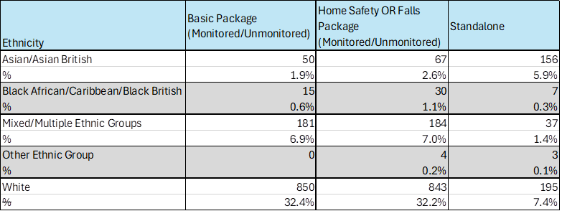

Overall ethnicity of existing people using the service.
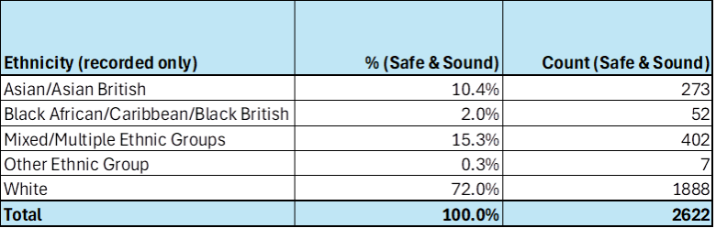

A representation of ethnicity by age profile, the most vulnerable of whom fall within the 65+ category.

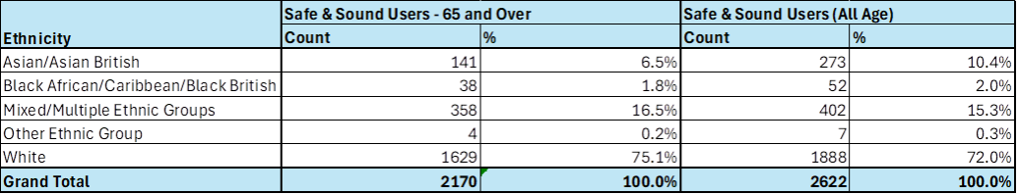

Cost Profile Analysis
This details the users mapped across to the new packages and a breakdown of package costs. The majority of existing users, representing 45%, if transferred across to the new charges would experience an uplift starting at £4.62 compared to the current £3.30. This reduces the impact of the change alongside with the recommended phased implementation.
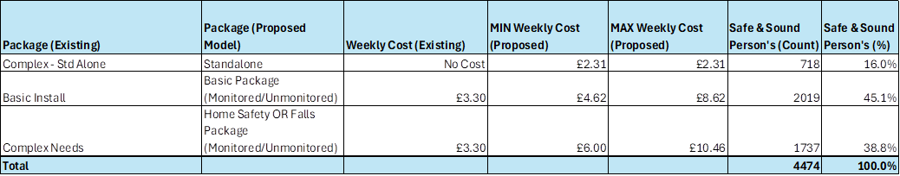

Gender
Over 60% of existing people who use the safe and sound service are female. Of those over 80% are presently paying a contribution to the service. Therefore, the impact of the change is expected to be minimal compared to if the majority were receiving the standalone service.
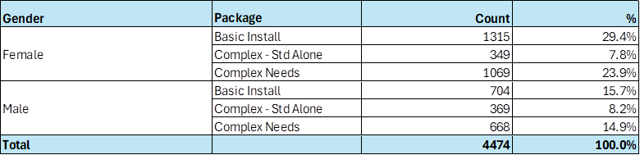

As part of the implementation of the new Digital ARC and through the consultation process we are aiming to capture additional details covering protected characteristics, this will help our understanding of the needs of the current service users.

2.5 How could the disproportionate negative impacts be mitigated or eliminated?
(Note: Legislation and best practice require mitigations to be considered, but need only be put in place if it is possible.)

We are proposing that subject to Executive approval the new charges are implemented from 1st April 2025 for all new service users. At this stage, we are seeking Executives approval to undertake a formal consultation exercise with key stakeholders and bring back the findings from this exercise to the Executive for their consideration. Following approval from Executive to go out to consultation, we will write to all existing service users who are receiving Safe and Sound service to inform them of the proposed changes and the implications for them, and to provide them with options for sharing their feedback.
Section 3: Dependencies from other proposals

3.1 Please consider which other services would need to know about your proposal and the impacts you have identified. Identify below which services you have consulted, and any consequent additional equality impacts that have been identified.

As this service is operated in conjunction with other organisations, the proposal is planned to be consulted with our partners which include, health and social care organisations, West Yorkshire Ambulance Service and the Yorkshire Fire and Rescue Service.
Section 4: What evidence you have used?

4.1 What evidence do you hold to back up this assessment?

From the data available via the following, we know that demand for ASC services will continue to increase in the coming years, so having access to robust and Care Act compliant case management system is a critical component for operational service delivery.

- Poppi and Pansi data

- ONS population projections.

- Carers feedback

- Feedback from people who receive support or their carers/advocats.

The evidence on the usage by groups with protected characteristics is included in the earlier sections of the EQIA.

4.2 Do you need further evidence?

There may be futher evidence from the consulation which will be considered once this is received.

Section 5: Consultation Feedback

5.1 Results from any previous consultations prior to the proposal development.

The plan is to seek approval at Council Executive on the 3rd September to go out to formally consult on the proposals outlined in this paper for a period of 3 months. This will cover not only people who use our services, but also families and carers, along with partners.

5.2 The departmental feedback you provided on the previous consultation (as at 5.1).
We undertake regular surveys with current service users who have provided positive feedback on their experience of using the service. Key messages include:
- 80.2% were either extremely or very satisfied with the equipment they received.
- 80.2% said that the TEC helped them have as much control over their daily life as they wanted.
- 80.2% said that the TEC helped them have as much control over their daily life as they wanted.
- 80.2% said that the TEC helped them have as much control over their daily life as they wanted.

5.3 Feedback from current consultation following the proposal development (e.g. following approval by Executive for budget consultation).

The consultation has started but not yet concluded.

5.4 Your departmental response to the feedback on the current consultation (as at 5.3) – include any changes made to the proposal as a result of the feedback.

This will be fed back when the consultation is completed.

