Tranche 3 Business Cases and EqIAs for Executive Report 3rd December 2024

Total Value £10.106 million

- BCFT – Family Help Model £0.6m
- Updated Tranche 2 Business Cases / EqIAs not contained in this appendix
- Sport and Leisure £0.497m
- To be supplied separately and subsequently.
- Street Scene – Commercial Opportunity £0.240m
- Business Case
- Equality Impact Assessment
- Spending Panel Outputs £1m
- Business Case
- Equality Impact Assessment
- Third Party Spend £1.5m
- Business Case
- Equality Impact Assessment
- Fees and Charges £2m
- Business Case
- Equality Impact Assessment
- Enabling Efficiencies with Digital Technology £0.680m
- Business Case
- Equality Impact Assessment
- Safe and Sound £0.789m
- Business Case
- Equality Impact Assessment
- Executive report of 3 September 2024
- Capital Programme Review £2.8m
- Overview Slides



Business Case
Project Name | Street Cleansing and Parks Service Review of all Commercial Operations Fees and Charges
Author | Philip Jackson: PMO  Richard Galthen/Catherine Smith: Service Leads
Directorate | Place
Service Area | Street Cleansing & Parks
SRO | Sue Spink
Project / Programme Manager | Philip Jackson/David Greenwood

Status: V0.13 Date – 1st November 2024

Document Management

1.1 Version Control
Version | Date | Author | Current Status of Business Case
v0.1 | 30/07/2024 | Taslima Qureshi | Initial drafting, strategic forming and identification of gaps in content requirements
v0.2 | 07/08/2024 | Richard Galthen | Second draft, outsourcing option removed.
v0.3 | 09/08/2024 | Richard Galthen | Third draft, renamed as Strategic Review
v0.4 | 23/08/2024 | Philip Jackson | Separation of commercial work and Area based working elements into separate business cases. Development of action planning and communication added
V0.5 | 02/09/2024 | David Greenwood | Revised content for review by the Service.
V0.6 | 04/09/2024 | Richard Galthen | Revised content
V0.7 | 05/09/2024 | Richard Galthen | Revised content
V0.8 | 07/10/2024 | David Hughes | Revised content
V0.9 | 15/10/2024 | Richard Galthen | Revised content – elaborated on events income and separated income-stream option C.
V0.10 | 17/10/2024 | Richard Galthen | Revised content based on feedback from Strategic Director Place
V0.11 | 18/10/2024 | Richard Galthen | Financial data updated
V0.12 | 31/10/2024 | David Shepherd | Review of options to include the potential for greater benefit of mitigation of exposure on repair, maintenance and utility charges.
V0.13 | 01/11/2024 | Sue Spink | Revised content

1.2 Document Approvals

Name | Title/Function | Date Approved | Signature
Cllr Sarah Ferriby | Portfolio Holder (where required)
David Shepherd | Executive Sponsor
Sue Spink | SRO
Diane Crookes-Walker/Errol Williamson | Finance
David Greenwood/Phil Jackson | Transformation
Ian Poppleton | HR *
Linda Bailey | Legal
Helen Johnston | Office of the Chief Executive

Executive Summary
The Street Cleansing & Parks Service was transferred from Neighbourhood Services to Waste Services in the Department of Place in December 2023. This was to ensure the service could better align with the delivery of existing waste services and reduce duplication.
The Street Cleansing & Parks Service provides both non-statutory and commercial services and is currently delivering them at an annual deficit. This is mainly due to the fact that pricing for these services is not set at market rates, which limits income and the ability to recover costs. The Council is also potentially carrying unnecessary financial exposure due to the existing terms and conditions, relating to the maintenance and leases of properties, land and lodge rentals.
A full budget analysis of these service has taken place from April 2024 and new data has been reviewed to consider how commercial services are best provided or potentially ceased in future.
This business case focuses on the following commercial services and recommends:
• Grounds maintenance for businesses –
It is recommended that the Council ceases to deliver these services and focuses its full attention on delivering improvements to the core statutory duties in relation to street cleansing and parks.
• Bowling Green maintenance and lease.-
he Council undertakes a full review of existing lease agreements specifically focusing on terms and conditions in relation to repairs, maintenance and utility charges.
• Football/rugby pitch/changing facility maintenance and lease.
It is recommended the Council explores the opportunity for the local Football Association to administrate and manage leases and maintenance to clubs and:
The Council undertakes a full review of existing lease agreements specifically focusing on terms and conditions in relation to repairs, maintenance and utility charges.
• Land and Lodge rental – park and cemetery-based properties
A full review is undertaken of the current lodges, rental rates, and lease arrangements, including lease lengths, to ensure they reflect market conditions and align with the Council's broader asset disposal strategy.
• Land lease – funfairs, circus and commercial events
A review of the fee structures - for commercial events only - is undertaken.
Where commercial activities cannot break even, the service may need to consider ceasing them or consider altering existing lease arrangements and fee structures to ensure financial sustainability.

3. The Strategic Case

3.1 Business Need
The Council faces severe financial challenges, among the most significant in local government nationally. The 2023/24 budget was overspent by £80m which along with the use of reserves in that year led to a structural budget gap of £120m. For the financial year 2024/25 there is an estimated budget deficit of £140m. In total the current cumulative deficit is £573m up to 2029/30. This estimate will undoubtedly change.
There are 4 fundamental reasons why this has arisen:
1. Exceptional growth in the cost of Children’s Social Care. In Bradford, gross spend on Children’s Social Care has increased by around £150m per year from around £100m in 2019-20 to around £250m in 2023-24.

2. The Council is generally poorly funded:
- Funding reductions have disproportionately affected Bradford, as identified by SIGOMA (special interest group of municipal authorities).

- Bradford’s band D Council tax is £145 lower than the average for Metropolitan Authorities and 80% of its households are below band D.

- Government reforms to Council funding, taking greater account of needs and local resources have also been repeatedly delayed. Independent analysis indicates that implementation of the reforms would have benefited Bradford by around £32m a year by now.

3.The Council has used large amounts of one-off reserves in recent years without an appropriate plan to deal with this in the future. In 2020-21 the Council had about £256m of usable reserves, this had reduced to around £42m by the end of March 2024.
4.Capacity, capability and cultural challenges within the council.
To return the council to financial sustainability the MTFS (medium term financial strategy) sets out the need to make very significant revenue savings, currently averaging approximately £40m per year, every year from 2024/25 to 2029/30. This is along with asset sales, reductions in the capital programme, enhanced grip on expenditure. This report sets out a proposal to contribute to the first of these savings targets.
The Street Cleansing & Parks Service (non-statutory and commercial) remodel aligns with the Bradford Council Plan in that the Council must ensure that each service is considered to provide value for money. It has been prosed through the Bradford Budget Emergency Response Transformation (BBERT) Plan to save £1.5m from April 2025 – 2026 from the Service.
Background
The Street Cleansing budget for 2024 – 2025 is £5.8m and the Parks budget is £3m.
The service operates with up to 250 positions and currently operates a c.£7m plant and equipment inventory consisting of fleets of mowers, tractors, vans, tippers, and various grounds-maintenance plant.
There are currently up to 11 operational staff and 6 vehicles completing non-statutory or commercial work, alongside their statutory service delivery. This causes a variety of issues:
- Capacity reduction to cover statutory work (holidays, sickness etc.)
- Budget pressure – fees not sufficient to cover operational costs.
- Fleet pressure – fleet needed 5 to 7 days per week with little/no opportunity for scheduled maintenance, without delaying service delivery.
Going forwards the service must aim to achieve full-cost recovery for delivering these non-statutory and commercial services and where appropriate maximise the income it generates.

Grounds maintenance for businesses:
The Service provides ad-hoc grounds maintenance for third-party organisations, such as restaurants and shops. This mainly includes ad-hoc requests for grass cutting, hedge trimming and sweeping. These services are currently provided to a relatively small customer base.
This commercial work also affects the Council’s core operations by causing delays and potential downtime on frontline services due to issues such as vehicle and equipment defects or repairs. As a result, the Council does not fully recover its costs for providing these services.
Issues:
The services provided to third-party organisations are currently priced at well below market rates. This limits the income generated and undermines the Service's ability to fully recover the costs. Essentially the Council is therefore, subsidising commercial clients this cannot continue.
Operating this service is causing unnecessary disruption by diverting resources away from core frontline services, negatively impacting the efficiency and effectiveness of the Service's statutory responsibilities.
Further Details:
The charges for delivery are agreed on request but have historically been as low as £50 for small areas. This income stream does not cover the cost of delivery, based on time, resource and equipment.
Income per year:
2019/20 - £0.047m
2020/21 - £0.052m
2021/22 - £0.060m
2022/23 - £0.093m
2023/24 - £0.065m
2024/25 - £0.020m (forecast at cp6)
Recommendation:
It is recommended that the Council ceases to deliver these services and focuses its full attention on delivering improvements to the core statutory duties in relation to street cleansing and parks.

Bowling Green maintenance and lease:
The Service currently manages weekly and seasonal grass cutting and maintenance for up to 29 bowling greens across the district.
Historically, fees and charges for these services have lacked oversight, leading to inconsistent pricing. In some cases, bowling clubs pay a fee per member for pitch maintenance.
Additionally, some clubs lease pavilions for as little as £55 per year, a nominal fee that covers both maintenance and utilities. These costs are far exceeding the lease income.
Issues:
The key issues with bowling clubs leasing pavilions for a small annual fee that includes the cost of maintenance and utilities includes a financial imbalance, where the costs of maintenance and provision of utilities exceed the income generated from rentals. The current arrangements between clubs and the council does not allow the council to recover its costs, resulting in the council subsidising clubs.
A further issue is an ineffective Pricing Structure. A lack of oversight in setting prices that reflect the true cost of service provision undermines the Council's ability to allocate resources efficiently and has led to long-term financial strain.
Further Details:
There are currently 29 Bowling Clubs across the district which lease Bowling Greens and Pavilions from the Council.
9 of these Clubs complete their own bowling green maintenance and only pay an annual lease for the pavilion “utility charge” of £55. This is a historic charge which was designed to cover all utility costs and building repairs/upgrades. However, current repairs/maintenance and utility costs far exceed the annual contribution from the Bowling Clubs.
20 of the Clubs pay for varying levels of bowling green maintenance via the Council. This requires multiple visits per week/month to ensure the greens are kept in playing condition and in most cases to very high standards. The Council has to procure, maintain, insure and replace various bespoke grounds maintenance assets to complete this work.
Due to historic pricing arrangements, based on £36 per registered member, these 20 clubs pay a total of up to £0.019m per year for the seasonal work to be completed, regardless of operational costs to the Council. These clubs currently have a total of 529 members.
In all cases, the Council remains liable for costs of running and maintaining the pavilions and providing the staff and equipment for the requested bowling green maintenance. This causes a significant budget pressure and operational capacity risk.
Some Clubs are registered commercially and/or provide a range of service to members – i.e. snacks, beverages and events.
Repairs, utilities and maintenance costs are recovered from the Parks Service budget for work such as:
- Electrical work
- Boiler repair, replacement
- Door repair, replacement
- Burglar alarm activation
- Fencing/Gates

Recommendation:
The Council undertakes a full review of existing lease agreements specifically focusing on terms and conditions in relation to repairs, maintenance and utility charges. Following this review, the Council will consider the following:
- Alterations to existing lease agreements
- Requesting tenants become wholly responsible for their own utility charges and / or:
- An uplift in membership price and pavilion lease fees
Football, Rugby pitch and changing facility maintenance and lease.
The Service maintains up to 88 sports pitches across the district, providing weekly and seasonal grass cutting and general maintenance.
On average, clubs pay the Council £488 per season for this service, though prices vary. Notably, clubs are free to generate their own income by charging teams or members as they choose.
The Council covers all maintenance and repair costs for pavilions and changing rooms, but it does not recover its full costs for these services.
Issues:
The clubs benefit from heavily subsidised grounds maintenance and upkeep service, while being free to set their own fees and potentially generate significant income. The Service is not recovering its costs for maintaining the pitches, leading to a financial shortfall.
A change to fees and charges for sport pitch grounds maintenance will ensure the clubs will contribute enough to cover the real costs, reducing the need for the Council to absorb the financial burden.
Further Details:
The Service completes various grounds maintenance activities in relation to sports pitches. This includes:
- Line marking
- Grass cuts
- Pitch repair
- Changing room provision, repair, and maintenance
- Administration of provision – invoicing, reconciliation, liaison
Income per year (includes approx. £0.03m funfair and festival costs)
2019/20 - £0.065m
2020/21 - £0.040m
2021/22 - £0.078m
2022/23 - £0.085m
2023/24 - £0.103m
2024/25 - £0.110m (forecast at cp6)
There is considerable time, and resource required for maintenance of up to 88 pitches and as some pitches are used many times per week by multiple teams, the demand for upkeep is high and therefore, detracts from statutory service provision.
It is noted that some Authorities provide this service by utilising the local Football Association to administrate and manage leases and maintenance to clubs.
It is also noted that the Council has implemented a standard tariff for use of artificial pitches (minimal maintenance) ranging up to £168 per match, which is considerably higher than the charge for grass pitches (high maintenance).

Recommendations:
The Council explores the opportunity for the local Football Association to administrate and manage leases and grounds maintenance to clubs.
The Council undertakes a full review of existing lease agreements specifically focusing on terms and conditions in relation to repairs, maintenance and utility charges. Following this review, the Council will consider the following:
1. Alterations to existing lease agreements
2. Requesting tenants become wholly responsible for their own utility charges and / or:
3. An uplift in standard tariff of charges for sports pitch and changing room rentals.

Land and Lodge rental – park and cemetery-based properties, cricket pitches and sports clubs
The Council rents out 18 lodges located in parks and cemeteries across the district, though some currently remain vacant. Despite offering valuable property assets, the Council only recovers approximately £80,000 annually in rental income, with some lodges being rented for as little as £350 per month, a rental much below market prices
Crucially, rental rates are not set at market levels, and utilities, repairs, and upkeep costs are not factored into the rent. This results in significant financial strain, as the Council is currently obliged to cover maintenance expenses, such as kitchen, window, and electrical replacements, from its revenue budget. As a result, the service does not recover the costs associated with maintaining these lodges.
Issues:
The issues that need to be addressed include; the need to correct underpriced rentals where lodges are rented at rates significantly below market value, which limits the Council's income from these valuable assets.
A failure to include costs in rental fees: Utilities, repairs, and upkeep are not factored into the rent, meaning the Council is subsidising these costs without recovering them through rental income and some lodges remain vacant, representing missed opportunities for generating income.
Further Details:
Additionally, there are multiple leases in place for cricket pitches, open space and other facilities. In total the income per year is:
2019/20 - £0.195m
2020/21 - £0.177m
2021/22 - £0.157m
2022/23 - £0.193m
2023/24 - £0.185m
2024/25 - £0.173m (forecast at cp6)

Recommendation:
A full review is undertaken of the current lodges, rental rates, and lease arrangements, including lease lengths, to ensure they reflect market conditions and align with the Council's broader asset disposal strategy.
This review should assess whether these properties should be leased at market rates and explore the potential for open market advertising to improve cost recovery and long-term financial sustainability.
The review will seek to understand the administrative costs relating to managing leases and invoicing and quantify the Councils financial exposure from utilities and repair costs.

Land lease – funfairs, circus and commercial events
The Council rents out park-based sites for events such as funfairs and circuses, generating income but there is significant potential to generate additional income and remain competitive.
Current daily fees range from as low as £112 to a maximum of £413, but these fees do not account for pre and post-event litter-picking, damages, or site remediation.
Funfairs and circuses are medium to large-scale commercial events that span multiple days, yet the fees vary across different parks and areas.
To maximise revenue and protect the Council from risk, fees should be standardised and increased based on event size and should include provisions for all associated costs, such as cleanup and damage repair.
The Council also incurs ad-hoc administrative costs for managing leases and invoicing, with utilities and repairs covered by an overall premises recharge and these need to be reviewed and revised.

Issues:
The fees charged for commercial events like funfairs and circuses are too low, not reflecting the scale of these events.
This leads to significant missed opportunities for revenue generation and incomplete cost recovery where current fees do not cover expenses such as litter-picking, damage repairs, and site remediation. As a result, the Council is subsidising these events by absorbing these additional costs.
An inconsistent fee structure across different parks and areas, currently leads to inconsistencies in pricing. This inconsistency can result in unfairness and missed opportunities to maximise income in higher-demand locations.
Further Details:
The Service is responsible for managing the lease and remediation of open spaces for use by:
- Commercial events
- Funfairs
- Festivals
There is no set tariff in place and day-rate prices are agreed upon request. The events vary in size and are subject to correct approval based on security assessments, size, impact on location etc.
Based on 2023/24, there were 28 funfairs and circus events spanning 168 days. In total, £0.034m was received in 2023/24.
It is unknown what the income generated for the businesses was, but to provide this opportunity, the Council requires administration officers, service managers and operational staff to arrange site checks, invoicing and remediation.
If continued, a standard tariff of charges, reflective of event size is required – i.e. small, medium and large events, this system seems standard in other Authorities, with some daily charges being more than the highest rate that Bradford charges.
In the case of very large-scale festivals/events, it is recommended to take a ticket-share or ad-hoc price approach to ensure the Council recovers its full operational costs and generates a small surplus for re-investment and upkeep of the facility.
Recommendation
A review of the fee structures - for commercial events only - is undertaken.
This will include a risk-based approach and ensure that all event-related costs the Council incurs are catered for.

Communication Plan
Internal service areas will meet to plan and review operational, financial, and legal aspects. Once a baseline is established, it will be shared with stakeholders.
A communication plan will ensure all internal and external stakeholders are informed of the findings and next steps. This will be communicated to operational staff with details on delivery and implementation dates.
The plan will also address communications with groups, such as bowling clubs, sports clubs, lodge tenants, commercial clients, and event organisers. It will explain the need for cost recovery and share best practices to support any changes in operations and fees. Communication methods will include:
- Formal letters to customers outlining changes, timelines, and possible service terminations.
- Offers to meet with individual organisations, including town or local council representatives, if requested.
- Collaboration with Marketing & Communications to develop a marketing strategy for commercial services, featuring new pricing and offers, promoted via social media, the Council website, professional networks, and direct communications with current users.

Key drivers for change:

Financial Sustainability:
To ensure financial stability of the Street Cleansing and Parks Service (non-statutory and commercial), the Council must address the risks of uncertain income from non-statutory work.
Implementing full-cost recovery for non-statutory and commercial services is essential. Where full cost recovery is not possible, the Council should discontinue commercial activities.
This approach will not only stabilise the Service’s finances but also create opportunities for increased income generation.

3.2 Vision
The Street Cleansing and Parks Service will ensure residents and those who contract with the service are getting value for money at market prices and that the service is efficient, sustainable and provides a range of commercial and non-statutory functions that require no subsidy and provide additional income where they are legally able to do so.

3.3 Objectives
The objectives are to provide commercial and non-statutory services at, or above full cost recovery or cease delivery in areas where this cannot be achieved, this will be through the following proposed actions:
Reporting structures
Implement a revised reporting and managerial structure, which will include an assessment of the dedicated non-statutory work teams, associated staffing and budgets.
Service Delivery
- The delivery of an efficient and economic service, that operates in line with best practice and market rates, providing a service for both customers and residents, whilst providing valuable income streams for the Council.

- Establish the maximum utilisation of resources including (but not limited to) staff and vehicles.

- Assessment of current operational practices, to achieve efficient operations and cease inefficient services where necessary.

- Ensure key stakeholders are clear on the role and function of the Team and how operational works are prioritised and determined.

Financial Performance
- Undertake an assessment (Benchmarking) of all non-statutory fees and charges with an aim to ensure minimum operation cost recovery and achieve market parity where possible.

- Assess rents and align to market prices.

- Provide a balanced budget, with improved transparency of budget use within the Service and corporately.

- The current approach to recharging will be replaced to ensure transparency and accuracy of costs and how they impact on full cost recovery using good practice seen within Waste Services Trade Waste and Garden Waste.

4. The Economic Case

4.1 Options Considered
Option A – Do Nothing.
The Council continues to deliver commercial, non-statutory services in the same way.
- Current forecasts (September 2024) are showing £0.3m overspend vs budget, these services would continue to be subsided by base budget creating an on-going financial pressure that cannot be met.

Option B – Cease delivery of grounds maintenance for businesses immediately and undertake a review of the following:
- Bowling Green maintenance and leases
- Football/rugby pitch/changing facility maintenance and lease.
- Land and Lodge rental – park and cemetery-based properties
- Land lease tariffs – funfairs, circus and commercial events
The review will determine the best approach to generating income, mitigation financial exposure and full-service cost recovery. This could be a blend of making alteration to lease arrangements (repair, maintenance and utility charges) and / or tariff increases.

Option C – An immediate increase to charges for all non-statutory and/or private work in line with market and commercial rates to better reflect costs of service provision:
A maximum percentage to be determined by market prices or what the market will withstand for sports pitch and bowling green maintenance. Includes a standard tariff creation for sports pitches. Example shown below with suggested charges:

Sports Pitch Season Hire Charges per club
Mini-Football (5v5, 7v7) - £300 (currently £244)
Youth Football (9v9, 11v11) - £350.00 (currently £244)
Senior Football - £750.00 (currently £488 to £608)

Changing Facilities Hire Charges (if available)
Mini-Soccer & Youth Football - £344
Senior Football - £800

Bowling Green membership
£40 per member - non-maintained greens (currently free to clubs)
£75 per member – maintained greens (currently £35 to clubs)
Pavilion utility charge - £200 (currently £55)

- Align lodge rentals with market prices and appraise potential sales (income from sales not part of proposal as ownership is not with the Service).

- Create a standard tariff for land rentals for commercial events- i.e. small/medium/large event prices. This ensures uniformity, transparency, and fairness in pricing. Example shown below with suggested charges:
- Small event (up to 499 people expected) - £500 per day (currently up to £413)
- Medium event (up to 2,000 people expected) - £750 per day (currently up to £413)
- Large event (up to 4,999 people expected) - £1,000 per day (currently up to £413)
- Major event (5,000+ people expected) - Price on request
- Ensure that charges are reviewed and adjust annually (for annual agreements) and upfront for ad-hoc agreements, to ensure full cost recovery.
Circa £0.24m minimum estimated saving by April 2025 based on achieving comparable market prices across the provided services.

4.2 Options Analysis - Summary

 | Option A  Do Nothing | Option B  Cease delivery of grounds maintenance for businesses immediately and undertake a review of the following: | Option C  Increase charges for all non-statutory and/or private work in line with market and commercial rates to better reflect costs of service provision:
Summary  [Please provide a description of the option]. | The Council continues to deliver services in the same way. | Increased statutory service provision by removing grounds maintenance and:  Determine the best approach to mitigating | Immediate increase to non-statutory fees to aid cost recovery
Non-Cashable Benefits | LOW  Customers not impacted by change, but existing issues with service remain. | LOW - Better statutory service by removal of non-statutory work – i.e. more availability for the district | MEDIUM – Private customers impacted by fee increases.  Better statutory service by reduced resource needed for non-statutory work – i.e. more availability for the district
  L | H
  M | NA
Financial Benefits | LOW  No financial benefits identified, however financial pressures remain. | HIGH – yet to be determined by a review of Councils overall exposure on repair and maintenance and utility charges. (The reduction of £40,000 p/a income from grounds maintenance income will be offset by reduced operating costs.) | MEDIUM – up to £0.24m  It should be noted that making an immediate increase could jeopardise the ability for a more significant intervention to be introduced in the same financial year
  L | H
  M | NA
Risks & Disbenefits | HIGH  Existing issues remain unresolved.  Lack of efficiency. | MEDIUM  Change for staff to cover different areas. Likely reductions in positions. | LOW  Potential for reduced demand – however this also reduces operational costs.
  L | H
  M | NA
Costs | LOW  No immediate investment costs but may be costs of disinvestment. | MEDIUM  Redundancy and pension costs are likely but, as yet, unknown. | LOW  No immediate investment.
  L | H
  M | NA
Overall Saving / Cashable Benefits (Financial Benefits minus Costs) | NA  No cashable benefits – potential for additional cost in the longer term. | HIGH – yet to be determined  Addressing the Councils overall exposure to repairs, maintenance and utility costs could be far more beneficial than an immediate increase in charges. | MEDIUM – up to £0.24m
  L | H
  M | NA
Recommendation | Not Recommended | Recommended | Not Recommended
  Not Recommended
  Recommended

4.3 Recommended Option
Please state which option is recommended and provide further detail regarding this option below.
Option B – Cease delivery of grounds maintenance for businesses immediately and undertake a review of the following:
• Bowling Green maintenance and leases
• Football/rugby pitch/changing facility maintenance and lease.
• Land and Lodge rental – park and cemetery-based properties
• Land lease tariffs – funfairs, circus and commercial events
The review will determine the best approach to generating income, mitigation financial exposure and full-service cost recovery. This could be a blend of making alteration to lease arrangements (repair, maintenance and utility charges) and / or tariff increases.

Phased delivery plan – draft
Phase 1 | - Review all charges and operational costs. Requires in-depth financial analysis and restructure of budgets.  - Develop engagement & communications plan, internal and external – with actual resources allocated to dealing with queries and information management. Trial new commercial delivery model while full-service review is being conducted  - Council’s managing workforce change framework to be adhered to. | Timescales  December 2024
Commercial | - Assess council’s current exposure from T&C’s on repair maintenance and utility charges  - Develop approaches for potential transfer of repair and maintenance liabilities and utility charges  - Develop a full revision of all fees/charges to ensure the service is fully efficient and recovering all non-statutory costs  - Options appraisal for opportunities to increase income-streams. Maximise ability to generate income.  - Cease commercial work where full cost recovery could not be negotiated or agreed. | April 2025
Fleet | Full review of fleet requirements for both statutory and non-statutory work – align with fleet replacement capital programme due in 2025  Appraise potential for increased vehicle capacity to 7.5 tonne models (HGV licence required) which would allow major reduction in overall vehicle quantity (7.5 tonne model can carry around 3 x more material than current models and can also carry 5 members of staff). Additional driver training/licences would be required. | February 2025
Assurance of compliance | Develop reporting mechanism for assurance of regulation compliance – setting up system reporting against targets and codes of practice for performance measuring and financial monitoring. | April 2025
Land and Revenue Rentals | Review all current land rental contracts and event calendar.  Assess charging structure and rates charged by other local authorities for similar rentals  Develop new charging structures for different events and organisers dependent. Differentiate between commercial and community rentals and events. | April 2025
Parks Lodges | - Determine an agreed position with Estates regarding which properties are within scope.  - Develop a definitive list of all properties, tenancy agreements in place, property values and current rental income  - With Estates, agree market and rental value for each property and forward plan for new approach. | April 2025

The Financial Case and Commercial Case

Financial Overview
The financial and commercial case emphasises the need for sustainable financial management and improved cost recovery in the Services’ non-statutory and commercial services. The key components of the financial and commercial case include:
Full-Cost Recovery Approach
- Objective: Implement full-cost recovery for all non-statutory and commercial services to ensure that they are self-sustaining and do not place additional strain on the Council's budget.
- Approach: Review and adjust pricing structures for all services, including lodge rentals, sports pitches, bowling greens, and commercial events, to reflect market value and cover maintenance, utilities, and operational costs.
Pricing Alignment with Market Rates
- Objective: Align rental and usage fees with market rates comparable in the private sector.
- Approach: Introduce standardised pricing for sports pitches, bowling greens, and lodges based on market research and industry benchmarks. Ensure that fees are competitive and transparent to drive revenue generation.
Review of Lease Agreements
- Objective: Assess and renegotiate lease terms for pavilions, lodges, and other Council properties to ensure fair and sustainable agreements.
- Approach: Adjust rental fees for pavilions and lodge tenants, to reflect the true cost of providing utilities, maintenance, and repairs. Consider open-market advertising of leases to increase competition and income.
4. Standardisation of Event Charges
- Objective: Create a standardised and advertised tariff for commercial events to replace ad-hoc pricing.
- Approach: Develop a transparent fee structure for events such as funfairs and circuses, ensuring that the fees reflect the size and scale of the events, as well as associated costs such as site cleanup and damage repair. This will ensure predictable and adequate revenue from commercial events.
5. Asset Utilisation and Disposal Strategy
- Objective: Maximise the use of Council assets and align with the Council’s asset disposal strategy.
- Approach: Review the usage of underutilised properties, such as vacant lodges, and explore options for leasing or disposal. This will ensure that assets are either generating revenue or are no longer a financial burden.
6. Financial Impact and Revenue Generation
- Objective: Demonstrate the potential for revenue growth and reduced financial pressure on statutory services.
- Approach: Provide financial models showing how aligning fees with market rates and implementing full-cost recovery could eliminate the current shortfall.

7. Operational Efficiency
- Objective: Improve operational efficiency by reducing unnecessary costs, such as maintaining assets that do not provide a financial return.
- Approach: Rationalise the use of vehicles and other resources tied to these services and explore outsourcing or ceasing services where full-cost recovery cannot be achieved. Liaise with Facilities Management regarding recharges and limiting costs where possible.

5.1 Financial Summary (Cost/Benefit Appraisal)

 |  | Cost Centre & Subjective Code | 2024/25  £000k | 2025/26  £000k | 2026/27  £000k | 2027/28  £000k
Financial Benefits | Budget Reduction
Financial Benefits | Income | Additional work required to validate multiple cost codes and income postings. |  | £0.24m
Recurring Costs
Implementation Costs
Total Net Cashable Benefit / Saving |  |  |  | £0.24m

5.2 Commercial Considerations
The Local Government Act 2003 includes a general power to charge for the provision required to recover costs of providing commercial services. This requirement, detailed in Section 3.1, will focus on the assessment of current contracts, Terms & Conditions, lease agreements and validation of the business case.
Set pricing of the following Commercial options to ensure full cost recovery:
- Sports pitch letting and maintenance

- Commercial grounds maintenance

- Events – funfairs etc.

5.3 Financial Summary (Cost/Benefit Appraisal)
Please complete the summary table below. If you have a request for additional funding to support deliver, please provide further detail.
 |  | Cost Centre & Subjective Code | 2024/25  £000k | 2025/26  £000k | 2026/27  £000k | 2027/28  £000k
Financial Benefits | Budget Reduction | Additional work required to validate multiple cost codes and income postings.
Financial Benefits | Income |  |  | £0.24m
Recurring Costs
Implementation Costs
Total Net Cashable Benefit / Saving |  |  |  | £0.24m

CAPITAL BUDGET –  Not Applicable | Cost Centre & Subjective Code | 2024/25  £000k | 2025/26  £000k | 2026/27  £000k | 2027/28  £000k
Total Financial Capital Benefits

5.5 Non-Financial Benefits
Non-Financial Benefit | Description | Measure
Dedicated service team for commercial/non-statutory work | Currently, commercial work pulls resource away from area-based teams from undertaking statutory work. With the creation of a team(s) dedicated to commercial work, it will allow all statutory and non-statutory work to be completed by dedicated teams managed centrally. This will be monitored in-house and performance managed. | Clearly planned and scheduled work for dedicated teams.
Greater service transparency | Clarity will be given to what the service is responsible for. Scheduling and planning will be clearer. This will support better communication with clients and potential clients. Key stakeholders will clearly understand what is statutory and non-statutory.
Better service planning | What needs to be done each week & prioritising of tasks and resources will be easier

5.6 Recurring Costs – not applicable
Costs | Cost Centre & Subjective Code | 2024/25  £000k | 2025/26  £000k | 2026/27  £000k | 2027/28  £000k
Total Costs

5.7 ‘One Off’ Implementation Costs – not applicable

Budget Type  (Revenue / Capital) | Cost Centre & Subjective Code | 2024/25  £000k | 2025/26  £000k | 2026/27  £000k | 2027/28  £000k
Total Financial Benefits

The Management Case

6.1 Scope & Exclusions
In Scope
All non-statutory and commercial services and activities to be reconfigured to achieve full cost-recovery or income generation and fees and charges reflect market prices.
Out of Scope
Street Cleansing statutory services to be reconfigured.
Parks statutory services to be reconfigured.

6.2 Delivery Approach and Governance
Initial restructure of service provision is straight forward from an operational perspective.
HR, Finance and Project management support required for full in-depth scoping.

6.3 Impacts and Dependencies

- Staffing Impacts: Proposal would change staffing arrangements as the team allocated to commercial/non-statutory work would now only do this and move away from doing statutory work.

- Statutory Consultation: None required for changes to commercial/non-statutory work

- Impact Assessments: Equality Impact Assessment to be completed.

- Dependencies:
    - Linked proposal for Street Cleansing/Parks Strategy review.

    - Any increases in fees & charges will be linked to the Council’s annual fees and charges review.

    - Any proposals to dispose of building assets will be considered as part of the Council’s asset disposal strategy.

6.4 Resource Requirements
- Service Resources – Service Manager, Assistant Director, Operational Managers, Administration Officers

- Corporate & OCX Resources (Finance, HR, Training, Procurement, Legal, Transformation, IT, Data Governance, Estates, Payroll, Customer / Contact Teams, Business Support/Administration, Insurance, Communications, Policy/Performance etc)

- External Resources – Potential for consultant for phase 2.

- Other Resources

6.5 High-level Plan, Milestones and Timescales

Milestone  Y/N | Action | Complete By (Date) | Action Lead
Y | Evaluate costs and income for each facility and category of provision |  | Catherine Smith/Richard Galthen
Y | Operational Validation |  | Catherine Smith/Richard Galthen
Y | Financial Validation |  | Finance/ Catherine Smith/Richard Galthen
Y | Devise new pricing strategy for each area of commercial work, based on income, costs and comparative data from other Local Authorities and commercial providers. |  | Catherine Smith/Richard Galthen
Y | Communicate revised pricing structure | 01/03/2025 | Catherine Smith/Richard Galthen
Y | Implement new pricing structure |  | Catherine Smith

6.6 Resource Requirements
Please detail the potential resources required to deliver the plan. These may be ‘one-off’ requirements.

Resource | Description (who is required, to do what, and when) | Required? (Y/N)
Human Resources (people)
Service Resources | AD, Senior management team, operational managers. | Y
Finance | Finance Senior | Y
HR (including training) | HR Senior | Y
Procurement
Legal |  | Y
Transformation & Change | PMO team | Y
IT
Data Governance
Estates | AD | Y
Payroll
Customer / Contact Teams
Business Support / Administration
Insurance
Communications | Comms Senior | Y
Policy & Performance
External Resource
Other
Non-Human Resources (things)
Accommodation
Technical resources (e.g. access to systems, hardware, software)
Data (e.g. benchmarking systems, productivity data) | National benchmarking, weighbridge and telemetry data. | Y
Information (key documentation or reports)
Other

6.7 Major Risks and Assumptions
Risk | Mitigations | Likelihood (L/M/H) | Impact (L/M/H)
Vehicle/staff availability or retention | Route optimisation, performance management, training | L | H
Commercial demand reduction | Advertise services, customer relations | M | L
Budget not met | Financial monitoring and management | L | H
Unable to raise sufficient income from commercial work to break even | Reduce amount of commercial work offered | M | M
Complaints & reputational damage from increase of charges from sports clubs, users and Councillors. | Open communication with clubs and Councillors regarding costs to provide the service  Look at options to restructure the offer/provision of services | M | M
Non-statutory work/income is not guaranteed. | Develop strong commercial case, based on best practice and communicate with customers. Where this does not bring required income, potentially withdraw service. | M | M
Street Cleansing service may be confused with separately funded project for Coty of Culture Cleansing Team. Projects are not linked | Clear internal and external communication setting out how and where these link and where they are separate | L | L
Unable to raise sufficient income from commercial work to break even | Develop strong commercial case, based on best practice and communicate with customers. Where this does not bring required income, potentially withdraw service. | M | M
Complaints & reputational damage from increase of charges from sports clubs, users and Councillors | Clear explanation of financial/income situation and need to ensure services break-even with all stakeholders | L | L
Sports clubs will fold due to unable to meet new costs introduced | This is outside the scope of this work. Clubs will need to manage their finances responsibly, as the Council and all organisations need to | L | L
Assumptions
Councillors’ main objective is the financial stability and long-term sustainability of the Council

Full-cost-recovery on non-statutory and commercial services must be agreed for those elements to continue

Continued “as-is” operation is not compliant with legislation or best use of public funds

6.8 Constraints
- Area-based operation and budget must be removed for this proposal to work and provide a district-wide, fit-for-purpose service.

- Possible constitutional issues to be resolved regarding the delegated powers to Area Committees and their role.

- Perception from sports clubs/users that operation should stay “as-is”

- Ceasing cleaning private and unadopted streets will likely be seen as a negative impact from the relevant residents. However, this is not budgeted or in-line with guidance and legislation.
The following key constraints must be addressed to ensure the success and smooth implementation of the business case:
- The current area-based operation and budget structure must be changed to create a district-wide, efficient service that meets modern needs and good practice seen elsewhere
- Sports clubs and users may resist changes, preferring the current system.

6.9 Dependencies
Dependency | Detail – how does it link | Implication | Action
Move from Area-based operation to a centralised service | This project is the accompanying piece of work to restructuring commercial work. It focuses on meeting the statutory duties of Street Cleansing & Parks | Proposal will directly affect the delivery of this. | The same team will deliver both parts simultaneously
Vehicle routing | Route optimisation required to ensure fleet efficiency. | Vehicles not efficient, causing overspends on fuel and maintenance. | Initially use waste collection routing, pending further analysis.
Budget restructure | Current budget structure needs complete revision to show transparency across the statutory and non-statutory services. | Continued overspend vs budget. | Working With Finance to restructure budgets.

Key Stakeholders
- Street Cleansing and Parks staff

- Waste and Fleet Services staff

- Fleet Services

- HR Business Partner (Dept. of Place)

- Finance Business Partner (Dept. of Place)

- Transformation and Change PMO (Dept. of Corporate Resources)

- Councillors/Members including Area Committees

- Public and groups or organisations currently in receipt of non-statutory or commercial services.

6.10 Impact Assessments

Equality Impact Assessment completed.

6.11 Previous Lessons Learned
- Route optimisation to be monitored and adjusted to manage operation with aims of reducing maintenance costs and fuel savings and increased operational efficiencies.

- Budget to be monitored and managed to ensure target is achieved or mitigated.

6.12 Affiliated Documents/Discussions

The following are affiliated to this project but are not involved in it:

The only other Waste and Fleet business case that has been submitted for the 25/26 budget process is:

- Garden Waste – A proposed change to the current garden waste service

The other affiliated business cases are not attached to the budget saving process. There are three projects where senior leadership has asked for a joint governance structure. These three are:

- Fleet Review – This covers the centralisation of departmental fleet budgets, upgraded fleet and fuel management systems, staffing hours & T&Cs, hire practices & vehicle procurement. A draft proposal has been written by T&C and shared with the service but has not progressed so far due to other priorities

- Depot – Currently Willmott Dixon are conducting a second phase review of all our depot sites and operations. The SRO from Estates and I are working with them. Their report and recommendations will be submitted by December 2024. They are looking at operations, locations, future need. Many depots are not in good order, not in the right place and unfit for future need, as well as constraining on current and future operations. Once complete, the aim is for Willmott Dixon to deliver a feasibility study for a new depot solution. Again, a draft proposal has been written for this with the business case to be produced by Willmott Dixon.

- Anaerobic Digestion – This is being led by our colleagues in Sustainability to develop an anaerobic digester on one of depot sites. By April 2026 all Councils are obliged to provide a kerbside food waste collection service to all residents. The plan is to put this organic matter into an anaerobic digester which will generate bio methane we can use to fuel some waste vehicles and to generate a profit through selling back onto the grid.

Appendices

Extracts relating to The Local Government Act 2003 (LGA 2003):
Section 93 includes a general power for local authorities in England and Wales to charge for discretionary services. Charges made under this power are limited to cost recovery. The general power to charge for discretionary services has the following key features:
- Authorities are under a duty to ensure that, year on year, the income from charges cannot exceed the costs of provision.

- Authorities must already have the power to provide the service.

- The recipient of the service must have agreed to its provision and to pay for it.
The full cost of providing the service must be calculated to determine the standard charge.
Gross total cost will include all expenditure attributable to the service/activity. Including employee costs, expenditure relating to premises and transport, supplies and services, third party payments, transfer payments, support services (and other overheads) and depreciation.
Service managers should, wherever possible, benchmark with the public, private and voluntary sectors not only on the level of charges made for services but the costs of service delivery, levels of cost recovery, priorities, impact achieved and local market variations.
https://www.legislation.gov.uk/ukpga/2003/26/section/93
https://www.cipfa.org/cipfa-thinks/articles/fees-and-charges-a-significant-income-for-councils
https://www.local.gov.uk/sites/default/files/documents/enterprising-councils-dc3.pdf

Equality Impact Assessment Form Reference –

Department | Place – Waste Services | Version no | 0.3
Assessed by | Richard Galthen | Date created | 09/08/2024
Approved by | Sue Spink | Date approved
Updated by | Richard Galthen | Date updated | 05/11/2024
Final approval |  | Date signed off

The Equality Act 2010 requires the Council to have due regard to the need to
- eliminate unlawful discrimination, harassment and victimisation;
- advance equality of opportunity between different groups; and
- foster good relations between different groups

Section 1: What is being assessed?

1.1 Name of proposal to be assessed.

Street Cleansing and Parks Service Review of all Commercial Operations Fees and Charges

1.2 Describe the proposal under assessment and what change it would result in if implemented.

This business case focuses on the following commercial services and recommends:
• Grounds maintenance for businesses –
It is recommended that the Council ceases to deliver these services and focuses its full attention on delivering improvements to the core statutory duties in relation to street cleansing and parks.
• Bowling Green maintenance and lease.-
The Council undertakes a full review of existing lease agreements specifically focusing on terms and conditions in relation to repairs, maintenance and utility charges.
• Football/rugby pitch/changing facility maintenance and lease.
It is recommended the Council explores the opportunity for the local Football Association to administrate and manage leases and maintenance to clubs and:
The Council undertakes a full review of existing lease agreements specifically focusing on terms and conditions in relation to repairs, maintenance and utility charges.
• Land and Lodge rental – park and cemetery-based properties
A full review is undertaken of the current lodges, rental rates, and lease arrangements, including lease lengths, to ensure they reflect market conditions and align with the Council's broader asset disposal strategy.
• Land lease – funfairs, circus and commercial events
A review of the fee structures - for commercial events only - is undertaken.
Where commercial activities cannot break even, the service may need to consider ceasing them or consider altering existing lease arrangements and fee structures to ensure financial sustainability.

1.3 Stage 1 Assessment:

In order to assess whether this proposal requires a full EqIA, a stage 1 assessment must be completed on all proposals. Once complete, please inform the EqIA with the outcome explaining how it was reached and who was consulted. Please also state if the need for an EqIA may be revisited, and if so under what circumstances.

Protected Characteristics: | Impact  Y/N
Age | Y
Disability | Y
Gender reassignment | N
Race | N
Religion/Belief | N
Pregnancy and maternity | N
Sexual Orientation | N
Sex | N
Marriage and civil partnership | N
Additional Consideration:
Low income/low wage | Y
Care Leavers | N

Stage 2: Full Equality Impact Assessment:

  - Will this proposal advance equality of opportunity for people who share a protected characteristic and/or foster good relations between people who share a protected characteristic and those that do not? If yes, please explain further. Please ensure you have understood the meaning of ‘equality of opportunity’ and ‘fostering of good relations’ and ‘protected characteristics’- before answering this part.

No

  - Will this proposal have a positive impact and help to eliminate discrimination and harassment against, or the victimisation of people who share a protected characteristic? If yes, please explain further.

No

  - Will this proposal potentially have a negative and/or disproportionate impact on people who share a protected characteristic? If yes, please explain further.

No

  - Please indicate the level of negative impact on each of the protected characteristics?

(Please indicate high (H), medium (M), low (L), no effect (N) for each)

Protected Characteristics: | Impact  (H, M, L, N)
Age | M
Disability | L
Gender reassignment | N
Race | N
Religion/Belief | N
Pregnancy and maternity | N
Sexual Orientation | N
Sex | N
Marriage and civil partnership | N
Additional Consideration:
Low income/low wage | M
Care Leavers | N

2.5 How could the disproportionate negative impacts be mitigated or eliminated?

Disproportionate negative impacts potentially for elderly (in relation to bowling greens) and customers with low income. However, our charges are not usually made directly to club members or a business’s customers etc.

Section 3: Dependencies from other proposals

3.1 Please consider which other services would need to know about your proposal and the impacts you have identified. Identify below which services you have consulted, and any consequent additional equality impacts that have been identified.

Estates – in relation to parks-based properties/lodges that are rented to tenants across the district.

Section 4: What evidence have you used?

4.1 What evidence do you hold to back up this assessment?

Data analysis shows that the current pricing system, budget and service structure has not been adequate for many years in relation to Street Cleansing and Parks provision. This has caused a budget pressure and also operational pressure on statutory work which directly affects residents.

4.2 Do you need further evidence?

Yes – continuous monitoring of data including collections, tonnages, income etc.

Section 5: Consultation Feedback

5.1 Results from any previous consultations prior to the proposal development.

N/A

5.2 The departmental feedback you provided on the previous consultation (as at 5.1).

N/A

5.3 Feedback from current consultation following the proposal development (e.g. following approval by Executive for budget consultation).

The public consultation has not happened yet- but relevant feedback will be considered

5.4 Your departmental response to the feedback on the current consultation (as at 5.3) – include any changes made to the proposal as a result of the feedback.

Click to return to contents page

Business Case Template

Project Name | Spending Control
Author | Jenny Cryer
Directorate | Office of the Chief Executive
Service Area
SRO
Project / Programme Manager

THIS TEMPLATE FOLLOWS THE INITIAL PROPOSAL TEMPLATE. THE TRANSFORMATION AND CHANGE PMO WILL ADVISE WHEN THE BUSINESS CASE TEMPLATE SHOULD BE COMPLETED AND PROVIDE GUIDANCE AND SUPPORT.

Status: V3
Date: July 2024

Contents
1. Document Management 103
1.1 Version Control 103
1.2 Document Approvals 103
2. Executive Summary 104
3. The Strategic Case 106
3.1 Background and Business Need 106
3.2 Vision 110
3.3 Objectives 111
4. The Economic Case 112
4.1 Options Considered 112
4.2 Options Analysis - Summary 112
4.3 Recommended Option 113
5. The Financial Case 114
5.1 Financial Benefits 114
5.2 Non-Financial Benefits 114
5.3 Recurring Costs 115
5.4 ‘One Off’ Implementation Costs 115
5.5 Financial Summary (Cost/Benefit Appraisal) 115
6. The Commercial Case 116
7. The Management Case 116
7.2 Delivery Approach and Governance 116
7.3 High-level Plan, Milestones and Timescales 116
7.4 Resource Requirements 117
7.5 Major Risks and Assumptions 118
7.6 Constraints 118
7.7 Dependencies 118
7.8 Key Stakeholders 118
7.9 Impact Assessments 119
7.10 Previous Lessons Learned 119
8. Appendices 120

Document Management

1.1 Version Control
Version | Date | Author | Current Status of Business Case

1.2 Document Approvals
The following areas need to approve the business case before submission to the T&C PMO
Name | Title/Function | Date Approved | Signature
 | Portfolio Holder (where required)
 | Executive Sponsor
 | SRO
 | Finance
 | Transformation
 | HR *
 | Legal
 | Estates (where required)
 | IT (where required)

*Please note – If the proposal has any workforce implications such as restructures, redundancies etc this document MUST be filled in and sent to HR for review, along with the EQIA.

Executive Summary
In April 2024, Bradford was given Exceptional Financial Support by central government.
As part of this arrangement, Bradford set out plans to put in place effective additional control of spending. These arrangements are being delivered in a planned way across all spending categories. A core Spending Control Panel was introduced on the 1st April 2024. The remit of the panel and the full suite of control measures are set out in this update along with management information about the spend reivewed.
Data has been collected on the impact of spending control. This data approaches the impact in two ways:
- Spend requests value, approvals and rejections
- Spend avoidance through comparison of in scope spending across years.
Spend Avoidance
This data demonstrates a reduction in in scope spending of £12.3million across Q1 and Q2.
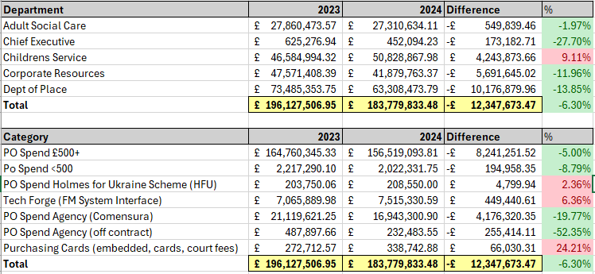
Spending Requests
As of 9th October 2024, between the dates of 1st April to 30th September there have been 4,900 total spend requests to the value of £500 or over actioned by the Spending Control Panel, this includes resubmitted items with the requested further information.
The average number of requests actioned per panel is 57.33. the number of requests has slowly been declining each month with the first month receiving 88.86 requests per panel to action, compared to September which received an average 41.19 requests to action.

Figure 1: The number of requests reviewed per month
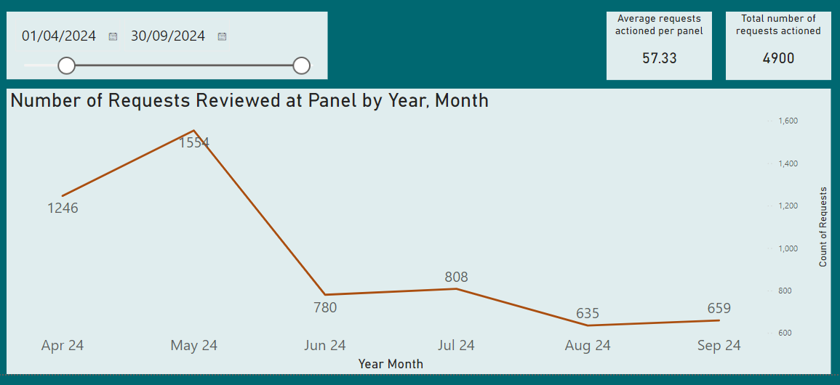
During this time, the Spend Control Panel has approved 4,737 requests to the value of £358,836,792. Of this, 41% of the total value approved was funding via external means.

Figure 2: Approved requests by budget
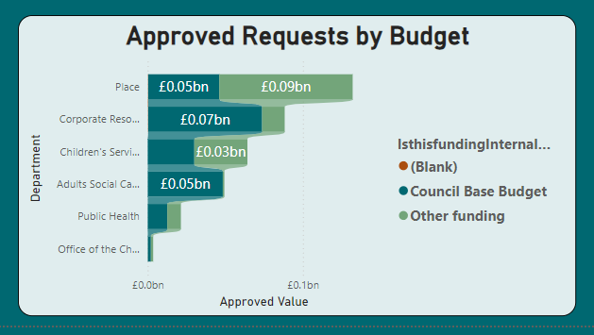
There are currently 163 requests to the value of £8,406,545 which have not been approved by the Spending Control Panel including resubmissions.
Table 1: The number, value and percentage of all request outcomes for Quarter 1 and 2
All Requests | Number of actioned requests | Value of actioned requests | % of requests | % of value of Actioned requests
All | 4900 | £367,243,337
Approved | 4737 | £358,836,792 | 97% | 98%
Rejected and not resubmitted or approved | 163 | £8,406,545 | 3% | 2%
Table 2: The number, value and percentage of approved request type for Quarter 1 and 2
Approved | Number of actioned requests | Value of actioned requests | % of approved requests | % of approved value
Other funding | 1437 | £146,028,275 | 30% | 41%
Council Based Budget | 3283 | £212,088,796 | 69% | 59%
Not assigned | 17 | £719,721 | 0% | 0%
Figure 3: Departmental breakdown of the requests reviewed by the Spending Control Panel.
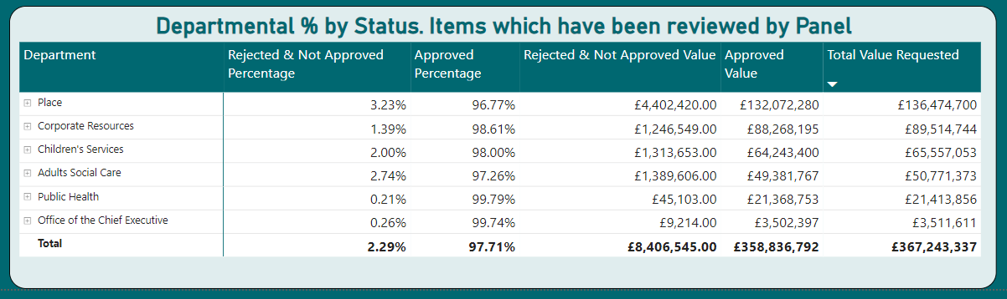

The Strategic Case

3.1 Background and Business Need
The spending control programme started with a review of all council spending. This was undertaken with Procure to Pay Team data, with support from the Finance Team. This led to the formation of a Spending Control Panel, and a roll out of additonal control measures across interface systems.
Spending within Bradford Coucil is through eighteen different payment routes.
Figure 4: Bradford Council payment routes for finacial year 2023/24
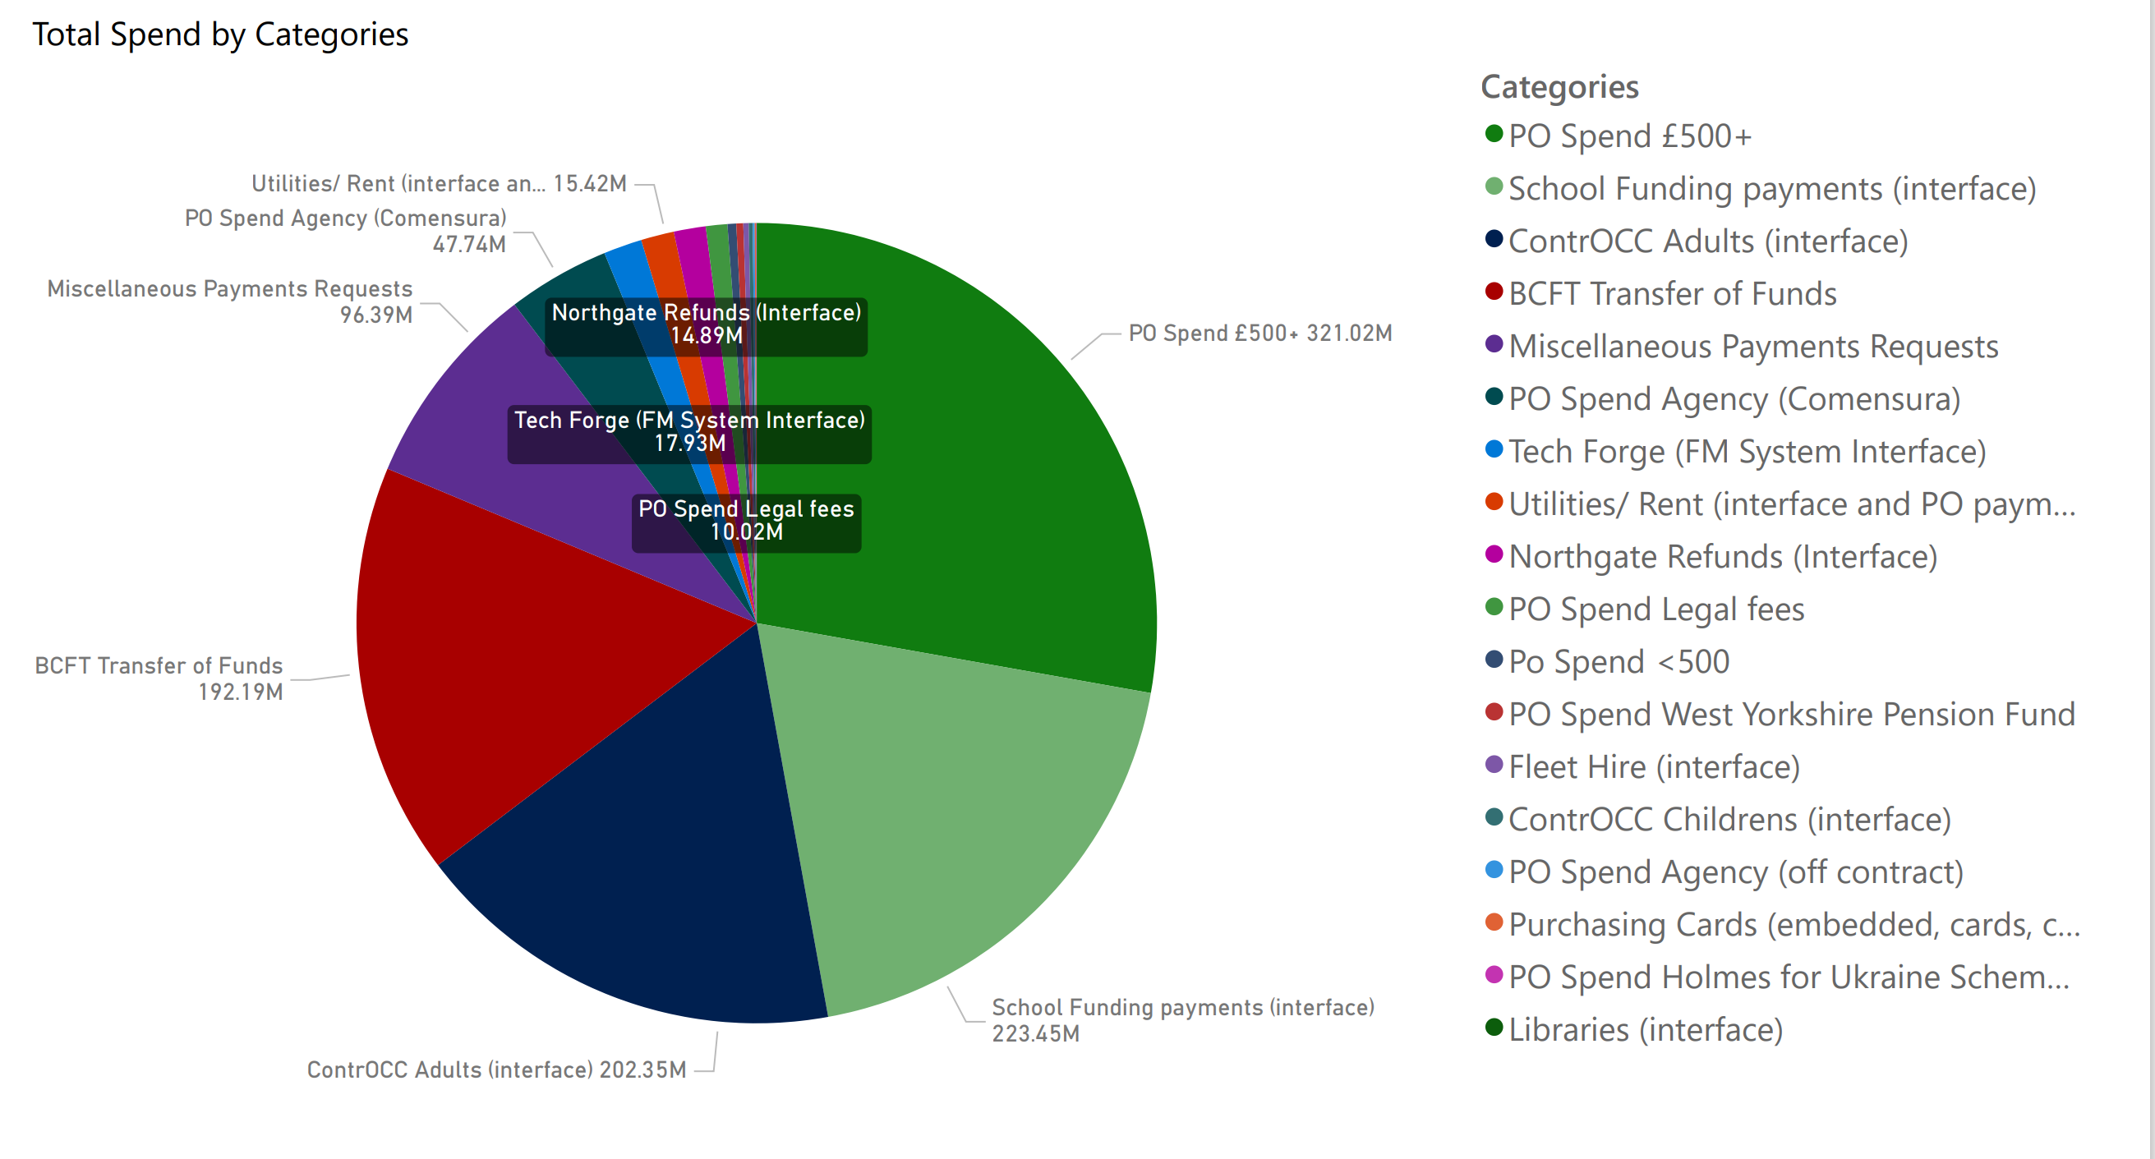
Core Spending Control Panel
The core Spending Control Panel started on the 1st April 2024. It is an automated process with a virtual panel meeting three times each week to review all requests and resubmissions. The remit of the panel is :
- All spending requests which require a Purchase Order for over £500
- All requests for corporate contracts over £500
- All write off requests for debt.
- All hire car requests for any passenger vehicles of any value.
- CHAPS and Faster Payments,
- International Payments
- Purchasing Card requests for card limit increase over £500
- All external print requests of any value
Spending Control Panel Operating Model
The panel reviews automated requests against the following criteria:
- Expenditure required to provide statutory* services at a minimum possible level.
*Statutory Duties are those which we are required by law to carry out.
- Urgent expenditure required to safeguard vulnerable citizens.
- Expenditure required through existing legal agreements and contracts.
- Expenditure funded through ring-fenced grants.
- Expenditure necessary to achieve value for money or mitigate additional in-year cost.
- Already legally committed.
- Income generation
- Other- need to specify reason.

The Spending Control Panel has additional responsibilities including:
- Reviewing monthly data for interface systems.
- Reviewing a monthly dip sample of 50 under £500 spends using the panel criteria and reporting on this.
- Retrospective review of spending in the miscellaneous payments category.
- Reporting on Purchase Orders raised retrospectively, after the date of the invoice.

Additional Control Panels
The council has introduced additional automated control panels to drive a culture of change across the organisation.
Figure 5: Summary of council control panels in place
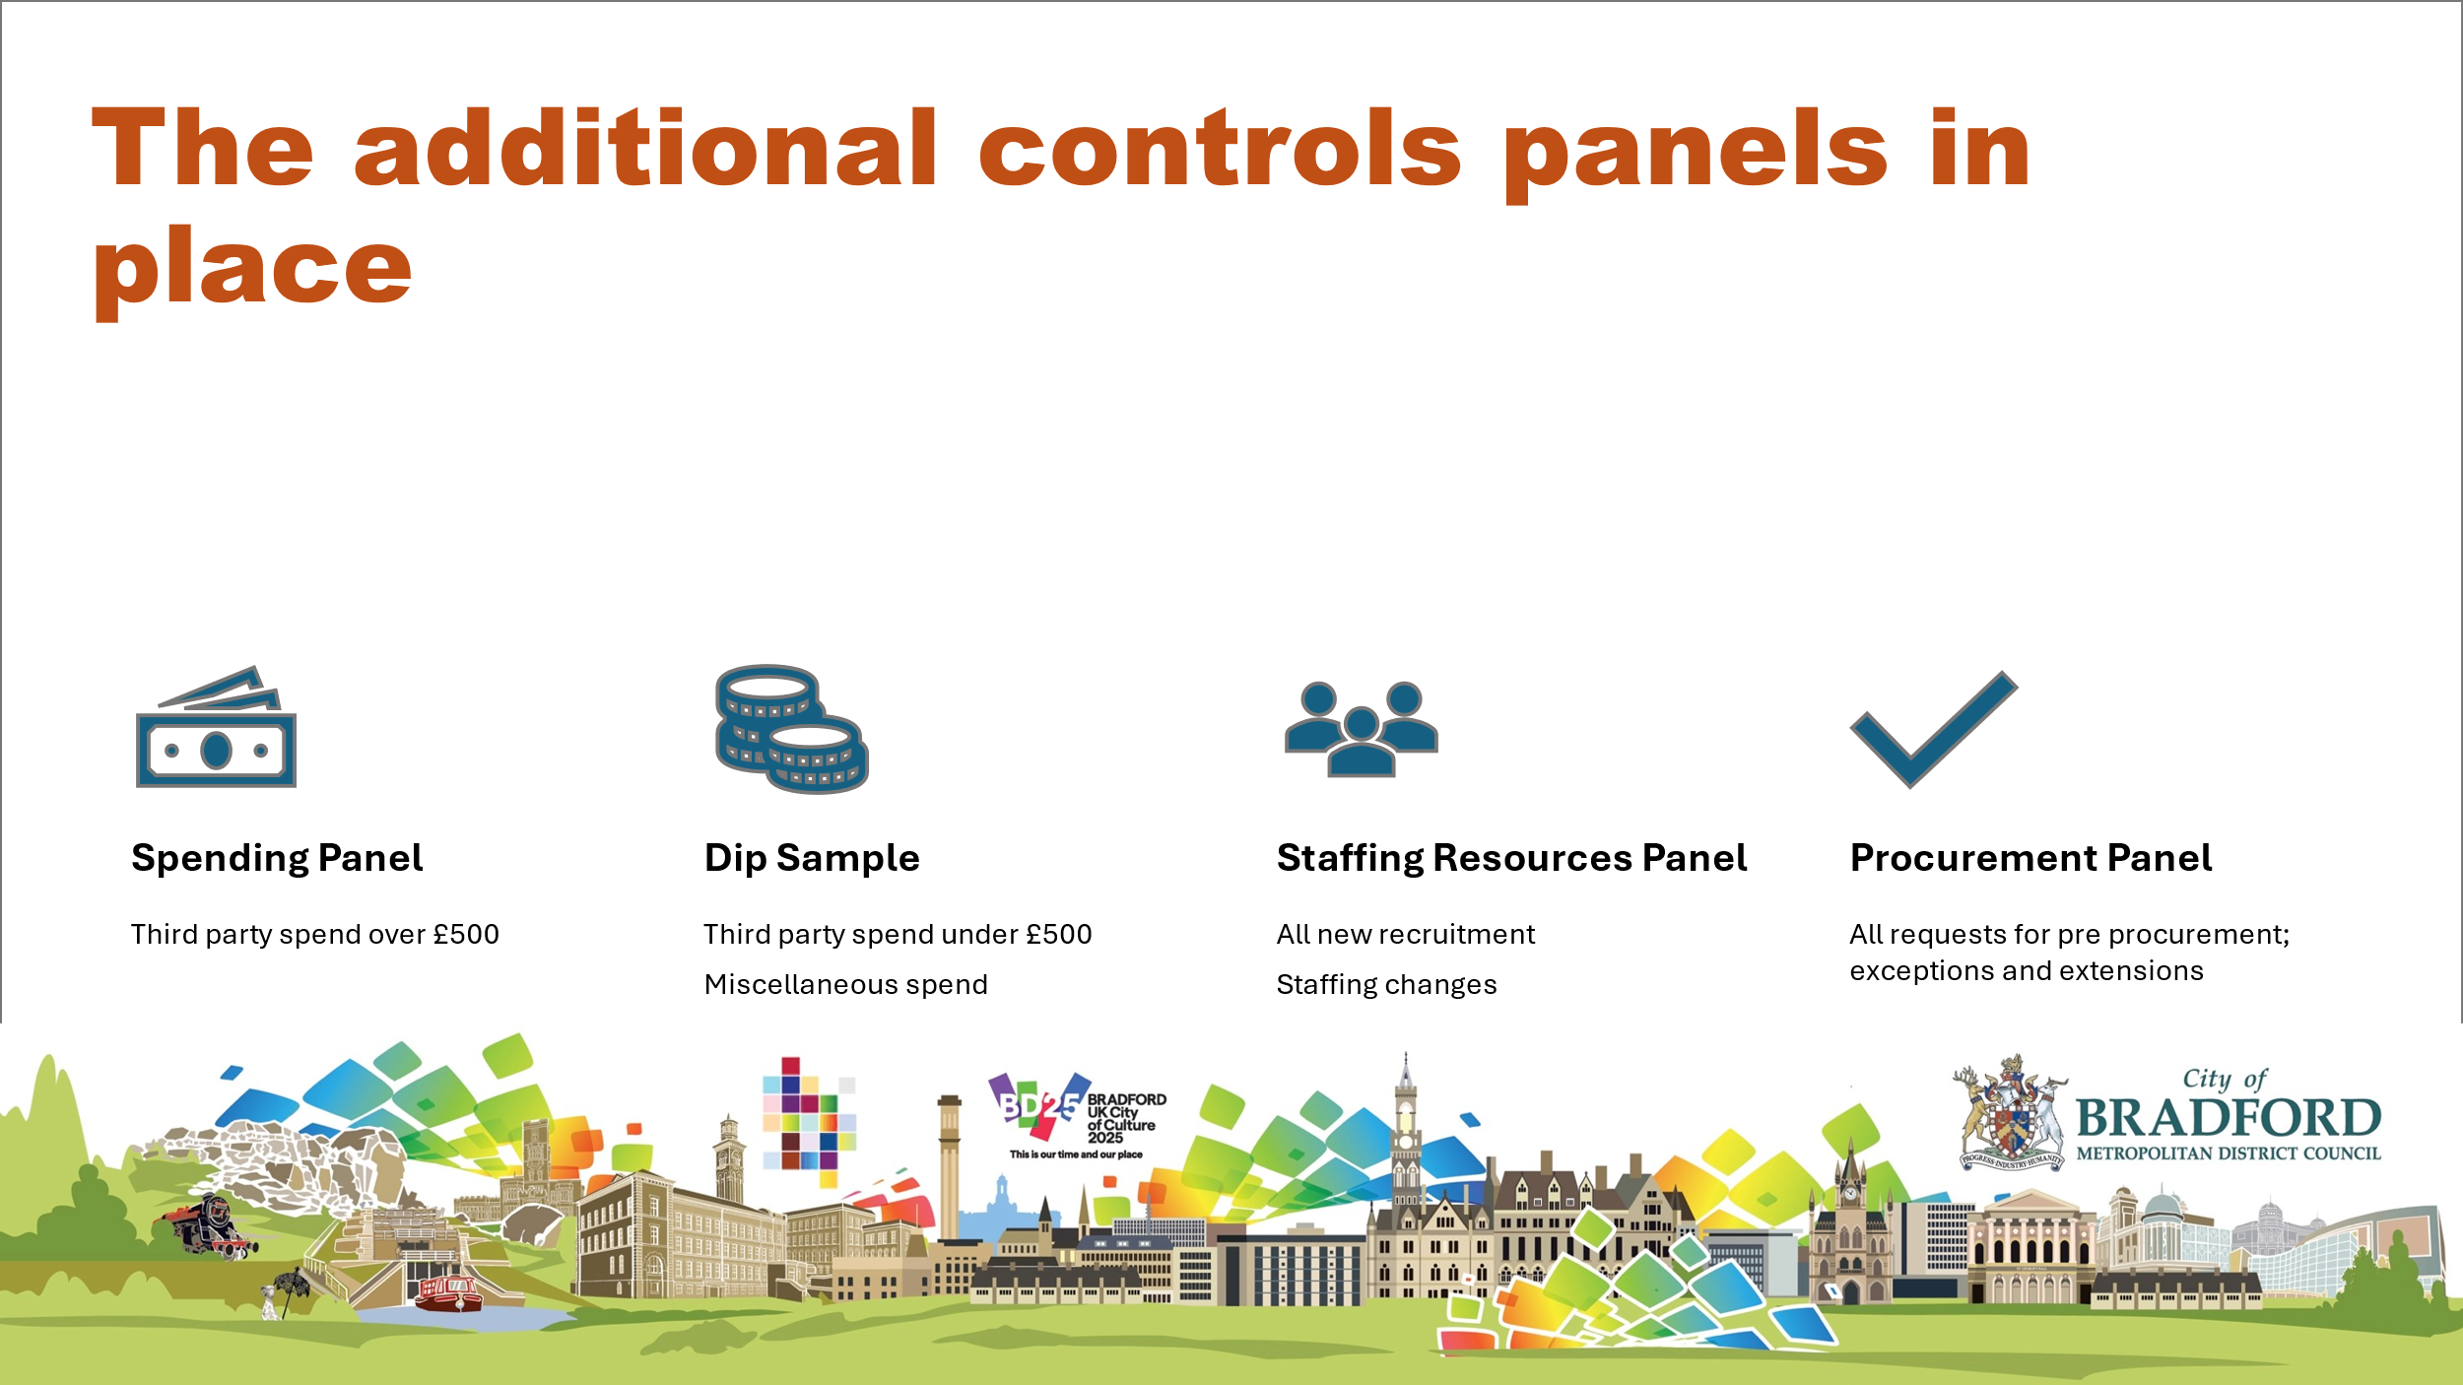
Overview of additional control panels:
- Dip Sample: Starting from the week beginning April 22nd there is a regular dip sample of spending claims under £500, utilising the criteria set by the core panel as the benchmark to report on those that would have received approval.
The dip sample identified 148 spending occurrences under £500 as a sample. An automated email was sent to the purchasers with a link to an online form to complete to account for the spending. This mirrors the spending approval form.
Of these, 103 were returned via the online form.
The total spend in the sample was £33.7k. 26 were deemed as spends which would not have been approved if submitted via the spending panel. The value of which was £9,278.9
- Miscellaneous Spend: During Q2 an automated email was sent to any user who had submitted a miscellaneous spend request during June. Users were provided with a link to an online form to complete to account for the spending. This mirrors the spending approval form.
401 requests were sent, all of these were returned.
The total spend in the sample was £1,616,184.11.
Of the 401 miscellaneous spends, 30 were deemed as spends which would not have received an approval if submitted via the spending panel. The value of which came to £1.3 million.
- Staffing Resource Panel: As of the 15th July 2024 the HR staffing Resource Approval Process was automated. This panel also has oversight of expenses and training requests.

Wider Spending Control Programme
There is a programme in place to deliver spending control and oversight on other key payment methods and interface systems used across the Council.
Table 3: Summary of the wider Spending Control Programme
Interface | What it covers | Spending Control
Tech Forge | This is the built environment interface payment system that processes built environment requests for planned work and maintenance and processes requests from departments | Monthly review of all spending against the agreed criteria for planned work and maintenance  All spend by department requires a spend control code
Tran Man | Fleet spending interface | All requests over £500 need spending code from the 22.4.24  All requests of any value for passenger car hire need spending code
Adult Controcc | Interface system to pay for care for adults. | Monthly review of all spending against the agreed criteria.  Request for spending control enhancement in non residential care packages
Libraries Interface | Libraries interface for book purchase | Monthly review of all spending against the agreed criteria.
Children’s Controcc | Interface system to pay for care for children | Monthly review of all spending against the agreed criteria
Grant awards to external organisations | Grants given by the council to external bodies. This is often ringfenced money that comes to the council for this purpose. | Automated form and cross council Grants Plane

“Deep Dive” Format
The process for deep dive is done as an agile exercise. A Deep Dive Lead is identified along with finance, procurement, PMO Team and at least one manager from the service which is the focus of the deep dive exercise.
The scope for the review will be set out and agreed with the Section 151 Officer and shared with BBERT. It includes consideration of:
- Full spending breakdown and financial information.
- Scope and role of the service and identification of the elements within this
- Funding sources
- Current controls
- Procurement compliance
- Virtual interviews with key managers in the service to understand challenges and opportunities.
- Consideration of areas where savings could be made.
- Recommendations for action in a final report.

Deep Dive | Cost saving actions | Possible Business case suggestions | Ball Park saving | Action completed by the service | Aim
Industrial Services Group |  | Cease manufacture of window units | £378,000 overspend, there will be other savings yet to be modelled. | Paper being prepared for Tranche 3 | Cease service
BACES | Fair contribution from health  Management of the catalogue  High value items panel |  | £554,000 structural overspend  200k saving already allocated following Deep Dive | Address issues with health, undertake service improvement. Aim to get back to budget allocated.  200k saving already allocated | Address budget gap
NRPF | Operational efficiency | Additional legal capacity case to speed up claims for recourse | £354,000  structural overspend | Business case to ask for EFS spend to reduce the time on no recourse via a commissioned piece of work | Address budget gap
Nursing and Residential | Control panel for spend  Process improvement for Controcc | Already in tranche 2 | As agreed with the service in tranche 2  £3,247k overspend in older people’s | Commissioned to inform existing commitment to deliver savings | Deliver existing spending commitment
Grounds Maintenance | Plan to enable prioritisation | 3rd Party spend saving tbc | Tbc, deep dive not completed | Review of all external spend and cost saving through central procurement – Business case from procurement/procurement/Principal Officer Grounds | Save money on 3rd party spend through better contracting, . Figure to be agreed

Summary
- Additional spending control is a necessary and important part of achieving financial sustainability for the council
- Spending control starts with every person doing the spending (and their manager) asking questions about whether the spend is essential, and if there is any other way of delivering that reduces the cost.
- Spending control gives us lots of very useful data and insight into spend.

3.2 Vision
The spending control process has been set up to ensure and demonstrate control across these areas and to prevent non essential spending.
It has also been set up to drive culture change across the organisation. Specifically this is to ensure that all spending is considered by every officer, and that there is a belief that all spending is being monitored and checked for compliance.

3.3 Objectives
Describe in more detail what will be achieved when the proposal has completed. Ensure that these are SMART – specific, measurable, achievable, relevant, and time-constrained and are aligned to the strategic direction.

The Economic Case
Please outline the main options which have been identified and assessed.

4.1 Options Considered
Always include a ‘Do Nothing’ Option. Please include a bullet pointed list of the options considered. E.g.
- Option A – Do Nothing. The Council continues to deliver services in the same way at the same cost.
- Option B – The Council reduces costs by way of sending control panels

4.2 Options Analysis - Summary
Please rate each option in terms of the extent to which it meets the following criteria and provide a brief description – High (H), Medium (M), Low (L), Not Applicable (NA). An example is shown in the column for Option A.
 | Option A  Do Nothing | Option B  [Title] | Option C  [Title] | Etc.  Please add further options as appropriate.
Summary  [Please provide a description of the option]. | The Council continues to deliver services in the same way. | Spending Panels
Non-Cashable Benefits | LOW  Customers not impacted by change, but existing issues with service remain. | H – better governance
  L | H
  M | NA
Financial Benefits | LOW  No financial benefits identified. | H – see financial analysis
  L | H
  M | NA
Risks & Disbenefits | HIGH  Existing issues remain unresolved.  Lack of efficiency. | L – reduces risk of overspends etc
  L | H
  M | NA
Costs | LOW  No immediate investment costs but may be costs of disinvestment. | L – existing resource undertaking the function
  L | H
  M | NA
Overall Saving / Cashable Benefits (Financial Benefits minus Costs) | NA  No cashable benefits – potential for additional cost in the longer term. | £xxxm
  L | H
  M | NA
Recommendation | Not Recommended | Recommended
  Not Recommended
  Recommended

4.3 Recommended Option
Option B is the recommended option

The Financial Case
This section outlines the financial benefits of the recommended option. Alongside the financial benefits, it should cover the affordability of the Business Case, capital and revenue recurring and ‘one off’ implementation costs and agreed sources of funding.

5.1 Financial Benefits
Please detail how the financial benefits will be made (revenue savings through…. / additional income generation through…) and complete the table below.
Please think about the profiled delivery of the savings – for example, if you expect to save £500k through a restructure, but this restructure will not ‘go live’ until October, you may get half of the financial benefits in the first year and the full value from year 2.
REVENUE BUDGET | Cost Centre & Subjective Code | 2024/25  £000k | 2025/26  £000k | 2026/27  £000k | 2027/28  £000k
.02% of total non pay spend |  |  | 1,000
Total Financial Revenue Benefits |  |  | 1,000

CAPITAL BUDGET | Cost Centre & Subjective Code | 2024/25  £000k | 2025/26  £000k | 2026/27  £000k | 2027/28  £000k
 |  |  | 0
Total Financial Capital Benefits |  |  | 0

5.2 Non-Financial Benefits
In addition to the financial benefits, please provide a summary of anticipated non-financial benefits and how they will be measured.
Non-Financial Benefit | Description | Measure
E.g. Improved customer satisfaction shown through reduction in complaints | Introduction of voice automation and a channel shift towards digital would minimise negative contact, abuse, and complaints from residents. | Number of complaints received.
Governance | Acting as check on expenditure
Culture | Driving changes in attitudes to spending – minimising expenditure rather than living within budget

5.3 Recurring Costs
Please consider potential recurring costs that will be required to support the business case. This could be related to IT system or license fees, additional staffing requirements, consumption costs, annual support and maintenance, costs to exit a facility, annual utility costs etc. This relates to organisational costs, and is not restricted to costs within your service.
Costs | Cost Centre & Subjective Code | 2024/25  £000k | 2025/26  £000k | 2026/27  £000k | 2027/28  £000k
 |  |  | 0
Total Costs |  |  | 0

5.4 ‘One Off’ Implementation Costs
Please consider what might be required to deliver or implement your programme, how long you may need this for, and how it will be funded. This relates to organisational costs, and is not restricted to costs within your service, and could include internal or additional resources (please consider corporate resource costs), consultancy costs, training, technical integration or installation, testing, costs to exit a facility etc. If your proposal impacts on estates or property please consult the appropriate team to ensure you include the correct costs. This could be funded through the financial benefits (in which case they may not be realised immediately) or via additional funding streams.
Budget Type  (Revenue / Capital) | Cost Centre & Subjective Code | 2024/25  £000k | 2025/26  £000k | 2026/27  £000k | 2027/28  £000k
 |  |  | 0
Total Financial Benefits |  |  | 0

5.5 Financial Summary (Cost/Benefit Appraisal)
Please complete the summary table below. If you have a request for additional funding to support deliver, please provide further detail.
 | Cost Centre & Subjective Code | 2024/25  £000k | 2025/26  £000k | 2026/27  £000k | 2027/28  £000k
Financial Benefits |  |  | 1000
Recurring Costs
Implementation Costs
Total Cashable Benefit / Saving |  |  | 1000

The Commercial Case
Please describe whether this business case is commercially viable. Is procurement required? What is known about the market place and is this proposal attractive? What contractual arrangements are in place or will be established? Where the business case involved a technical change, consideration should be given to the IT strategy.
The work is undertaken within existing resources

The Management Case
This section covers how the business case will be delivered successfully including governance structures, plans and resources for successful implementation.
7.1 Scope
Please provide detail of the confirmed scope of the recommended option. Please include areas that are both in scope, and out of scope.
All Council expenditure

7.2 Delivery Approach and Governance
How will you approach delivery – will this be managed in service, via a project etc? Please provide details of your delivery team or project and programme board structure. Please detail if a key decision is required. Please note that the Transformation and Change PMO will track all delivery.
Please include key roles and responsibilities:
Role | Name
Executive Sponsor (member of CMT)  Overall accountability | S J Mair
Senior Responsible Officer (SRO)  Decision maker, accountable for the project | J Cryer
Project/Programme Manager  Day to Day management of the project linking in with the T&C PMO. | J Cryer
Supplier (s)
Key resources required to deliver the project.
Users (s)
The people who will use or be impacted by the outputs.

7.3 High-level Plan, Milestones and Timescales
This business case will be delivered by….

Please complete the table below with high level actions. If your Business Case includes:
- Staffing impacts - please ensure that you build in sufficient time to complete the Managing Workforce Change guidance and activities.
- IT impacts – please ensure that you have included the relevant technical teams from the start and understood timelines relating to technical change.
- Procurement – please ensure that you have built in the correct procurement steps and appropriate timelines.

Milestone  Y/N | Action | Complete By (Date) | Action Lead
3 times weekly | Meetings to asses and challenge expenditure | 3 times weekly | J Cryer

7.4 Resource Requirements
Please detail the potential resources required to deliver the plan. These may be ‘one-off’ requirements.

Resource | Description (who is required, to do what, and when) | Required? (Y/N)
Human Resources (people)
Service Resources
Finance | Support to the challenge process | y
HR (including training)
Procurement | Support to the challenge process | y
Legal | Support to the challenge process | y
Transformation & Change | Support to the challenge process | y
IT
Data Governance
Estates
Payroll
Customer / Contact Teams
Business Support / Administration
Insurance
Communications
Policy & Performance
External Resource
Other
Non-Human Resources (things)
Accommodation
Technical resources (e.g. access to systems, hardware, software)
Data (e.g. benchmarking systems, productivity data)
Information (key documentation or reports)
Other

7.5 Major Risks and Assumptions
Please outline the key risks that could, if left unmanaged, negatively impact the success of the Business Case. This can include the financial implications or risk of doing nothing. Further detail will be included in the Project Risk Log.
Risk | Mitigations | Likelihood (L/M/H) | Impact (L/M/H)
There is a risk that xxxx may happen which may result in yyyy | What can be done to reduce the risk?
Inappropriate expenditure may still get approved | Continuous challenge | L | L

Please detail any assumptions which have been made during the development of the business case in a bullet pointed list below. This may include assumptions around technical requirements, resources etc.

7.6 Constraints
Please list any key constraints below (e.g. financial, time, resources, quality etc.)
None

7.7 Dependencies
A dependency is a task that relies on the completion of an activity elsewhere. This could be within the project or external to the project. Please provide information regarding any areas of this Business Case where a dependency might be present.

Dependency | Detail – how does it link | Implication | Action
Dept input

7.8 Key Stakeholders
Please list any key stakeholders that might be impacted by the proposal.
Name /Organisation | Role | Likely Impact/Interest
Depts

7.9 Impact Assessments
Please give details of the relevant impact assessments completed and any key actions from these assessments. This includes Equality Impact Assessment, Data Protection Impact Assessment, Environmental Impact Assessment etc. Please include these assessments in the appendices as appropriate.

7.10 Previous Lessons Learned
Please provide details from similar projects or activities that might inform delivery.

Appendices
Please include appropriate impact assessments and any other key relevant document.

Equality Impact Assessment Form Reference –

Department | Corporate Resources | Version no | V0.01
Assessed by | Helen Johnston | Date created | 05/11/2024
Approved by |  | Date approved
Updated by |  | Date updated
Final approval |  | Date signed off

Please keep a record of when updates are made and who has made them. Final approval should be given before the EqIA is published. A referencing system will be in place for annual budget changes, but outside of this, you should use your service’s own reference. The reference should remain the same from initial proposal through to implementation and on going reviews. Please remember that a full EqIA ONLY needs completing if you have decided there are impacts (positive or negative) on people at stage 1 of the EqIA process.. If there are no impacts then this should be recorded both on the EqIA and in a publicly available format (e.g. a committee report) with a summary of why you have reached this conclusion.

The Equality Act 2010 requires the Council to have due regard to the need to
- eliminate unlawful discrimination, harassment and victimisation;
- advance equality of opportunity between different groups; and
- foster good relations between different groups

Section 1: What is being assessed?

1.1 Name of proposal to be assessed.

Spending Control Panels – outputs

1.2 Describe the proposal under assessment and what change it would result in if implemented.

Spending Panels provide a process to support the effective and efficient use of funds. They bring a consistency to General Fund spending decisions across the Council.

The proposal is to apply a percentage reduction in spend across the board to generate £1m per annum.

Applications submitted for Spending Panels’ consideration are supported by an EQIA where required.

1.3 Stage 1 Assessment:

In order to assess whether this proposal requires a full EqIA, a stage 1 assessment must be completed on all proposals. Once complete, please inform the EqIA with the outcome explaining how it was reached and who was consulted. Please also state if the need for an EqIA may be revisited, and if so under what circumstances.

Protected Characteristics: | Impact  Y/N
Age | N
Disability | N
Gender reassignment | N
Race | N
Religion/Belief | N
Pregnancy and maternity | N
Sexual Orientation | N
Sex | N
Marriage and civil partnership | N
Additional Consideration:
Low income/low wage | N
Care Leavers | N

Click to return to contents page

Business Case Template

Project Name | Reference - 25/26 12b  (Cross Cutting)  Third Party Spend
Author | Terry Maley, Head of Procurement
Directorate | Corporate Resources
Service Area | Procurement
SRO | Joanne Hyde
Project / Programme Manager | Terry Maley

Status: V3
Date: October 2024

Document Management

1.1 Version Control
Version | Date | Author | Current Status of Business Case
V1 | 10 September 2024 | Terry Maley | Draft
V2 | 16 October 2024 | Karen Ind | Draft for Tranche 3
V3 | 17 October | Terry Maley | Final Edit for Tranche 3 submission

1.2 Document Approvals
The following areas need to approve the business case before submission to the T&C PMO
Name | Title/Function | Date Approved | Signature
 | Portfolio Holder (where required)
Steven Mair | Executive Sponsor
Joanne Hyde | SRO
David Heath | Finance
Gemma Emmet | Transformation
Anne Lloyd | HR *
Jason Field | Legal
 | Estates (where required)
 | IT (where required)

*Please note – If the proposal has any workforce implications such as restructures, redundancies etc this document MUST be filled in and sent to HR for review, along with the EQIA.

Executive Summary
As part of the council’s transformation programme, and in support of the wider aim to attain future financial sustainability, the Procurement Service have been tasked with securing £2m in savings from third party suppliers in 25/26. The first £0.5m of savings have been put forward previously and this business case sets out how a further £1.5m of savings will be made. Capture will be monitored as part of the council’s Bradford Budget Emergency Response Team (BBERT). These savings are cross-cutting (council wide) and, therefore, not exclusive to one council department.
In 23/24, the council spent circa £435m on third party suppliers. Whilst not all this expenditure can be directly influenced by procurement activities, the council seeks to reduce this expenditure in line with medium-term financial planning. Given the magnitude of the financial challenges facing the council, this business case seeks to review current corporate council contracts and makes proposals on delivering cost reductions and / or generate income.
Further savings for 26/27 are being modelled but are out of scope of this business case.
An executive summary of the proposed savings for this business case is detailed in the table below:
Savings Strategy | Savings Value (£.m)
Generate additional rebate via the increased use of payment cards with identified suppliers | 0.600
Channel all consultancy expenditure via a Crown Commercial Services (CCS) framework to benefit from more advantageous terms | 0.700
Re-procure gas and water supply on more advantageous terms | 0.200

The council is also having dialogue on the provision of the agency worker contract supplied by Comensura Ltd. This is due to expire in March 2025 and there is an option to extend the contract for a further 12-month period. Any extension will depend on the commercial terms available and cost reductions. It should be noted that the Comensura workstream is being treated separately to the work specified in the table above.

The Strategic Case

3.1 Background and Business Need
This business case supports the key objectives of the council in reducing costs and supporting the onward journey toward future financial sustainability. It supports the fiscal planning that underpins the Medium-Term Financial Strategy (MTFS) and will meet the 25/26 BBERT targets provided.

3.2 Vision
This business case aims to identify a further £1.5m in 25/26 savings (in addition to £0.5m previously put forward) that can be used to support the MTFS and the council’s onward journey to financial sustainability. The effective management of the council’s supply chain is a key component in delivering the cashable savings needed to support the council’s planning.

3.3 Objectives
When completed the proposed savings will have met the savings target inherent in the MTFS. This is essentially important in supporting the council’s financial recovery and future planning. When this proposal has been completed the council will have saved £2m in 25/26. This objective is specific to the procurement service, measurable by the actual amount of savings captured, achievable, very relevant to the council’s needs and to be delivered in 25/26 in line with the milestones set out in Section 7 of this document.

The Economic Case

4.1 Options Considered
- Option A – Do Nothing. The council continues to deliver services in the same way.
- Option B – Formulate a savings programme of procurement related projects that can save £2m in aggregate in 25/26.

4.2 Options Analysis - Summary

 | Option A  Do Nothing | Option B  Savings Programme worth £2m
Summary  [Please provide a description of the option]. | The council continues to deliver services in the same way. | Implement a £2m savings strategy in 25/26
Non-Cashable Benefits | LOW  Customers not impacted by change, but existing issues with service remain. | MEDIUM  This approach will deliver improvements in contract management
  L | H
  M | NA
Financial Benefits | LOW  No financial benefits identified. | HIGH  This will deliver savings in line with the MTFS
  L | H
  M | NA
Risks & Disbenefits | HIGH  Existing issues remain unresolved.  Lack of efficiency. | MEDIUM  Procurement Service has limited capacity and capability in the delivery of savings
  L | H
  M | NA
Costs | LOW  No immediate investment costs but may be costs of disinvestment. | MEDIUM  Procurement Service needs investment and this has been scoped up in a different business case.
  L | H
  M | NA
Overall Saving / Cashable Benefits (Financial Benefits minus Costs) | NA  No cashable benefits – potential for additional cost in the longer term. | £2m
  L | H
  M | NA
Recommendation | Not Recommended | Recommended
  Not Recommended
  Recommended

4.3 Recommended Option
This business case proposes a savings programme based on a series of procurement related projects, that in aggregate (with the previous £0.5m proposals) will meet the £2m saving target that supports the MTFS.

The Financial Case
The recommended option brings benefits in sourcing savings that accord with the council’s Medium Term Financial Strategy.

5.1 Financial Benefits
The main financial benefit will be £1.5m in savings, cost reductions or income generation in 2025/26 as detailed in this document.
REVENUE BUDGET | Cost Centre & Subjective Code | 2024/25  £000 | 2025/26  £000 | 2026/27  £000 | 2027/28  £000
Total Financial Revenue Benefits |  |  | 1,500

5.2 Non-Financial Benefits
Non-Financial Benefit | Description | Measure
This process will help develop better business processes and practice to enable future savings capture for the council. | Staff will become more familiar with enhanced contract management practice that will better position the council to capture savings. | Number of complaints received.
The Procurement Service will have clear purpose and leadership. This may boost morale and confidence in the service. | Having a savings target will allow the procurement team to prioritise work and focus on strategic priorities. | Reduction in procurement staff absences
The planned procurement projects will allow the council to promote social value | The procurements can deliver non-cashable benefits via the promotion of social value and new Procurement Act 2023 legislation | Social value benefits as defined in the contracts

5.3 Recurring Costs
This business case focuses on the capture of a further £1.5m in savings in 2025/26. There are no recurring costs.

5.4 ‘One Off’ Implementation Costs
This business case focuses on the capture of a further £1.5m in savings in 202526. There are no one-off costs.

The Commercial Case
The recommended option in this business case is commercially viable and will deliver savings in line with the council’s fiscal planning. The recommended procurement activity will be undertaken in full compliance with new legislation and industry best practice. This will maximise the council’s commercial position. The concept of value for money extends beyond price and commercial benefits will also be delivered via the promotion of social value and other community benefits to Bradford.

The Management Case
This section covers how the business case will be delivered successfully including governance structures, plans and resources for successful implementation.
7.1 Scope
The recommended option in this business case is a Savings Strategy Programme made up of five individual procurement projects. A key point to note is that work is required to commence now to ensure that the savings can be secured at some point in 2025 / 26. All these projects will run simultaneously, and careful oversight and monitoring will be required. These projects will run from 1 October 2024 to 31 March 2026 and have an aggregate aim of capturing £2m, or more, in savings or income generation. The projects will be predominantly resourced by the Procurement Service, however some subject matter expertise will be needed to support pre-market engagement and the evaluation of bids received. The project delivery and project governance approaches are set out below.

7.2 Delivery Approach and Governance
Delivery for all projects will be the responsibility of the Head of Procurement who will act as the Senior Responsible Officer. Each procurement project will be planned out using a consistent approach and maximising the benefits of new procurement legislation that takes effect on 28 October 2024. Delivery will be managed in service by the Procurement function. Highlight reports will be used by the procurement leadership team to track progress and this will be fed into the Transformation and Change PMO. Overall programme performance will be tracked using a balanced scorecard and fed into Corporate Resources DMT. Projects will be managed by exception, with any escalations reported to Corporate Resources DMT and BBERT meetings allowing for mitigation actions to be agreed and implemented.
Please include key roles and responsibilities:
Role | Name
Executive Sponsor (member of CMT)  Overall accountability | Joanne Hyde
Senior Responsible Officer (SRO)  Decision maker, accountable for the project | Terry Maley
Project/Programme Managers  Day-to-day management of the project linking in with the T&C PMO. | Michael Rowntree (Project A),  Julie Jenkins (Project B)  Kerry Bailey (Project C)  Darren Jacobs (Project D)  Michele McCartan (Project E)
Supplier (s)  Key resources required to deliver the project. | Key incumbent suppliers and new bidders
Users (s)  The people who will use or be impacted by the outputs. | All council departments

7.3 High-level Plan, Milestones and Timescales
This business case will be delivered by structuring the five projects as follows:

PROJECT | TITLE
Projects A and B put forward previously in Tranche 2 (£0.5m)
Generate additional rebate via the increased use of payment cards with identified suppliers | PROJECT C
Channel all consultancy expenditure via a Crown Commercial Services (CCS) framework to benefit from more advantageous terms | PROJECT D
Re-procure gas and water supply on more advantageous terms | PROJECT E

More detail on each individual project is provided below

PROJECT C – GENERATE ADDITIONAL REBATE VIA VIRTUAL PAYMENT CARD

This project is not a procurement exercise, but a strategy designed to generate additional income via increased rebate from suppliers.
There is an opportunity to increase the corporate purchasing card programme to generate additional income via increased rebate. It is now increasingly common for other local authorities in the country to pay suppliers by card and receive an annual rebate from their card provider. Larger local authorities, such as Bradford, have this as a preferred payment method in their terms and conditions and the council will seek to do likewise. A card process has been designed to pay high value, low volume invoices by a virtual card used by the Accounts Payable team. The standard P2P process will still be followed, with the order raised on SAP with spending approvals being sought and obtained. There are benefits to suppliers in full early payment and cashflow management advantages.
The council has established the following list of suppliers where there may be commercial benefits in moving the supplier to a virtual card payment. This list should not be viewed as exhaustive.

- AGGREGATE INDUSTRIES
- TARMAC
- SPECIALIST COMPUTER CENTRE
- ROYAL MAIL
- N POWER
- ZURICH
- CORONA ENERGY
- EQUANS
- ELOLVE CONSTRUCTION
- KPMG
- TANNAH LIFTS
- VIRGIN MEDIA
- ATKINSREALIS PPS LIMITED
- JW YOUNGS (BUTCHERS) LTD
- ARROW COUNTY SUPPLIES LTD
- BYTES SOFTWARE SERVICES LTD
- EVOLVE CONTRUCTION SERVICES (YORKSHIRE) LTD
- CAR HIRE (SAY OF SWANSEA) LIMITED
- BRENNTAG UK HOLDING LTD
- DENNIS EAGLE LTD

A high-level timeline for Project C is detailed in the table below:

OCT 24 | NOV 24 | DEC 24 | JAN 25 | FEB 25
Learning visit to Leeds Council  Proof of concept with AWM  Agree list of suppliers  Contact suppliers | Clarification meetings with suppliers | Apply virtual card payments | Apply virtual card payments | Apply virtual card payments

This means that by taking learning from a neighbouring authority who are more advanced in the use of virtual cards and by developing a “proof of concept” with the council’s waste management supplier, the council will be in a position to check the income generation target of £0.6m in December 2024 and this will be rolled out across all invoicing with target suppliers in Q4 of this fiscal year.

PROJECT D – CHANNEL CONSULTANCY EXPENDITURE VIA A CROWN COMMERCIAL SERVICES FRAMEWORK

This project does not relate to a specific procurement but a funnelling of council expenditure through a government framework that can provide much better value for money. It is also designed to identify and eradicate unnecessary or unsanctioned expenditure on consultants.
The council spends several million pounds per annum on consultants. Whilst the council will always have some reliance on external specialist professional services, expenditure on consultants needs to decrease to support fiscal planning. The process for hiring consultants is disjointed and there is no real grip on approvals and ensuring value for money. Proposals to change this are being developed and a specific approval gateway for the appointments of consultants to support with the Medium-Term Financial Strategy is being developed. This will result in the following business benefits that will help the council to reduce expenditure on external consultants:
- Provide greater visibility, grip and control on the council’s use of consultants
- Funnel requests via a new decision-making gateway which will decline some consultancy requests that cannot demonstrate value for money. This will reduce aggregate expenditure from current levels.
- Make more use of Management Consultancy Services 3 (MCF3) and take advantage of capped rates and other strong commercial terms that the CCS have put in place when forming the framework.
- Specifications will be developed to ensure that consultants are working towards tight budgets and timelines. Outcomes will be specified, and payments will be linked to progress milestones. This will ensure greater value for money.

A high-level timeline for implementing this project is provided in the table below:

OCT 24 | NOV 24 | DEC 24 | JAN 25 | FEB 25
Report to CMT. Agree planned reduction in expenditure  Set up approval panel  Prohibit spending without panel code | Allocate procurement resource to operate CCS framework.  Funnel all consultancy work via CCS framework | Measure expenditure versus planned reductions | Measure expenditure versus planned reductions | Measure expenditure versus planned reductions

PROJECT E – Gas and Water Re-procurements

The council’s gas and water supply is due for renewal in 2025. Gas is currently provided by the Yorkshire Purchasing Organisation (YPO) and water by Yorkshire Water. For gas, the council is currently exploring alternative funding models that could deliver cost reductions. There is an option to switch supply to another Public Buying Organisation (PBO) and price comparisons will commence with Crown Commercial Services (CCS). It is felt that current gas costs could be bettered to generate a saving of £0.2m depending on energy market conditions that the council cannot control. Water rates will be subject to the same cost comparison analysis to determine any savings potential in switching suppliers.
A high-level timeline for this project is detailed below:

OCT 24 | NOV 24 | DEC 24 | JAN 25
Scope savings in switching gas supply in context of new price cap.  Scope savings in water services in switching supplier | CMT report and approvals | Agree any switching process and check savings potential based on market conditions | Contract with new supplier(s)

Milestone  Y/N | Action | Complete By (Date) | Action Lead
Project C | Increase income via rebate from virtual payment card | 31 March 2025 | Terry Maley
Project D | Funnel all consultancy requests via a CCS framework | 31 March 2025 | Terry Maley
Project E | Make savings in water and gas supply | 31 March 2025 | Terry Maley

7.4 Resource Requirements
Resource | Description (who is required, to do what, and when) | Required? (Y/N)
Human Resources (people)
Service Resources |  | N
Finance | Support in Project D | Y
HR (including training) | Support in Project D | Y
Procurement | This is a procurement business case | Y
Legal |  | Y
Transformation & Change | Support in tracking all projects via PMO | Y
IT | Support in Project A | Y
Data Governance |  | N
Estates |  | N
Payroll |  | N
Customer / Contact Teams |  | N
Business Support / Administration |  | N
Insurance |  | N
Communications | Support in Project D | Y
Policy & Performance | Support in Project D | Y
External Resource |  | Y
Other |  | N
Non-Human Resources (things)
Accommodation
Technical resources (e.g. access to systems, hardware, software)
Data (e.g. benchmarking systems, productivity data)
Information (key documentation or reports)
Other

7.5 Major Risks and Assumptions
The major risks and assumptions are detailed below:
Risk | Mitigations | Likelihood (L/M/H) | Impact (L/M/H)
There is a risk that the procurements may be aborted or delayed which may result in the loss of savings | The work with Comensura is hoped to provide some mitigation savings if one or more of the procurement projects stall. | Medium | High
There is a risk that the Procurement Improvement Plan is not approved which would materially weaken the council’s ability to deliver this business case. | This business case would need to be re-written and the 25 / 26 scoping | Medium | High

The recommended option in this business case has been developed under the following assumptions:
- That the Procurement Act 2023 will take effect on 24 February 2025 as planned and the council can maximise the new flexibilities this will bring.
- That the Procurement Improvement Plan (a separate business case to transform the Procurement Service) will be fully approved, resourced and implemented. This is essential in ensuring that there is sufficient capability and capacity to undertake the work needed to generate the totality of the £2m (Tranche 2 and 3) savings
- That the council will focus its procurement activities on the key strategic projects that make up the 25/26 Savings Programme as detailed in the Executive Summary. This will mean that other procurement-related work may be deferred and delayed.
- That any double counting of savings potential across the departments has been checked and minimalised
- The council has reliable data to plan the procurement projects and that subject matter experts will be made available across the departments to support the procurement processes. This is particularly important in ensuring that the evaluations of competitive bids can be undertaken by expert colleagues from across the departments.
- The Procurement Service will stretch their savings targets wherever possible. Where work identifies greater savings potential, this will be actively pursued. It may be necessary to manage over and under-performance across the projects to achieve the aggregate goal.

7.6 Constraints
Currently, the council does not have a strong contract management culture. Steps are being taken to address this, but there may be a paucity of data and documentation that will constrain commercial negotiations with external parties.

7.7 Dependencies
This business case is entirely dependent on the Procurement Improvement Plan being approved and implemented. This sets out the transformational funding needed to invest in the Procurement Service to ensure it has the capability and capacity needed to deliver the savings detailed in this paper. If the Procurement Improvement Plan were not to be approved, then this business case would need to re-written and the Procurement Service’s contribution to the MTFS re-evaluated.

7.8 Key Stakeholders
The savings proposal inherent within this paper will require input from a high number of internal and external key stakeholders. This includes, but is not limited to:
- Procurement Service
- Finance
- Legal
- Corporate Management Team
- Departmental Management Teams impacted by the procurements
- The council’s third-party supply chain
- Crown Commercial Services
- Yorkshire Purchasing Organisation

7.9 Impact Assessments
An equality impact assessment has been undertaken and is attached as an appendix.

7.10 Previous Lessons Learned
The savings proposed in this paper are entirely commensurate with what other councils, of a similar size and demographic have achieved. The savings proposed in this paper do not make the council an outlier and any learning will be derived from other local authorities wherever possible.

Appendices

An equality impact assessment has been undertaken and is attached as an appendix.

Equality Impact Assessment Form Reference –

Department | CORPORATE RESOURCES | Version no
Assessed by |  | Date created | 10 Sept 2024
Approved by |  | Date approved
Updated by |  | Date updated
Final approval |  | Date signed off

Section 1: What is being assessed?

  - This pertains to a Business Case designed to deliver £2m in savings in 25 / 26 via a Programme underpinned by five procurement-related projects. These are detailed in the table below:

Savings Strategy | Title | Savings Value (£.m)
Re-procure a case management system for both Adult and Children’s social care | Project A | 0.250
Re- procure Security contract and make savings on off-contract expenditure | Project B | 0.250
Generate additional rebate via the increased use of Payment cards with identified suppliers | Project C | 0.600
Channel all Consultancy expenditure via a Crown Commercial Services (CCS) framework to benefit from more advantageous terms | Project D | 0.700
Re-procure Gas and Water supply on more advantageous terms | Project E | 0.200

1.2 This proposal would support the Council’s journey towards future financial sustainability and the medium-term Financial Strategy by delivering £2m in savings via the actions as detailed above. This is a key objective of the Council’s wider Transformation Programme.

1.3 Stage 1 Assessment:

None of the protected characteristics are impacted by this proposal. This outcome was reached by the Head of Procurement who prepared the business case and is being presented to the Subject Matter Expert (Khalida Ashrafi) for quality assurance and validation. The intention is to keep this Stage One assessment under continual review in case any of the protected characteristics should become impacted. This is deemed unlikely given the clear-cut nature of the business case.

This decision, and the rationale behind it, will be made available in public documentation when the consultation process with Elected Members has concluded and the business cases become available for general access with commercial sensitivities redacted.

Protected Characteristics: | Impact  Y/N
Age | N
Disability | N
Gender reassignment | N
Race | N
Religion/Belief | N
Pregnancy and maternity | N
Sexual Orientation | N
Sex | N
Marriage and civil partnership | N
Additional Consideration:
Low income/low wage | N
Care Leavers | N

Click to return to contents page

Business Case Template

Project Name | Fees and Charges
Author | Andrew Cross
Directorate | Cross Cutting
Service Area | Multiple
SRO | Marium Haque
Project / Programme Manager | Amani Ali

Status: V3
Date: July 2024

Contents
1. Document Management 103
1.1 Version Control 103
1.2 Document Approvals 103
2. Executive Summary 104
3. The Strategic Case 106
3.1 Background and Business Need 106
3.2 Vision 110
3.3 Objectives 111
4. The Economic Case 112
4.1 Options Considered 112
4.2 Options Analysis - Summary 112
4.3 Recommended Option 113
5. The Financial Case 114
5.1 Financial Benefits 114
5.2 Non-Financial Benefits 114
5.3 Recurring Costs 115
5.4 ‘One Off’ Implementation Costs 115
5.5 Financial Summary (Cost/Benefit Appraisal) 115
6. The Commercial Case 116
7. The Management Case 116
7.2 Delivery Approach and Governance 116
7.3 High-level Plan, Milestones and Timescales 116
7.4 Resource Requirements 117
7.5 Major Risks and Assumptions 118
7.6 Constraints 118
7.7 Dependencies 118
7.8 Key Stakeholders 118
7.9 Impact Assessments 119
7.10 Previous Lessons Learned 119
8. Appendices 120

Document Management

1.1 Version Control
Version | Date | Author | Current Status of Business Case
0.1 | 04/11/2024 | A Cross | Draft

1.2 Document Approvals
The following areas need to approve the business case before submission to the T&C PMO
Name | Title/Function | Date Approved | Signature
 | Portfolio Holder (where required)
 | Executive Sponsor
Marium Haque | SRO
Andrew Cross | Finance
Anne Marie Wooler | Transformation
 | HR *
Christine Meakins | Legal
 | Estates (where required)
 | IT (where required)

*Please note – If the proposal has any workforce implications such as restructures, redundancies etc this document MUST be filled in and sent to HR for review, along with the EQIA.

Executive Summary
The Council has well documented financial challenges and needs to improve its financial position by reducing costs and increasing income where possible.

Sales, fees and charges are key sources of income, and the Council provides a wide range of chargeable services with well over 1,000 different prices for products as diverse as swimming sessions, planning applications, cremations and highways permits amongst others.

There is a significant amount of regulation that governs sales, fees and charges, and in all cases the Council must ensure compliance with legislation.

In some instances, charge rates are directly set by Government, but in others the Council has powers to set prices as long as it remains compliant with the regulations, and it is economic to do so in line with market conditions.

In addition to the financial challenges, the Council’s cost base also increases each year in line in inflationary pressures. This includes for example staff pay awards that are budgeted at 4% for 2025-26. It should however be noted that in recent years lower paid staff have typically received higher % increases in pay than senior staff, and many of the services that generate high levels of fees and charges, are those with typically higher proportions of lower paid staff including Schools Meals and Sports Facilities for example.

A default 6% target increase in in-scope sales, fees and charges income budgets for 2025-26 is proposed which would raise c£4.8m.

To help achieve this, a general 6% increase in prices is proposed for those services where the Council can set them, with a small number of deviations for the Council services that have provided an alternative justification.

Adult Social Care will also have a £0.6m increase in income budgets to derive from means tested service user contributions. ASC currently receives c£29m from Services users receiving care in their own homes and in residential settings. Charging thresholds are set by government and the amount that people pay is dependent upon their financial assessment. Modelling indicates that a 2% increase is a realistic budget increase for 2025-26.

It should also be noted that there are some other budget proposals that have some cross over with sales, fees and charges, and although referenced in this business case, they have been excluded from the budget impact to avoid double counting. This includes for example
Garden Waste fees
Highways charges and car parking
School Meals – subject to a separate recovery plan?
Income from investment estate – as it is being sold

Overall, the proposed increase in sales fees and charges related budgets for services that are within the scope of this proposal is £5.4m.

The Strategic Case

3.1 Background and Business Need
The Council has well documented and very significant financial challenges, and it also has inflationary increases such as staff pay awards that it has to fund.
The Medium-Term Financial Strategy outlines the scale of the challenge, and the need to reduce expenditure and increase income to help return the Council to a financially sustainable position that doesn’t require a capitalisation direction.
Based on the Councils July 2024 MTFS, Council borrowing will increase by over £470m as a result of the required capitalisation directives.
Every £1 borrowed will have to be paid back over the next 20 years, and it will also be subject to annual interest payments over that period.
Reducing expenditure, and increasing income as quickly as possible therefore has the twin benefit of reducing the amount of capitalisation directive required in 2025-26, and also then helps reduce the interest costs result in a concomitant reduction in future capitalisation directives.
Sales, fees and charges typically increase by inflation each year to take account of staff pay award and other inflationary pressures, and the staff pay award for 2025-26 is currently budgeted at 4%.
It should also be noted, that although the pay award in 2024-25 ended up as c4% across the Council overall, the cost base for some of the services that generate larger amounts of Fees and Charges – for example Sports Facilities, School Catering amongst others, had proportionally higher increases in their cost bases because the pay award was tiered. For example an employee on NJC point 2 received a £1,290 flat rate pay award equating to 5.77%, where staff above PO6 had a pay award of 2.5%.
Based on the above, Director of Finance/ Corporate Management Team have proposed a target of a 6% budget increase for in scope sales fees and charges to help bridge the budget gap.

3.2 Vision
In addition to raising much needed additional income that will help pay for inflationary increases in costs and generate additional income that can help close the unprecedented Council wide budget gap, a Fees and Charges review is also being undertaken to improve Governance and Transparency.
The Governance and Transparency associated with sales, fees and charges will improve as they will be subject to a separate report and specific recommendations that are proposed to be included within the suite of Budget reports that will be voted on by Budget Council in March 2024.
Additionally, the Council’s web pages are being improved to make it easier for users to locate fees and charges for Council services by creating a dedicated Fees and Charges site.
Significant effort has been made on the above to generate a centralised list of fees and charges which is included in Appendix A, and work on the coding of Sales Fees and Charges to the Councils accounting system to better align budgeting, management and reporting is ongoing.
Though the above outlines the near-term improvements and the work undertaken to date, it should be noted that improvements to the governance, transparency, and reporting associated with fees and charges is an ongoing process and is not complete at the time of drafting this Business Case.

3.3 Objectives
As a result of the proposed increases, the Council would budget to increase the amount raised from sales , fees and charges by £5.4m in 2025-26.
The increased income will help fund the pay-awards and other inflationary pressures that Council services are facing, and also contribute to making the Councils budget more sustainable as previously outlined.
Governance; transparency, and monitoring and reporting improvements are also objectives as previously outlined.
Most charges would be increased on 1st April 2025, but in some instances, the charges will apply from a different implementation date, for example 1st September for the new academic year.

The Economic Case

4.1 Options Considered
- Option A – Do Nothing.
- Option B – Increase in scope sales, fees and charges budgets by 6%.
- Option C – Increase in scope sales, fees and charges budgets by 10%

4.2 Options Analysis - Summary
 | Option A  Do Nothing | Option B  [Increase by 6%] | Option C  [Increase by 10%]
Summary  [Please provide a description of the option]. | The Council doesn’t increase charges and has to fund inflationary pressures from other sources resulting in either additional unfunded pressures that increase the capitalisation directive values (and hence borrowing) or more cuts to services | The Council increases fees and charges in line with inflationary pressures and some small additionality to help make Council services more financially sustainable | The Council increases fees and charges to cover inflationary pressures and has a stretch target for sales fees and charges which would be difficult to deliver and put result increased costs to service users
Non-Cashable Benefits | LOW  Customers would pay benefit as they would be paying less in real terms, however the Council would then have unfunded inflationary pressures leading to additional service cuts, or additional unsustainable borrowing.
  L | H
  M | NA
Financial Benefits | LOW  No financial benefits to the Council identified. Would result in additional unfunded inflationary pressures. | Medium  The increases would help pay for inflationary pressures, and provide a small contribution to enabling the Council to get to a more financially sustainable position. | High  The increases would help pay for inflationary pressures, and provide a larger contribution to enabling the Council to get to a more financially sustainable position
  L | H
  M | NA
Risks & Disbenefits | HIGH  Would result in additional unfunded inflationary pressures to the Council. | Medium  Sales, Fees and Charges to Service users will increase by more than the general rate of inflation. | High  The increased income budgets would have an increased risk of being underdelivered.
  L | H
  M | NA
Costs | LOW  Low  Administrating increases to prices and charges is business as usual | Low  Administrating increases to prices and charges is business as usual | Low  Administrating increases to prices and charges is business as usual
  L | H
  M | NA
Overall Saving / Cashable Benefits (Financial Benefits minus Costs) | NA  No cashable benefits – potential for additional cost in the longer term.
  L | H
  M | NA
Recommendation | Not Recommended | Recommended | Not Recommended
  Not Recommended
  Recommended

4.3 Recommended Option
Option B - increase sales fees and charges budgets by 6% for in-scope services, with a general increase in sales fees and charge related prices by a default 6% with allowable deviations from this only where a there is an overriding case (for example where Government set the rates) as outlined in Appendix B.

The Financial Case

5.1 Financial Benefits

REVENUE BUDGET | Cost Centre & Subjective Code | 2024/25  £000k | 2025/26  £000k | 2026/27  £000k | 2027/28  £000k
 | Multiple non Adult Social Care codes | 4.8 | 0.0 | 0.0 | 0.0
 | Adult Social Care | 0.6 | 0.0 | 0.0 | 0.0
Total Financial Revenue Benefits |  | 5.4 | 0.0 | 0.0 | 0.0

CAPITAL BUDGET | Cost Centre & Subjective Code | 2024/25  £000k | 2025/26  £000k | 2026/27  £000k | 2027/28  £000k
Total Financial Capital Benefits |  | N/A

5.2 Non-Financial Benefits

Non-Financial Benefit | Description | Measure
Improved Governance | A separate report and recommendations on Sales Fees and Charges will be included in the suite of Budget reports provided to Budget Council in March 2024
Improved Transparency | The Council’s website will be improved to have a dedicated site for the Sales, Fees and Charges values of Council Services

5.3 Recurring Costs

Costs | Cost Centre & Subjective Code | 2024/25  £000k | 2025/26  £000k | 2026/27  £000k | 2027/28  £000k
Total Costs |  | 0.0 | 0.0 | 0.0 | 0.0

The additional costs of services that are being part funded by Sales Fees and Charges are included within the pay awards/ inflationary assumptions in other parts of the budget that are outside of the scope of this business case.

5.4 ‘One Off’ Implementation Costs

Budget Type  (Revenue / Capital) | Cost Centre & Subjective Code | 2024/25  £000k | 2025/26  £000k | 2026/27  £000k | 2027/28  £000k
Total Financial Benefits |  | 0.0 | 0.0 | 0.0 | 0.0

Price increases occur each year and the administration costs associated with increasing charges are contained within existing budgets.
?? Bradford Schools online??

5.5 Financial Summary (Cost/Benefit Appraisal)

 | Cost Centre & Subjective Code | 2024/25  £000k | 2025/26  £000k | 2026/27  £000k | 2027/28  £000k
Financial Benefits |  | 5.4 | 0.0 | 0.0 | 0.0
Recurring Costs |  | 0.0 | 0.0 | 0.0 | 0.0
Implementation Costs |  | 0.0 | 0.0 | 0.0 | 0.0
Total Cashable Benefit / Saving |  | 5.4 | 0.0 | 0.0 | 0.0

The departmental impact of the 6% increase in sales fees and charges for in-scope services is shown below, and detailed in Appendix A.

In addition to the above, a 2% increase in the £29m budget for service user contributions in Adult Social Care would add an additional £0.6m.

The Commercial Case
The cost of Council services increases each year because of pay awards/ inflationary pressures, and consequently the Council increases sales, fees and charges each year to help contribute towards these. As previously outlined, many of the services that generate the larger amounts of sales fees and charges are also those that typically have lower graded staff that have been receiving pay awards in excess of the general level of inflation (CPI).
Consequently, the cost base of those services is also disproportionately impacted. To help fund those increases and make a small contribution to the Council returning to a financially sustainable position, a 6% increase in budgets is proposed.
To help deliver a 6% increase, a default 6% increase in prices is also proposed with deviations where rates are set by Government or where Council services have provided a justification for a different rate.

The Management Case
7.1 Scope
The 6% Budget increase will apply to those services outlined in Appendix A. This will increase related budgets by £4.8m.
Adult Social Care income budgets for services user contributions will also increase by 2% resulting in a £0.6m increase.

Out of scope services include
Garden Waste charges - as subject to a separate business case.
Highways charges and car parking – as subject to separate business case
School Meals – subject to a separate recovery plan?
Income from investment estate – as it is being sold

7.2 Delivery Approach and Governance
The list of sales fees and charges service budget increases is included in Appendix A
The list of sales fees and charges price increases is included in Appendix B – (Work in progress – some anomalies still need answers).
The prices will be included in a Sales Fes and Charges report that will be included as part of the suite of budget reports that will be provided to Budget Council in March 2025.

Please include key roles and responsibilities:
Role | Name
Executive Sponsor (member of CMT)  Overall accountability | Marium Haque
Senior Responsible Officer (SRO)
Decision maker, accountable for the project
Project/Programme Manager
Day to Day management of the project linking in with the T&C PMO.
Supplier (s)
Key resources required to deliver the project.
Users (s)
The people who will use or be impacted by the outputs.

7.3 High-level Plan, Milestones and Timescales
This business case will be delivered by….

Please complete the table below with high level actions. If your Business Case includes:
- Staffing impacts - please ensure that you build in sufficient time to complete the Managing Workforce Change guidance and activities.
- IT impacts – please ensure that you have included the relevant technical teams from the start and understood timelines relating to technical change.
- Procurement – please ensure that you have built in the correct procurement steps and appropriate timelines.

Milestone  Y/N | Action | Complete By (Date) | Action Lead

7.4 Resource Requirements
Please detail the potential resources required to deliver the plan. These may be ‘one-off’ requirements.

Resource | Description (who is required, to do what, and when) | Required? (Y/N)
Human Resources (people)
Service Resources
Finance
HR (including training)
Procurement
Legal
Transformation & Change
IT
Data Governance
Estates
Payroll
Customer / Contact Teams
Business Support / Administration
Insurance
Communications
Policy & Performance
External Resource
Other
Non-Human Resources (things)
Accommodation
Technical resources (e.g. access to systems, hardware, software)
Data (e.g. benchmarking systems, productivity data)
Information (key documentation or reports)
Other

7.5 Major Risks and Assumptions

Risk | Mitigations | Likelihood (L/M/H) | Impact (L/M/H)
There is a risk that xxxx may happen which may result in yyyy | What can be done to reduce the risk?

7.6 Constraints
Please list any key constraints below (e.g. financial, time, resources, quality etc.)

7.7 Dependencies
A dependency is a task that relies on the completion of an activity elsewhere. This could be within the project or external to the project. Please provide information regarding any areas of this Business Case where a dependency might be present.

Dependency | Detail – how does it link | Implication | Action

7.8 Key Stakeholders
Please list any key stakeholders that might be impacted by the proposal.
Name /Organisation | Role | Likely Impact/Interest
Service users

7.9 Impact Assessments
See Appendix C for Equality Impact Assessment

7.10 Previous Lessons Learned
Please provide details from similar projects or activities that might inform delivery.

Appendices

Appendix A – Proposed in scope Service Sales Fees and Charges budget increases in 2024-25
Appendix B – Proposed list of prices for 2025-26 – see attached spreadsheet
Appendix C – Equality Impact Assessment – to follow

Appendix A – In Scope Service Sales Fees and Charges budgets and impact of 6% increase

Appendix A



Equality Impact Assessment Form Reference –

Department | Corporate Resources | Version no | V0.1
Assessed by | Andrew Cross | Date created | 14/11/2024
Approved by |  | Date approved
Updated by |  | Date updated
Final approval |  | Date signed off

Please keep a record of when updates are made and who has made them. Final approval should be given before the EqIA is published. A referencing system will be in place for annual budget changes, but outside of this, you should use your service’s own reference. The reference should remain the same from initial proposal through to implementation and on going reviews. Please remember that a full EqIA ONLY needs completing if you have decided there are impacts (positive or negative) on people at stage 1 of the EqIA process. If there are no impacts then this should be recorded both on the EqIA and in a publicly available format (e.g. a committee report) with a summary of why you have reached this conclusion.

The Equality Act 2010 requires the Council to have due regard to the need to
- eliminate unlawful discrimination, harassment and victimisation;
- advance equality of opportunity between different groups; and
- foster good relations between different groups

Section 1: What is being assessed?

1.1 Name of proposal to be assessed.

Increase income through a six percent increase in sales, fees, and charges across a wide range of chargeable services.

1.2 Describe the proposal under assessment and what change it would result in if implemented.

The cost of Council services increases each year because of pay awards and inflationary pressures, and consequently the Council increases sales, fees and charges each year to help contribute towards these.

Many of the services generating larger amounts of sales, fees and charges are also those that typically have lower graded staff that have been receiving pay awards in excess of the general level of inflation (CPI).

Consequently, the cost base of those services is also disproportionately impacted. To help fund those increases and make a small contribution to the Council returning to a financially sustainable position, a 6% increase in budgets is proposed.

To help deliver this 6% increase, a default 6% increase in prices is also proposed with deviations where rates are set by Government or where Council services have provided a justification for a different rate.

The proposal intends to raise an additional £5.4m of income in 2025-26

1.3 Stage 1 Assessment:

In order to assess whether this proposal requires a full EqIA, a stage 1 assessment must be completed on all proposals. Once complete, please inform the EqIA with the outcome explaining how it was reached and who was consulted. Please also state if the need for an EqIA may be revisited, and if so under what circumstances.

Protected Characteristics: | Impact  Y/N
Age | Y
Disability | Y
Gender reassignment | N
Race | N
Religion/Belief | N
Pregnancy and maternity | N
Sexual Orientation | N
Sex | N
Marriage and civil partnership | N
Additional Consideration:
Low income/low wage | Y
Care Leavers | N

Stage 2: Full Equality Impact Assessment:
The full impact assessment process outlined below, will examine what the impact of the proposal is likely to be on protected groups, low income groups and care leavers.

The Equality Act 2010 requires that we give due regard to advancing equality of opportunity and fostering good relations. Will your proposal support either of these two aims? It is particularly important that positive impacts are highlighted when they affect a lot of people or have high impact on a small number of people.

  - Will this proposal advance equality of opportunity for people who share a protected characteristic and/or foster good relations between people who share a protected characteristic and those that do not? If yes, please explain further. Please ensure you have understood the meaning of ‘equality of opportunity’ and ‘fostering of good relations’ and ‘protected characteristics’- before answering this part.

No

  - Will this proposal have a positive impact and help to eliminate discrimination and harassment against, or the victimisation of people who share a protected characteristic? If yes, please explain further.

No

  - Will this proposal potentially have a negative and/or disproportionate impact on people who share a protected characteristic? If yes, please explain further.

Although the proposed 6% increase in sales, fees and charges is in line with the increased cost of providing the chargeable services in scope, some protected groups may be more impacted than others, as, for instance, these chargeable services may:

- be necessary to support daily living
- be accessed to build and maintain social and community connections
- cost more proportionally due to income level

Disproportionate impacts may be experienced by older and younger people, those with disabilities and those on low incomes.

  - Please indicate the level of negative impact on each of the protected characteristics?

Proportionality needs applying when considering the level of the impact. A change in social care provision is likely to have much higher impact than reducing grass cutting, even though both could have impacts.

(Please indicate high (H), medium (M), low (L), no effect (N) for each)

Protected Characteristics: | Impact  (H, M, L, N)
Age | M
Disability | M
Gender reassignment | N
Race | N
Religion/Belief | N
Pregnancy and maternity | N
Sexual Orientation | N
Sex | N
Marriage and civil partnership | N
Additional Consideration:
Low income/low wage | M
Care Leavers | N

2.5 How could the disproportionate negative impacts be mitigated or eliminated?
(Note: Legislation and best practice require mitigations to be considered) Please state what mitigations are to be brought into place for any group scoring a medium and above. If no mitigations are being considered, the reasons for this should also be included here.

This assessment does not assess the impacts of the increase in sales, fees, charges for chargeable services provided by each department.
Assessments are being undertaken across the range of chargeable services, with possible mitigations identified where it is found there is a disproportionate impact on a protected characteristic(s)

These departments provide chargeable services:

- Corporate Resources
- Children’s Services
- Adult Services
- Place
- Office of the Chief Executive

Section 3: Dependencies from other proposals

3.1 Please consider which other services would need to know about your proposal and the impacts you have identified. Identify below which services you have consulted, and any consequent additional equality impacts that have been identified.

All departments are involved in this proposal and are working with their services and the corporate centre to undertake granular equality impact assessments against chargeable services, and to contribute to the production of a cumulative equality impact assessment against this proposal that will also be used to inform the Council’s overall budget saving proposals cumulative equality impact assessment.
Section 4: What evidence have you used?

4.1 What evidence do you hold to back up this assessment?

Please identify any evidence you have that supports your assessment. Key points need to be listed here. If the evidence is outlined in a large document, this should be referenced (from a public location) with a link but key points must still be highlighted.

Intelligence Bulletin 30 July 2024 – A profile of Bradford District 2024

Demographics of Bradford District – JSNA

Information about individual fees and charges.

4.2 Do you need further evidence?

Departmental equality impact assessments against their chargeable services are required.
Section 5: Consultation Feedback

5.1 Results from any previous consultations prior to the proposal development.

Specific fees and charges increases were proposed and approved 2024-25. Consultation feedback about these is contained in this document:

Insert link

5.2 The departmental feedback you provided on the previous consultation (as at 5.1).

The response to feedback received in previous years is contained in this document:

Insert link

5.3 Feedback from current consultation following the proposal development (e.g. following approval by Executive for budget consultation).

This will be available in a report to Council Executive Committee of 18 February 2025

5.4 Your departmental response to the feedback on the current consultation (as at 5.3) – include any changes made to the proposal as a result of the feedback.

This will be available in a report to Council Executive Committee of 18 February 2025.

Click to return to contents page

Business Case Template

Tranche Ref | 3
Project Name | 25-26 X27 47 80 81 Enabling Efficiencies with Digital Technology
Author | Taslima Qureshi / Gemma Emmett
Directorate | Transformation and Change PMO
Service Area | Cross-Cutting
SRO | Joanne Hyde
Project / Programme Manager | Gemma Emmett

Status: V3
Date: July 2024

Document Management

1.1 Version Control
Version | Date | Author | Current Status of Business Case
V0.1 | 07/08/2024 | Taslima Qureshi | Initial draft
V0.2 | 16/08/2024 | Vicky Smith | Review and tracked changes
V0.3 | 11/10/2024 | Taslima Qureshi | Updated to focus on savings specifically for Tranche 3
V0.4 | 16/10/2024 | Gemma Emmett | Further review and amendments
V0.5 | 18/10/2024 | Gemma Emmett | Amendments following review by Finance

1.2 Document Approvals
The following areas need to approve the business case before submission to the T&C PMO
Name | Title/Function | Date Approved | Signature
Cllr Ross-Shaw | Portfolio Holder
Joanne Hyde | Executive Sponsor | CMT
TBC | SRO
Karen Ind / Akram Rizvi / David Heath | Finance | 17/10/24
Gemma Emmett | Transformation | 18/10/24
Emma Lawer | HR *
Linda Bailey | Legal
Dominic Barnes-Browne | IT

*Please note – If the proposal has any workforce implications such as restructures, redundancies etc this document MUST be filled in and sent to HR for review, along with the EQIA.

Executive Summary
This business case relates solely to the delivery of £680k efficiencies that will be enabled through the wider Digital Transformation Programme. The wider digital transformation programme is being collaboratively scoped up during Q3 and Q4 2024/25 and will create the underlying and enabling organisational digital infrastructure to support the Council to become smaller, financially sustainable, and operate as efficiently as possible. The wider programme will be a critical enabler for the delivery of the digital efficiencies outlined in this business case and will enable City of Bradford Metropolitan District Council (CBMDC) to adopt a strategic approach to:
- Modernising digital and data infrastructure and architecture
- Automating processes, systems and leveraging data
- Enhance operational efficiencies and improve service delivery
- Achieve cost savings by reducing manual input, staff time on tasks, third party costs
- Future-proof operations to be agile, scalable and sustainable
This business case recommends several digital opportunities that will enable the delivery of £680k efficiencies in 2025/26 through low to medium complexity digital technology quick wins. This will be made through staffing and contract reductions across departments enabled through efficiencies created by digital technology such as Integration, Process Digitisation and Robotic Process Automation (e.g. the application of Power Automate, extension of already adopted Amazon Web Services technology, and adoption and roll-out of Co-Pilot transcription automation). It is likely that savings will be made through the alignment of systems and reduction of transactional supporting activity and administration. Working on an average salary of £30k this will mean potential workforce impacts on a minimum of 20 FTE across the council. However, contract and system savings will be prioritised to minimise direct impacts on employees.
The delivery of savings is dependent on the digital infrastructure created by the wider programme and therefore, it is expected that further detail on the savings will be worked up alongside the development of the programme in Q3 and Q4 2024/25. There are also multiple dependencies with other large transformation programmes for example Customer Contact Management, Workforce Unitisation, and ERP. Cross-organisational engagement, understanding and co-design will be vital to the delivery of these savings.

The Strategic Case

3.1 Background and Business Need
The Council faces severe financial challenges, among the most significant in local government nationally. The 2023/24 budget was overspent by £80m which along with the use of reserves in that year led to a structural budget gap of £120m. For the financial year 2024/25 there is an estimated budget deficit of £140m. In total the current cumulative deficit is £573m up to 2029/30. This estimate will undoubtedly change.
To become financially sustainable, the organisation will need to operate differently and is likely to become smaller. Services will need to transform in terms of their operating models, systems, processes and culture. Benchmarking shows that across the organisation there are comparatively high levels of manual effort and a lack of system integration. There is an opportunity to streamline and improve efficiencies through the implementation of digital technologies – moving away from more costly and less effective manual processes to digital methods.
Analysis of innovation across other local authorities shows that efficiencies can be delivered effectively through digital approaches. Case Studies of good practice and the effective adoption of digital technology such as Microsoft Co-Pilot include Barnsley Council (modernisation of council operations to transform the Borough) and Buckinghamshire Council amongst many others.
It is imperative that we build and maintain an agile IT architecture fit for the digital age both internally facing and for citizens. The customer contact management programme has begun the drive to improve the customer journey with the implementation of digital capability and technology such as automation (for voice contact and to streamline manual processes), optimisation of the website and webforms, and centralise resources dealing with customer contact across the organisation.
Similar channel shift to wider ‘digital first’ capabilities for staff, and as an organisation, would also improve service delivery, reduce operating costs and manage demand more effectively, ensuring the local authority workforce and IT infrastructure and architecture is agile and adaptable in the digital age.

3.2 Vision
We will develop solutions that make best use of digital technology, data, intelligence, and research and that use digital tools to deliver greater levels of connection, information, and access to services.
We will establish and implement the business capabilities necessary for the Council to become a digitally enabled organisation, optimising efficiencies in internal processes and better meeting the growing demands on services in a more cost-effective way.
This means becoming ‘digital-first’, which is defined as digital services that are so straightforward and convenient that all those who can use them will choose to do so whilst those who can’t are not excluded.

3.3 Objectives
- To achieve short term savings within 2025/26 utilising automation.
- To develop a programme of ‘agile automation’ to identify and deliver savings through Power Automate.
- To develop co-pilot and transcription technology to identify and develop savings.
- To use automation to support translation services to reduce contract costs.

The Economic Case
There are a spectrum of digital opportunities that can be implemented to create efficiencies and enable cost reduction, for example:
Low to Medium Complexity & Quick Wins:
- Integration and Process Digitisation
Integrating applications and data to digitise processes and data flow. Integration can be enabled through APIs, connectors and other methods to seamlessly connect systems to each other.
- Robotic Process Automation
Driving efficiencies across the value chain via RPA for repetitive manual activities. Critical to create operational data and capacity that traditionally has not existed

Medium to High Complexity and Longer-Term Benefits
- Intelligent Automation
A combination of RPA and Artificial Intelligence (AI) technologies which together empower rapid end-to-end business process automation and accelerate digital transformation.
- Conversational AI
Virtual agent / chatbot technologies for internal employee and external interactions, enquiries and support.
- Internet of Things (IoT)
Devices with sensors, processing ability, software or other technologies that connect and exchange data with other devices and systems, or over the internet or other communication networks.

4.1 Options Considered
Several delivery options have been considered to deliver the £680k savings in 2025/26. These are outlined in the table below. However, the wider Digital Transformation programme is likely to enable and deliver longer-term and higher complexity benefits.

Option | Description | Recommendation
- Do Nothing | The Council continues to deliver digital services in the same way. | Not Recommended.
B. Deliver Quick Wins Only | Deliver low complexity interventions that can be implemented easily with existing tech and capability. | Not Recommended.
C. Deliver low & medium complexity interventions for quick wins | Deliver low & medium complexity quick wins with medium impact. | Recommended options for short term savings in 2025/26.
D. Deliver Quick Wins, Medium & Long-Term Benefits | Deliver medium- & long-term complex and high impact (validated) interventions in addition to quick wins and medium complexity once baselines have been established.  Most cost effective option for the resources required to achieve benefit. | Recommended option in overarching digital and data enabling programme
.

4.2 Options Analysis - Summary
Please rate each option in terms of the extent to which it meets the following criteria and provide a brief description – High (H), Medium (M), Low (L), Not Applicable (NA). An example is shown in the column for Option A.
 |  | Option A  Do Nothing | Option B  Deliver Quick Wins Only | Option C  Deliver low & medium complexity interventions for quick wins | Option D  Deliver validated Quick Wins, Medium- & Long-Term Benefits
Summary |  | The Council continues to deliver services and resident contact in the same way. | Deliver low complexity interventions that can be implemented easily with existing tech and capability. | Deliver low/medium complexity interventions for quick wins | Deliver long term complex and high impact (validated) interventions in addition to quick wins and medium complexity.
Levers | Channel Shift and Automation | NA  Manual & duplicative tasks prevalent | Low  Improve low complexity internal processes | Medium  Reduce manual input via automation but compliance will be low | High  Optimised, rationalised systems, rolling out automation.  Upskilled workforce
 | Process Improvement | NA  No change to processes, systems or people (ways of working) – efficiency not improved and likely to increase cost over time with dated infrastructure | Low  Policies improved to enable some improved consistency and standardisation. | Low/ Medium  Some operational improvements but low consistency and standardisation. | High  Operational excellence programme  Cross-service processes, systems and culture change redesign
 | Reduce Avoidable Demand | NA  No improvements to processes and systems to provide cost effective services to residents | Low  Improved signposting  Policies improved to enable some improved consistency and standardisation. | Low  Improved signposting  Policies improved to enable some improved consistency and standardisation. | High  Operational excellence programme  Cross-service processes, systems and culture change redesign to improve services to residents
 | Better Use of Resources | NA  Duplicative tasks across directorates and silo working. | Low  Low-level service-specific improvements (not organisation wide) | Low  High level of resources required to achieve short term benefit | High  Invest in IT capability to support better use of resources.  Implement RPA and AI tech.  Cross structure redesign – centralised function including complex.
 | Cashable | Low  No cashable benefits realised. | Low  No material cashable benefits realised. | Medium  potential for service-specific structural change through better use of technology | High  savings through consolidation of systems.  Delivery of Option D savings and potential for further savings related to complex projects.
 | Non-Cashable | Low  No transitional friction. | Low  Some improvements to processes. | Medium  Immediate and medium impact of some process improvements. | High  Wholescale processes, systems and culture change re-design focussed on improving digital capabilities.
Overall Risks |  | High  Poor customer and employee experience.  Lack of efficiency.  Challenge to on-going transformation.  Costly to continue to run ‘as is’ position | Medium  Lack of efficiency.  Internal processes, systems and culture change not radically improved.  Challenge to on-going transformation. | Medium  Lack of efficiency across organisation.  Internal processes, systems and culture change not radically improved.  Challenge to on-going transformation. | High  Efficiency in wholescale processes, systems and culture change re-design focussed on improving digital capabilities relating to implementation of new technology  Expected Savings and cost reductions
Overall Costs |  | Low/Medium  No immediate investment costs.  Likely costs of disinvestment – waste remains in processes and systems and manual effort  Costly to continue to run ‘as is’ position | No immediate investment costs.  Likely costs of disinvestment – waste remains in processes and systems and manual effort  Costly to continue to run ‘as is’ position | Medium  Medium resource / IT investment.  Likely costs of disinvestment – waste remains in processes and systems and manual effort | High  Option D – full validation of benefits.  Initial costs to deliver programme  Savings payback anticipated over short term and long-term through cost reductions
Overall Saving (Cashable Benefit - Recurring Cost) |  | None  Likely additional cost in longer term. | None  Likely additional cost in longer term. | High  £600k anticipated in 2025/26  Potential for an additional savings this needs to be validated through wider digital and data programme. | High  Potential for significant efficiencies and cost savings across the organisation, values will be validated.
Recommendation |  | Not Recommended. | Not Recommended. | Recommended (2025/26 savings).  Review and validate additional benefits. | Recommended (Wider Digital Transformation Programme).  Review and validate additional benefits.

4.3 Recommended Option
Overall, both options C and D are recommended. This Business Case focusses on Option C to deliver savings within 2025/26 (Option D will be considered in the wider Digital Transformation enabling programme).
This business case recommends several areas that will enable the delivery of £680k efficiencies in 2025/26 through low to medium complexity quick wins. This will be made through staffing and contract reductions across departments enabled through efficiencies created by digital technology such as Integration, Process Digitisation and Robotic Process Automation (e.g. the application of Power Automate, extension of already adopted Amazon Web Services technology, and adoption and roll-out of Co-Pilot transcription automation). It is likely that savings will be made through the alignment of systems and reduction of transactional supporting activity and administration. Working on an average salary of £30k this will mean potential workforce impacts on a minimum of 20 FTE across the council. However, contract and system savings will be prioritised to minimise direct impacts on employees.
The delivery of savings is dependent on the digital infrastructure created by the wider programme and therefore, it is expected that further detail on the savings will be worked up alongside the development of the programme in Q3 and Q4 2024/25. There are also multiple dependencies with other large transformation programmes for example Customer Contact Management, Workforce Unitisation, and ERP. Cross-organisational engagement, understanding and co-design will be vital to the delivery of these savings.

Low to Medium Complexity & Quick Wins: Integration, Process Digitisation and Robotic Process Automation

Specifically, this business case will enable savings through the development of the areas outlined below. As further detail is worked up, the profile of savings against these areas and against departments will be refined and is subject to change. An indicative profile of savings is shown below to illustrate. The range in anticipated impacted FTE reflect that not all efficiencies will be delivered on the 1st of April 2025 – it is likely that efficiencies will be enabled throughout the year (and into future years as the wider programme develops the infrastructure and enables higher complexity delivery).

 | Anticipated Saving 25/26 £k | Finance / CR / OCX | Children’s | Adults | Place | Contract Reduction
1.Power Automate | 400  (c. 12-20 FTE or contract savings) | 25% c. £100k | 25% c. £100k | 25% c. £100k | 25% c. £100k | X
2.Transcription and Co-Pilot | 200  (c. 8-10 FTE or contract savings) | 25% c.£50k | 25% c.£50k | 25% c.£50k | 25% c.£50k | X
3.Translation | 80 |  |  |  |  | 80
Total | 680  (minimum impact to 20 FTE) | 150 | 150 | 150 | 150 | 80

- MS Power Platform (Power Automate) – to achieve savings c£400k 2025/26 with 2026/27 to be established
MS Power Platform (Power Automate) refers to the suite of tools and technologies provided by MS Power Platform, specifically Power Automate, for automating repetitive and mundane tasks traditionally performed by humans. Power Automate is a leading Robotic Process Automation (RPA) platform which will allow the Council to develop, deploy, and manage software that emulate human actions interacting with digital systems.
Work has already begun in this area and examples include the development of the organisational Master Plan. Whilst it is recognised that some of the focus of this work will remain on developing ‘grip and control’ in the organisation, work has also begun to ‘programme’ this work to focus on areas of high priority and high benefit and a pipeline of opportunities is in development.

Potential use cases for MS Power Platform (Power Automate) across the Council
- Finance and Accounting: Automating invoice processing, accounts reconciliation, and financial reporting.
- Human Resources: Streamlining employee onboarding, payroll processing, and leave management.
- IT Operations: Automating routine IT tasks such as software deployment, system monitoring, and user account management.
- Social Care: Managing client data, scheduling appointments, and processing payment
- Customer Service: Enhancing customer support with automated responses and ticket management. N.B. this will be out of scope for these savings but will support the delivery of the Customer Contact Management programme.

Benefits of MS Power Platform, Power Automate
- Increased efficiency: Automating repetitive tasks frees up human resources for more strategic activities.
- Reduced errors: Bots perform tasks with high accuracy, minimising the risk of human error.
- Cost savings: Automation reduces operational costs by optimising resource utilisation.
- Scalability: Automation solutions can be scaled to handle increasing workloads without proportional increases in cost or effort.
- Improved compliance: Automated processes adhere strictly to defined rules and regulations, ensuring consistent compliance.

In summary, Power Automate leverages RPA technology to streamline business processes, improve efficiency, and enhance accuracy by automating repetitive tasks. Its comprehensive suite of tools enables the design, deployment, and management of automation solutions across various industries and functions.

Next steps
The team already working on ‘Agile Automation’ will work with the business analysis team and subject matter experts to further analysis and define opportunities for the application of power automate to release resources. Links will be made to the workforce unitisation baselining to ensure join up and remove the risk of ‘double counting’. It is likely that savings in this area will be made through the reduction of transactional activity and administration.

To achieve c.£400k, it is anticipated that systems and contracts can be consolidated and the workforce will be reduced by approximately 12 to 20 FTEs, depending on when these resources can be released. Some may be released immediately in April 2025 (vacancies) but others may be released throughout the year (delivering part-year savings but also contributing to savings in 26/27 when the full year effect will be realised).

- Transcription and co-pilot: saving £200k 2025/26 (aligned to separate full technical solution description business case)
Transcription:
Amazon Web Services (AWS) have developed offline and online methods of capturing conversation, transcribing what has been said, summarising and providing actions, along with overall sentiment. Allowing officers and members to review, amend and approve rather than the mundane task of capturing content.
Benefits: reduce admin, free up time to focus on core deliverables, reduce cost, capacity injection into service lines. Improved resident experience.
Co-pilot:
Co-Pilot refers to AI-powered assistants or tools that help users navigate tasks and processes, providing support, recommendations, or partial automation. Microsoft Co-Pilot, for example, integrates AI-driven capabilities into commonly used applications like Word, Excel, and Teams. Council can leverage Co-Pilot tools to improve efficiency, enhance decision-making, and simplify processes for both staff and residents.
Benefits: can help staff draft reports and policy documents by suggesting text, summarising content, and ensuring consistency across documents.
In tools like Excel, Co-Pilot can automate data analysis by identifying trends, generating insights, and suggesting visualisations.
It can assist in creating personalised responses to resident inquiries, automating email drafts, and suggesting responses for common queries in real time.
It can assist in researching existing legislation, policies, and case law, drafting policy briefs or summarizing legal documents for decision-makers.

Potential use cases for Transcription / Co-Pilot across the Council
- Reduction in meeting administration e.g. producing minutes and actions. For example, partnership or governance meetings.
- Production of updates / briefing notes – e.g. for governance, communications and marketing purposes. For example, translating a briefing note into a basic presentation.
- Updating systems – e.g. customer contact management. For example, summarising phone calls directly into the CRM. N.B. this will be out of scope for these savings but will support the delivery of the Customer Contact Management programme.
- Drafting paperwork – e.g. social work. Lifting the administrative burden of paper-work.

Next steps
A team will be established to further analyse and define opportunities for the application of co-pilot/transcription to release resources. Links will be made to the workforce unitisation baselining to ensure join up and remove the risk of ‘double counting’. It is likely that savings in this area will be made through the reduction of transactional activity and administration.

To achieve c.£200k, it is anticipated that systems and contracts can be consolidated and the workforce will be reduced by approximately 8 to 10 FTEs, depending on when these resources can be released. Some may be released immediately in April 2025 (vacancies) but others may be released throughout the year (delivering part-year savings but also contributing to savings in 26/27 when the full year effect will be realised).

- Translation – saving £80k 2025/26 (aligned to separate full technical solution description business case)
Currently Bradford Council translates documents into other languages using the third-party contractor, Supreme Linguistics Services. The cost to services for a document to be translated is £0.05 per word and averages to £210 per document. In the 2023-24 financial year, this came to a total cost of £69k.
Translation costs for documents can therefore be expensive, and so the council’s Interpretation and Translation Services offer a potential area for significant cost savings. This can be done by commissioning software that automates the translation of text documents, in turn reducing the time and cost needed to do so.
An implementation of Document Translate could be undertaken by Bradford Council through the commissioning of City Trax, an organisation that specialises in deploying innovative technological solutions to local government organisations. This has been proven at Swindon and Edinburgh Councils, with significant cost and time saving achieved.
Proposal:
Procure City Trax implementation and the Amazon Web Services (AWS) translation software and integrate its use into Bradfords Interpretation and Translation Services. The cost of implementation for this option is £3.9k. However, it is predicted to result in a reduction in document translation time of up to 99.94%, and a cost saving of up to 99.96% per document translated. The savings and operational efficiency achieved will be:
- Saving in base budget of £80k by automated document translation services made available to all council services, covering 75 languages.
- The council will only pay for each use of the software (approx. £0.07 per document).
- The solution is being further developed by other councils to introduce voice translation – this could reduce costs in the future.

The Financial Case

5.1 Financial Benefits
The identified savings opportunities in 2025/26 through MS Power Platform (Power Automate), with an associated value of c.£400k, a further £200k in transcription and co-pilot, and £80k for translation has been identified (£680k in 2025/26). These opportunities will need to be validated.
Automation will reduce manual tasks which are currently required, including between different processes and systems which is currently carried out by staff.
The true value of this time efficiency will be defined in technical solution benefit realisation from conducting an end-to-end review analysis with the designed automation solutions.
These savings will be profiled to department budgets once full validation process is completed, but an indicative profile is show in section 4.3 above.

Financial Summary | 2025-26  £000k | 2026-27  £000k | 2027-28  £000k
Savings opportunities:
Internal robotics processing automation; reduction in manual effort, vacancy management  - MS Power Platform (Power Automate) – cross cutting automation manual tasks | 400 To be validated as per workstream
Co-pilot and transcription of meetings | 200 To be validated as per workstream
Translation | 84
Total savings: | 684 | *
*For efficiencies that are delivered during the year in 2025/26 there are likely to be full year effect additional savings in 26/27. This is TBC as the projects are scoped in more detail.

5.2 Non-Financial Benefits
Cost avoidance is a significant deliverable from this programme.
we should expect to see that:
- A reduction in year-on-year IT and service areas operational costs based on efficiencies made from the reduction on manual input required and improvement made in ways of working.
- With the consolidation of applications, the council will have a simplified, more accurate and more time sensitive view of its data with which it can track and report key metrics, generate powerful insights, and will be better able to share and collaborate internally and with partners.
- Staff will be able to work smarter using technology, reducing wasted time on manual input in work practices.
- The Council will be better able to support new initiatives such as Digital Services, Mobile and Remote workforce enablement, and AI.
- The cloud-based IT investments will be responsive to changes in requirements, services and the market, enabling the council to react, bringing on-board new services or transforming existing ones, rapidly and cost-effectively.
- Cloud enabled software and data will be more easily moved or integrated to take advantage of new features and services.
- Simplified, well managed Data Architecture will support enhanced Business Intelligence as well as new directions such as AI.
- The reduced complexity of the IT environment will make security oversight and audit simpler and would reduce the potential for vulnerabilities.
- Third Party Cloud services will come with Security and Compliance measures 'built-in', reducing the effort required by the council to build the same level of service, and simplifying management and reporting.

5.3 Recurring Costs
Costs | Cost Centre & Subjective Code | 2024/25  £000k | 2025/26  £000k | 2026/27  £000k | 2027/28  £000k
City Trax implementation and the Amazon Web Services (AWS) translation software |  |  | 4
Total Costs |  |  | 4

5.4 ‘One Off’ Implementation Costs
It is anticipated that some additional resources will be required to support the delivery of this business case and the wider Digital Transformation Programme. Transformation funding will be sought for these resources outside of this business case process. Further detail regarding these posts is in Appendix A. The required resources are:
Budget Type  (Revenue / Capital) | 2024/25  £000k | 2025/26  £000k | 2026/27  £000k | 2027/28  £000k
Additional Technical Support – 2 x PO3 | 39 | 104 | 104
Interim Programme Management x 20 weeks | 75 | TBC | TBC
PM / BA - 2 x PO3 | 39 | 104 | 104
Programme Support / Graduate 1 x PO1 | 19 | 50 | 50
Total Implementation Costs | 172 | 258 | 258 | TBC

5.5 Financial Summary (Cost/Benefit Appraisal)
 | Cost Centre & Subjective Code | 2024/25  £000k | 2025/26  £000k | 2026/27  £000k | 2027/28  £000k
Financial Benefits |  |  | 684
Recurring Costs |  |  | 4
Implementation Costs* not included in this business case but shown here for reference |  | 172 | 258 | 258 | TBC
Total Cashable Benefit / Saving |  |  | 680

The Commercial Case
The marketplace for tools to support technological innovation is automation and AI. This business case adheres to the IT Strategy and road map which aims to build and maintain an agile IT architecture fit for the digital age.
In terms of procurement of technical solutions, the approach will be to first re-use (consolidation), then buy (procurement), then build. Appropriate procurement regulations and approaches will be followed where there is a commercial need to buy products to support the delivery of the business case. For each individual project, procurement will be undertaken if required to ensure agreed understanding of requirements and that best value for money is achieved.

The Management Case
7.1 Scope
The Programme will be managed through the Digital Transformation Programme Board and all departments will be represented to ensure the cross-cutting programme is sufficiently represented across the organisation.
Transformation & Change Programme methodology will be used throughout the Programme and Project Managers will report into the Programme with the progress and highlight reports of projects.

7.3 High-level Plan, Milestones and Timescales

Action | Timescale
Wider Digital Transformation Programme
Wider Digital Transformation Programme Development | 01/10/24 – 31/03/24
Wider Digital Transformation Programme Delivery | 01/04/25 onwards
Low to Medium Complexity & Quick Wins
Power Automate c.£400k:
Planning - Cross-council engagement and pipeline confirmation | 01/10/24 – 31/12/24
Planning - Benchmarking and Use Case analysis | 01/10/24 – 31/12/24
Planning - Prioritisation and project initiation to deliver savings | 01/12/24 – 31/12/24
Individual project delivery (including consultation and engagement as appropriate)  - Technical infrastructure design and infrastructure set up (4 weeks)  - Development and testing (4-6 weeks)  - Potential Workforce Re-organisation (12 weeks) | 01/01/25 – 31/03/25
Go live on Power Automate projects  - Implement tech (plus training)  - Complete potential workforce re-organisation – release posts / vacancies.  - On-going support and optimisation | 01/04/25 – 30/09/25
Co-Pilot / Transcription c£200k:
Planning - Cross-council engagement and pipeline confirmation | 01/10/24 – 31/12/24
Planning - Benchmarking and Use Case analysis | 01/10/24 – 31/12/24
Planning - Prioritisation and project initiation to deliver savings | 01/12/24 – 31/12/24
Individual project delivery (including consultation and engagement as appropriate)  - Technical infrastructure design and infrastructure set up (4 weeks)  - Development and testing (4-6 weeks)  - Potential Workforce Re-organisation (12 weeks) | 01/01/25 – 31/03/25
Go live on Co-Pilot / Transcription projects  - Implement tech (plus training)  - Complete potential workforce re-organisation – release posts / vacancies.  - On-going support and optimisation | 01/04/25 – 31/03/26
Translation
Project initiation | 01/10/24 – 30/11/24
Procurement Process (framework call-off) | 15/11/24 – 31/12/24
Technical Planning and Design | 01/01/25 – 15/02/25
Configuration and Integration | 16/01/25 – 28/02/25
Testing and QA | 01/03/25 – 15/03/25
Training | 01/03/25 – 15/03/25
Deployment and Go Live | 15/03/25 – 31/03/25
Contract End | 31/03/25

7.4 Resource Requirements
The Programme will need resources across the organisation to ensure the programme is successful.
- Executive Sponsor
- Senior Responsible Officer
- Dedicated Programme and Project Teams to include Programme, Project Managers, Programme/Project Support and Business Analysts – see additional resource request in Appendix A.
- Dedicated IT Resource – see additional resource request in Appendix A.
- Representatives from all services (Place, Adult Social Care, Childrens Services, Corporate Resource)
- Policy & Performance
- Communication
- Digital Inclusion
- HR
- Finance
- Procurement
- Diversity and Equalities
- Information Governance & Investigations
- Member Champions (where required)

7.5 Major Risks and Assumptions
The risks identified will be regularly monitored by the Programme Manager and project managers throughout the lifecycle of the programme(s) to ensure they do not impede progress. Updates on these risks will also be reported back to the programme board on a priority basis.

 | Risk | Risk Categorisation | Risk Type | Mitigation | RAG (High/ Medium/ Low)
1 | The Bradford Budget Emergency Response Transformation Plan and proposals may change the validation on benefits and savings upon implementation | Economic & Financial | Benefits & Economic | Review of BBERT Proposals for impacts and dependencies to identify potential for any reduction in benefits.  Review BBERT risks and ensure mitigation are in place.
2 | Dependent transformation programmes may have an impact on delivery timescales if delays occur in the delivery of digital transformation | Operations | Benefits & Resources & Scheduling | Ensure programme is resourced appropriately and that all programme management methodology is followed to track progress
3 | High reliance on cultural behaviour change to enable benefits to be realised | Professional / Managerial & Staffing | Staff/ Customer | Work with HR and specialists to develop organisation wide training programme
4 | Benefit calculations and assumptions prove to be invalid, potentially impacting the scale and pace of benefits realisation | Economic & Financial & Customer/ Citizen | Benefits & Cost | Robust Benefits Management approach to be implemented and managed.  as part of the PMO (Programme Management Office) workstream
5 | High reliance on delivery of technology / data solutions to enable the benefits to be realised | Technology | Technical Complexity | Ensure the resource plan is the appropriate mix of technical, strategic and operational staff
6 | Key stakeholders buy-in across organisation: required in support of Implementation of new ways of working | Reputational / Political / Economic | Dependency | Comprehensive communication and engagement plan to be delivered as part of Implementation
7 | New implementation design does not integrate with existing projects | Technology & Operations | Technology Complexity | Robust Implementation strategy and Release planning approach will support Implementation phase through understanding key interdependencies and planning for them accordingly  • A blended approach of waterfall and Agile methodology allows for flexibility to prioritise during the programme
8 | The complexity of the programme and projects and the wide variety of roles required are not fully considered | Staffing | Organisational | A review has considered internal resources as currently known and identified where resource support is necessary and appropriate
9 | Business Analysts and IT roles are not created and funded | Staffing | Resources | Costs could be obtained from FTE Saving efficiencies
10 | FTE Savings are not double-counted due to vacancy overspend in service areas | Economic & Financial | Cost & Economic | Service Structure reviews are currently taking place within HR Transformation Programme to validate the true reduction of staff effort on manual processes
11 | Strategies developed are not properly embedded in the culture and organisation | Compliance & Operations | Quality | Communication & workshops to be undertaken for strategies developed and embedded.  All levels of leadership to be consistent in the message of “new way of working”
12 | If workflows are not designed well with digital inclusion, equalities, and data protection at the forefront, this could lead to legal challenge | Legal | Legislative | To work closely with digital inclusion, equalities and data protection leads to ensure all legal basis is covered.
13 | Tasks and activity take longer than originally planned | Scheduling | Time | Detailed project plans and work estimates will be undertaken within the foundation stages of projects. Risks and issues associated with scheduling will be escalated to the project and programme boards, respectively.
14 | High reliance on delivery of enabling services for example HR, IT, Procurement, Communications to enable the benefits to be realised | Technology | Technical Complexity | • Extra support has been costed into Business Case
15 | Potential industrial action | Legal/HR | Organisational | Ensure all requirements for staff consultation and engagement is conducted.  Do full comms strategy

7.7 Dependencies
Dependency | Detail – how does it link | Implication | Action
Full governance structure to implemented by April 2025 | Without effective governance arrangements with strategic buy-in, the programme will not be able to take form | Delivery elements for the following programmes will be impacted:  Overarching digital and data enabling programme  Application and IT Infrastructure 2024-2027 Business Case  Workforce unitisation  Customer contact management  Modern workplace transformation  Culture transformation programme  Localities programme  Improving our use of data (linked to the (linked to Health Determinants Research Collaboration) | Governance structure to be in place by Q4 of 2024/25  Recruitment of personnel required to be in place by 1st April 2025

7.9 Impact Assessments
Please see Equality Impact Assessment completed

Appendices

8.1 Appendix 1 – Request for Additional Resource
It is anticipated that some additional resources will be required to support the delivery of both the ‘Enabling Efficiencies with Digital Technology’ business case, and the wider Digital Transformation Programme. Both areas closely support the organisation’s financial sustainability objectives and future organisational needs. Transformation funding is sought for these resources as outlined below – these requirements will enable the delivery of the following business case and programme.
- Enabling Efficiencies with Digital Technology Business Case – this is the immediate delivery of low to medium complexity digital solutions and quick wins through digital integration, process digitisation and robotic process automation (RPA) to deliver cashable savings of £680k in 2025/26.
- Digital Transformation Programme - the wider digital transformation programme is being collaboratively scoped up during Q3 and Q4 2024/25 and will create the underlying and enabling organisational digital infrastructure to support the Council to become smaller, financially sustainable, and operate as efficiently as possible. The wider programme will be a critical enabler for the delivery of the digital efficiencies and savings outlined in the business case above and will enable City of Bradford Metropolitan District Council (CBMDC) to adopt a strategic approach to:
  - Modernising digital and data infrastructure and architecture
  - Automating processes, systems and leveraging data
  - Enhance operational efficiencies and improve service delivery
  - Achieve cost savings by reducing manual input, staff time on tasks, third party costs
  - Future-proof operations to be agile, scalable and sustainable
The wider programme is likely to include the:
  - Development of governance, policy and strategy to ensure a One Council approach;
  - Development of technical infrastructure and solutions;
  - Development of organisational skills and capabilities to work in a digitally enabled way;
  - Continued identification and delivery of further efficiencies (2026/27 onwards) using wider application of low to medium complexity digital solutions e.g. digital integration, process digitisation, RPA; and
  - Identification, design and delivery of medium to higher complexity solutions that will deliver longer-term benefits (2026/27 onwards) e.g. intelligent automation, conversational AI and chatbot, and internet of things/sensor technology.

The required resources are:
Budget Type  (Revenue / Capital) | 2024/25  £000k | 2025/26  £000k | 2026/27  £000k | 2027/28  £000k
Additional Technical Support – 2 x PO3 | 39 | 104 | 104
Interim Programme Management x 20 weeks | 75 | TBC | TBC
PM / BA - 2 x PO3 | 39 | 104 | 104
Programme Support / Graduate 1 x PO1 | 19 | 50 | 50
Total Implementation Costs | 172 | 258 | 258 | TBC

Further detail regarding each post and why it is required to support the programme is outlined below. This has been estimated until March 2027, but further requirements will be reviewed as the overall Transformation Business Case is developed.

Overall Rationale for Additional Resources
Increasingly organisations are creating or enhancing their digital capability and functions within their corporate transformation function. To illustrate this, a couple of local authority examples are outlined below:
- Leeds City Council has a Digital Change function within the Corporate Transformation Team which includes a manager and 14 FTEs, specifically focussed on digital user research, interactive design and digital analysis (including business analysis). This is in addition to other organisational transformation resources within the Corporate Transformation Team.
- North Yorkshire Council has a Digital function within the Corporate Transformation Team which includes a manager and 11 FTEs, specifically focussed on digital design, product management, customer and user experience, digital analysis and digital adoption. This is in addition to other organisational transformation resources within the Corporate Transformation Team.

Whilst digital resources exist across the organisation, these are not currently brought together in a coherent or consistent way – this is an area that will be reviewed in the wider Digital Transformation Programme and also the Workforce Unitisation Transformation Programme. We are also aware that we are lacking some of the capacity and capability to enable and support short- and long-term digital transformation.
A business case is in preparation detailing the full resource requirements for the Corporate Transformation Team, across all transformation programmes. However, to accelerate the Digital Efficiencies Business Case, and wider Digital Transformation Programme, some initial resources need to be agreed immediately. The delivery of both areas is dependent on the organisation having the right capacity and capability to deliver, and the need to deliver financial savings in 2025/26 has accelerated the need for additional resources. It is anticipated that these additional resources will support the delivery of the immediate savings requirements and enable longer-term benefits and savings.

Additional Technical Support (2 x FTE)
Two additional resources are sought for the IT team to enhance digital capacity and capability and to specifically:
- Provide technical digital expertise
- Provide end-to-end management of digital platforms (including developments, upgrades, efficient management, compliance etc)
- Create and design the technical automation workflows
- Conduct system and user acceptance testing
- Ensure alignment with the IT environment, technical infrastructure, standards and strategy.
- Enable effective system integration with systems like ERP, CRM, and databases.

Programme Management (additional interim requirement until Mar 25. Longer term TBC)
Interim Programme Management resource is required to quickly enable the scoping and set up of the efficiencies business case and wider programme. An ‘Agile Automation’ Programme Manager has been seconded into the Transformation Function and it is anticipated in the longer term that this role may become a permanent requirement and may be able to take on the programme management of the efficiencies and transformation programmes. However, in the short term, some specific digital programme management expertise is sought to provide specific capacity and capability to ensure the programme sets out on the right track; ensure the planning and delivery of the savings moves at pace; and to support and upskill the ‘Agile Automation’ Programme Manager.
Project Management / Business Analysis (2 x FTE)
The current digital efficiencies business case outlines 3 large projects that need to be delivered at pace. This will require close project management to ensure cross-cutting organisational efficiencies and savings are deliverable, planned, managed and the benefits tracked.
Overall, digital opportunities will be scoped through the business analysis of process (BPR), workflow and system use. The Corporate Transformation Function has a small amount of business analysis capacity and capability, but this is targeted to support both the Customer Contact Management and Workforce Unitisation Programmes currently. Further resource is specifically required to undertake digital process re-design linked firstly to the digital efficiencies business case, but also to support the identification of future opportunities.
Once the overall Transformation Programme is scoped, further business analysis and project management capacity is likely to be required, but this request will enable the digital programme to move more immediately at the pace required.
Programme Support / Graduate
The Transformation function has piloted (for the organisation) and now runs an effective 2-year local graduate scheme. The intention is to recruit further graduates in Q3 2024. Given that ‘digital’ is a growing functional and enabling area, it would be beneficial to recruit an additional graduate to support this work and to start to ‘grow our own’ digital talent for the organisation. Bradford University has a strong Digital and AI programme and there was high interest in our graduate scheme previously from graduates with digital qualifications. The efficiencies business case and wider programme will undoubtedly need programme support, and the intention is to bring in new graduate talent to work across the Transformation and IT functions to support our organisational digital aspirations.

Approval is sought from the Chief Executive and the Director of Finance (S151) to provide additional transformation funding for the resources outlined above.

Equality Impact Assessment Form Reference –

Department | Transformation and change | Version no | V0.2
Assessed by | Taslima Qureshi | Date created | 30/08/2024
Approved by | Gemma Emmett | Date approved | 16/09/2024
Updated by | Khalida Ashrafi | Date updated | 03/09/2024
Final approval | Jenny Cryer | Date signed off | 17/09/2024

Please keep a record of when updates are made and who has made them. Final approval should be given before the EqIA is published. A referencing system will be in place for annual budget changes, but outside of this, you should use your service’s own reference. The reference should remain the same from initial proposal through to implementation and ongoing reviews. Please remember that a full EqIA ONLY needs completing if you have decided there are impacts (positive or negative) on people at stage 1 of the EqIA process. If there are no impacts, then this should be recorded both on the EqIA and in a publicly available format (e.g. a committee report) with a summary of why you have reached this conclusion.

The Equality Act 2010 requires the Council to have due regard to the need to
- eliminate unlawful discrimination, harassment and victimisation.
- advance equality of opportunity between different groups; and
- foster good relations between different groups

Section 1: What is being assessed?

1.1 Name of proposal to be assessed.

Overarching Digital Transformation Programme. Within this programme there are seven projects which will be have individual equality impact assessments completed.

1.2 Describe the proposal under assessment and what change it would result in if implemented.
The overarching digital transformation programme provides an overview to rationale benefits of digital transformation in City of Bradford Metropolitan District Council (CBMDC), emphasising its potential to drive significant efficiencies and savings across the organisation in response to BBERT financial sustainability, council Improvement plan, and aligns to the district digital strategy and IT digital strategy.
The digital transformation programme is a critical enabler for City of Bradford Metropolitan District Council (CBMDC) to adopt a strategic approach to modernising infrastructure, automating processes, and leveraging data, to enhance operational efficiencies and improve service delivery to achieve significant cost savings, but also future-proof operations for sustained success.
The programme will take a whole-council approach to bring together digital services transformation to multiple areas within a local authority and will design to address the systemic barriers that make it challenging for the Council to sustain digital transformation and to become modern, resilient organisations.
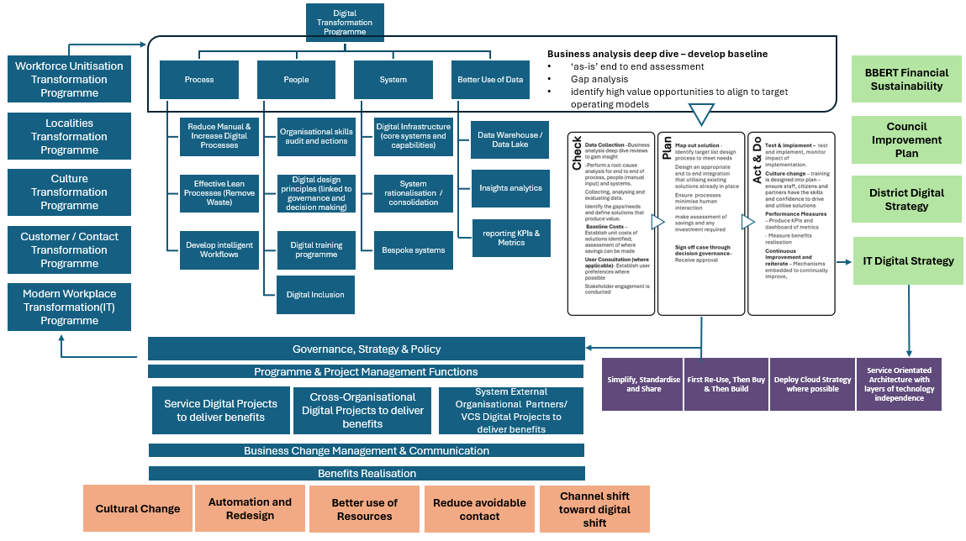

Background and Business Need
The programme business case will design the overarching governance structure needed to take a whole-council approach to bring together digital transformation corporately and to multiple service areas within the Council.
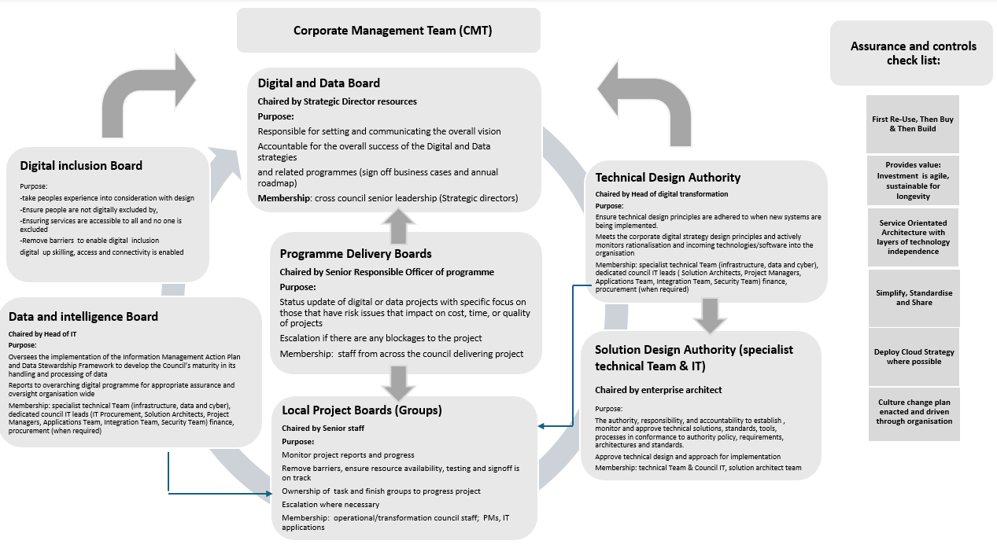
The programme will enable the building blocks for key delivery areas in other transformation and change programmes:
- Application and IT Infrastructure 2024-2027 Business Case
- Workforce unitisation
- Customer contact management
- Modern workplace transformation
- Culture transformation programme
- Localities programme
- Improving our use of data (linked to the HDRC)
It is imperative to build and maintain an agile IT architecture fit for the digital age both internally facing and for citizens.
The customer contact management programme has begun the drive to improve the customer journey with the implementation of digital capability and technology such as automation (for voice contact and to streamline manual processes), optimisation of the website and webforms, and centralise resources dealing with customer contact across the organisation. This structural consolidation aims to improve customer experience by increasing efficiency and reducing duplication and hand-offs.
Similar channel shift to ‘digital first’ capabilities for staff, and as an organisation, would also improve service delivery, reduce operating costs and manage demand more effectively, ensuring the local authority workforce and IT infrastructure and architecture is agile and adaptable in the digital age.

Vision
To establish and implement the business capabilities necessary for the Council to become a digitally enabled organisation, optimising efficiencies in internal processes and better meeting the growing demands on services in a more cost-effective way.
This means becoming ‘digital-by-default’, which is defined as digital services that are so straightforward and convenient, that all those who can use them will choose to do so, whilst those who can’t are not excluded.

Objectives
The objectives for the overarching digital programme below:

- To embody a ‘digital first’ culture, which does not exclude those who can’t, and that our staff, citizens and partners have the skills and confidence to drive and utilise this

- To ensure our services are customer-focussed, lean and cost- effective and are easily accessible and provide resolution at the earliest opportunity.

- To ensure end to end digital enabling capabilities, that are efficient and well run which will champion a workforce culture of high performance, high challenge and high support

- To have digital infrastructure which prevent avoidable demand through early help, help signpost residents to community-based assets, and supporting residents to live well

- Take collective responsibility and ownership for the Council Strategy, prioritising cross-departmental collaboration and a One Council approach and have proportionate governance in place for effective decision-making to achieve this.

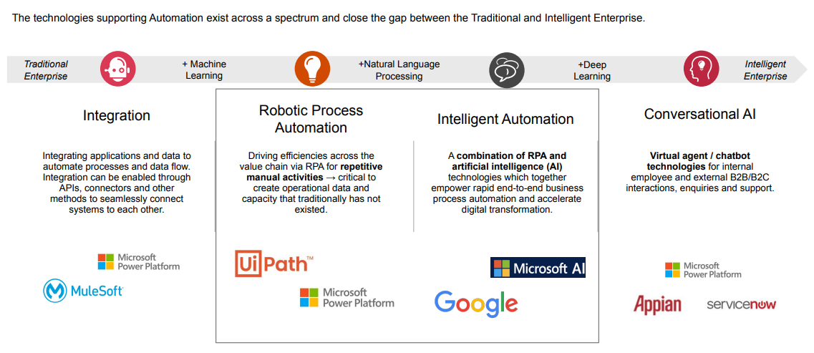

Section 1: What is being assessed?

Each individual programme listed below will be completing individual EqIAs detailing the impact on protective characteristics:
- Application and IT Infrastructure 2024-2027 Business Case
- Workforce unitisation
- Customer contact management
- Modern workplace transformation
- Culture transformation programme
- Localities programme
- Improving our use of data (linked to the HDRC)
This EqIAs will not seek to replicate these, but will detail the impact of the proposal on internal (workforce) and external (customers and stakeholders) with protected characteristics

Protected Characteristics: | Impact  Y/N
Age | N
Disability | Y
Gender reassignment | N
Race | N
Religion/Belief | N
Pregnancy and maternity | N
Sexual Orientation | N
Sex | N
Marriage and civil partnership | N
Additional Consideration:
Low income/low wage | Y
Care Leavers | N

Stage 2: Full Equality Impact Assessment:

  - Will this proposal advance equality of opportunity for people who share a protected characteristic and/or foster good relations between people who share a protected characteristic and those that do not? If yes, please explain further. Please ensure you have understood the meaning of ‘equality of opportunity’ and ‘fostering of good relations’ and ‘protected characteristics’- before answering this part.

Yes, digitally enabling a council and optimising efficiencies in internal processes can lead to several positive improvements in terms of equalities impacts for people with protected characteristics:

Improved Accessibility
- For people with disabilities (physical, visual, or hearing impairments): Digital platforms can be designed to be more inclusive by offering accessibility features like screen readers, voice commands, captions, and alternative text. This makes services more accessible to people who may struggle with traditional, in-person, or paper-based services.
- For people with limited mobility: Digital services reduce the need for physical visits, allowing people to access services from the comfort of their homes, which can be particularly beneficial for those with mobility impairments or chronic illnesses.

Increased Flexibility in Service Delivery
- For carers or people with children: Offering digital services means people can access them at times that suit their schedules. This can particularly benefit individuals with caregiving responsibilities or parents, who may struggle with fixed office hours.
- For older people: Training and easy-to-use interfaces can empower older adults to engage with digital services, offering independence and reducing reliance on physical visits.
Elimination of Bias and Discrimination
- For all protected groups: Digital processes can standardise the delivery of services, reducing the potential for unconscious bias or discrimination in decision-making. Automated processes are often more consistent and transparent than human-led ones, ensuring fairer outcomes.

Wider Reach for Hard-to-Reach Groups
- For people in remote or underserved areas: Digital services provide better access to people living in remote locations, ensuring that geographic barriers don’t limit access to council services.
- For non-native speakers or people with language barriers: Digital platforms can include multilingual support or translation features, which can improve access to services for people whose first language isn’t English.
- For ethnic minorities, women, and LGBTQ+ communities: Digital transformation can give underrepresented or marginalised groups easier and safer ways to interact with the Council, participate in consultations, and access support. Online environments may feel more neutral or anonymous, encouraging participation from those who might otherwise feel marginalized in face-to-face interactions.

Data-Driven Insights to Identify Inequalities
- The use of digital systems allows the Council to collect and analyse data on service usage. This can help identify where certain groups (e.g., people with disabilities, ethnic minorities, or older people) may be under-served or facing barriers, leading to more targeted interventions and support.

Cost Reduction for Low-Income Groups
- For people on low incomes: The shift to digital can reduce costs related to transport or childcare, making it easier for low-income groups to access services without incurring additional financial burdens.

  - Will this proposal have a positive impact and help to eliminate discrimination and harassment against, or the victimisation of people who share a protected characteristic? If yes, please explain further.

No

  - Will this proposal potentially have a negative and/or disproportionate impact on people who share a protected characteristic? If yes, please explain further.

The programme has a low level of potential impact on disability protected characteristics and low income/low wage.

  - Please indicate the level of negative impact on each of the protected characteristics?

(Please indicate high (H), medium (M), low (L), no effect (N) for each)

Protected Characteristics: | Impact  (H, M, L, N)
Age | N
Disability | L
Gender reassignment | N
Race | N
Religion/Belief | N
Pregnancy and maternity | N
Sexual Orientation | N
Sex | N
Marriage and civil partnership | N
Additional Consideration: | N
Low income/low wage | L
Care Leavers | N

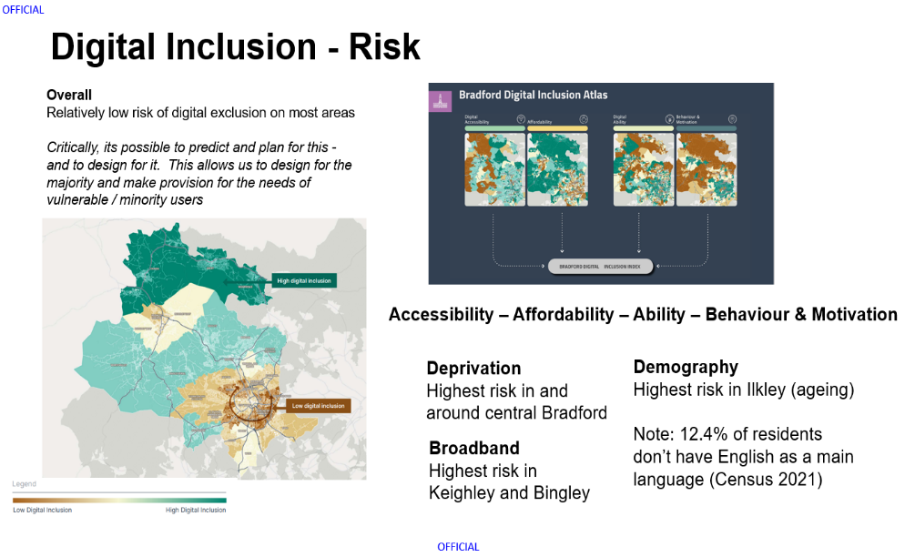

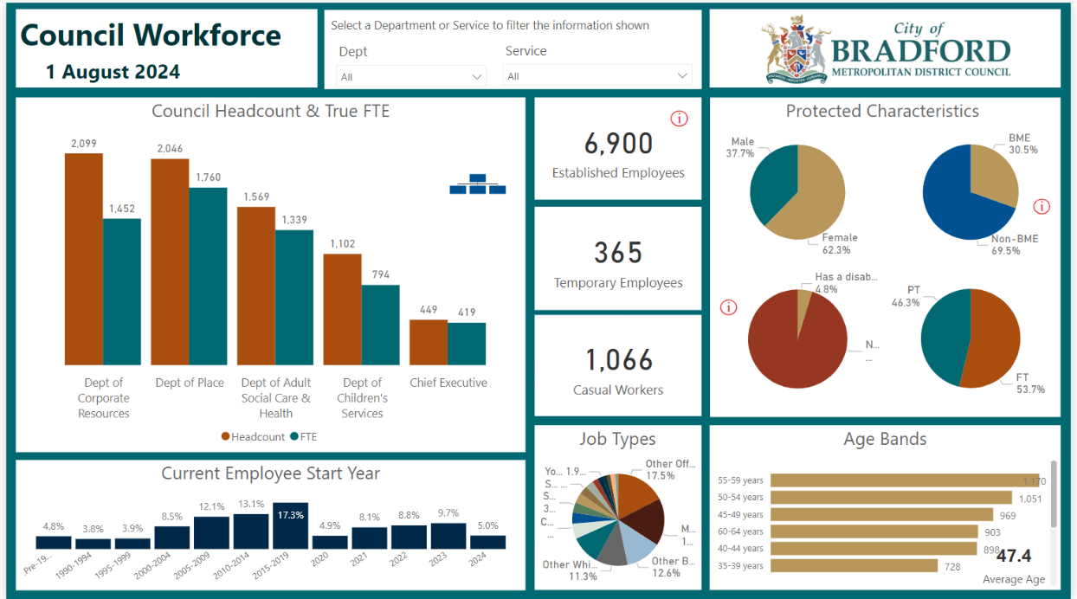

2.5 How could the disproportionate negative impacts be mitigated or eliminated?

There are specific actions in place to mitigate risk of disproportionate negative impact.

Digital inclusion
Digital inclusion refers to the equitable access to and effective use of digital technologies and services. It encompasses factors such as internet connectivity, availability of devices, digital skills, and digital literacy. A high level of digital inclusion ensures that all individuals can participate fully in the digital society, benefiting from the opportunities it offers.

Mitigation:
A formalised governance structure is in place (detailed above), with a dedicated digital inclusion board to ensure those who may be digitally excluded will have appropriate means to access Council services. Similarly, internal staff will be trained and reskilled to use systems and improve process functionalities within the council.

- Digital Skills Training: will be offered to improve digital literacy for groups that may struggle with technology, such as people with disabilities. Providing ongoing technical support will also help ensure these groups can navigate digital platforms confidently.

- A range of functional requirements will be included in the specifications of systems to ensure that we can best evaluate how they meet the needs of everyone, specifically in terms of staff groups with accessibility requirements for system/app used as part of their role, and for citizens to have a range of channel option to choose how to engage with the Council that best suits their needs that are accessible to them, this will continue to include face to face contact.

Any significant impact on workforce would be subject to staff consultation in accordance with Councils Managing Change Policy.

Digital Inclusion Objective
- Promote Equitable Access to Digital Services
- Monitor and address digital divides based on socioeconomic status, geography, age, disability, or other protected characteristics.

- Enhance Digital Literacy
- Develop and support programs to increase digital literacy and skills, particularly for groups at risk of digital exclusion (e.g., older adults, people with disabilities, low-income households).
- Provide accessible, tailored training to help people confidently engage with digital services, ensuring no one is left behind in the shift to digital.

- Ensure Accessibility of Digital Platforms
- Ensure that all council digital platforms comply with accessibility standards, ensuring they are usable for people with disabilities, older adults, and non-native speakers.
- Regularly review and improve user experience through inclusive design, with input from people with protected characteristics.

- Maintain Multi-Channel Service Delivery
- Ensure that non-digital alternatives (e.g., telephone or face-to-face services) remain available for those who cannot or prefer not to access services online.
- Promote a hybrid service model, combining digital and non-digital channels to meet diverse needs.

- Foster Collaboration and Engagement with Communities
- Engage with local communities, advocacy groups, and service users to co-design digital services that meet the needs of all, including underrepresented or marginalized groups.
- Establish regular feedback mechanisms to understand the needs, experiences, and challenges faced by different communities when accessing digital services.

- Promote Data Privacy and Security for Vulnerable Groups
- Ensure that digital platforms are secure and protect personal data, particularly for individuals who may have heightened concerns (e.g., survivors of domestic abuse, LGBTQ+ individuals).
- Build trust by promoting transparent practices around data use, ensuring privacy is respected in all digital services.

- Monitor and Evaluate Digital Inclusion Progress
- Establish metrics to assess digital inclusion, tracking progress in reducing the digital divide and increasing digital engagement across all demographics.
- Conduct regular equality impact assessments to ensure that digital services do not disproportionately disadvantage any group and adjust strategies accordingly.

- Address Barriers to Digital Inclusion
- Identify and address specific barriers faced by protected groups, such as language, cultural sensitivities, financial constraints, or limited technical skills.
- Offer targeted support to overcome these barriers, such as subsidized internet access, assistive technologies, or multilingual resources.

- Support Staff Training and Capacity Building
- Ensure council staff are trained to support residents in accessing digital services, including training on equality, diversity, and digital inclusion principles.
- Equip frontline staff with the knowledge and tools to assist people who may face barriers to digital access, offering personalized support where necessary.

- Develop Strategic Partnerships
- Partner with technology providers, educational institutions, non-profits, and community organizations to expand the reach of digital inclusion initiatives and secure additional resources for vulnerable groups.
- Work collaboratively with regional and national initiatives aimed at closing the digital divide and improving inclusion.

Digital Inclusion Programme Board – Terms of Reference summary
- The primary purpose of the Digital Inclusion Board will be to provide strategic oversight, supporting collaborative working across the district and beyond; monitoring progress against development and delivery of the programme, including benefits realisation and finance.
- The board will ensure that matters which might prevent the success of the programme are addressed swiftly. Issues requiring escalation to the Board will be raised via the Digital Inclusion Programme Manager
- The Digital Inclusion Board members will also act as programme champions who are committed to the programme objectives, the proposed outcomes and the approach to delivery. This will improve visibility of the programme at a range of senior leadership sessions in organisations across the district
Accountability & Management
- The Digital Inclusion Board will be chaired by the sponsor, Marium Haque Children’s Services Director.
- The Digital Inclusion Working Group will be accountable to the Digital Inclusion Board and will be chaired by the Digital Inclusion Programme Manager
- The day-to-day work and management of the Digital Inclusion Working Group will be led by the Digital Inclusion Programme Manager
- The Digital Inclusion Working Group will report to the Digital Inclusion Board monthly in the first instance, moving to bi-monthly, to provide updates on progress and activity. The Digital Inclusion Programme Manager will prepare and present this report
- The Digital Inclusion Board will approve progress updates to the Health and Wellbeing Board on a minimum quarterly basis, or as directed by the Health and Wellbeing Board. The Digital Inclusion Programme Manager will prepare and present this report

Section 3: Dependencies from other proposals

3.1 Please consider which other services would need to know about your proposal and the impacts you have identified. Identify below which services you have consulted, and any consequent additional equality impacts that have been identified.

The programme will be cross cutting through the council and regular communications will be undertaken internally and externally through the council communication team. During the Programme initiation a communication strategy will be undertaken to identify all stakeholders who will be involved.
As part of the programme all training which will be arranged will consider protected characteristics. All training will ensure that where possible it isn’t all via MS Teams, user guides will also be written and where appropriate super users for the system (regardless of their protected characteristic) will be available to support colleagues and users.

Section 4: What evidence have you used?

4.1 What evidence do you hold to back up this assessment?

The Programme have reviewed Bradford’s rich demographic dataset to understanding resident characteristics, trends, and preferences to ensure these can be taken into consideration in future decisions around customer contact solutions (feeding into the Council owned business case).
For workforce data, the council utilises BI Power dashboard reporting capabilities to ensure it has continual reporting on workforce data on those with protected characteristics.
As part of the programme, we will be working closely with the communications team to identify forums for the organisation to be involved in where we can consult. This engagement will continue through the current Business Case stage and beyond into delivery.

Section 5: Consultation Feedback

Each individual programmes listed below will be completing individual EqIAs detailing the impact on protective characteristics and the consultation plan with staff and residents. These programmes are:
- Application and IT Infrastructure 2024-2027 Business Case
- Workforce unitisation
- Customer contact management
- Modern workplace transformation
- Culture transformation programme
- Localities programme
- Improving our use of data (linked to the HDRC)
This EqIAs will not seek to replicate these, but will ensure compliance detailed in section 2, question 2.5, on how potential disproportionate negative impacts will be mitigated via robust monitoring in governance structures.

Click to return to contents page

Business Case Template

Project Name | 25-26 91 Safe and Sound
Author | Rachael Meadows-Hambleton
Directorate | Adult Social Care
Service Area | Older People’s Services
SRO | Rachael Meadows-Hambleton
Project / Programme Manager | Rachael Meadows-Hambleton/June Pursey

THIS TEMPLATE FOLLOWS THE INITIAL PROPOSAL TEMPLATE. THE TRANSFORMATION AND CHANGE PMO WILL ADVISE WHEN THE BUSINESS CASE TEMPLATE SHOULD BE COMPLETED AND PROVIDE GUIDANCE AND SUPPORT.

Status: V3
Date: September 2024

Document Management

1.1 Version Control
Version | Date | Author | Current Status of Business Case
V.01 | 10.09.24 | Parvez Akbar | Draft
V0.2 | 13.09.24 | Rachael Meadows- Hambleton

1.2 Document Approvals
The following areas need to approve the business case before submission to the T&C PMO
Name | Title/Function | Date Approved | Signature
 | Portfolio Holder (where required)
Iain Macbeath | Executive Sponsor
Rachael Meadows-Hambleton | SRO
Katie Whitely | Finance | 18.9.24
Imran Rathore | Transformation
Mark Henderson/Siobhan Binks | HR *
 | Legal
 | Estates (where required)
 | IT (where required)

*Please note – If the proposal has any workforce implications such as restructures, redundancies etc this document MUST be filled in and sent to HR for review, along with the EQIA.

No impact to workforce identified.
c

Executive Summary
The Safe and Sound Service is a community alarm and technology offer hosted by Bradford Council that offers people and their families’ peace of mind and independence. If an alarm is triggered, the person is contacted by our 24/7 call operation and family members can be contacted or a response service summoned to resolve the situation.
There will be a national digital switchover in 2026, which along with a revised service offer means we are replacing equipment and offer enhanced services to people living with dementia. A charge of £3.00 plus VAT was in place since 2014, increasing to £3.30 plus VAT from April this year.
Given the council’s financial circumstances, this report proposes a consultation with people to implement a new varied charging model.
This will bring us more in line with neighbouring local authorities across the region.
This has the potential to increase the level of income generated through charging in 2025/26 by up to an additional £0.834m per annum. This is dependent on the findings of the consultation and presentation back to Council Executive on the 7 January.
Any phasing of the increase as a result of the consultation, could reduce the amount of additional income in 2025/26, and consequently, the budget saving for 2025-26 is estimated at £0.600m after implementation and recurring costs, rising to £0.804m in 2026-27.

The Strategic Case

3.1 Background and Business Need
Safe and Sound is part of Bradford Council, Adult Social Care Service. It is a combination of what was previously known as Careline and Telecare. It is a person-centred service supporting people to stay safe and independent in their own home.

The Safe and Sound Service operates in partnership with other health and social care organisations and emergency services, such as, West Yorkshire Ambulance Service and the Yorkshire Fire and Rescue Service, delivering a 24/7 emergency response to people’s homes.

3.2 Vision
To ensure that the service is sustainable, reliable and is cost effective, we have undertaken a detailed appraisal of our current funding model. This has included benchmarking our approach with other Local Authorities across the region. It is expected that the level of income will rise significantly, thereby reducing the level of subsidy supplied by the council.

3.3 Objectives
To implement a new varied charging structure for the Safe and Sound Service with effect from April 2025, with increased rates benchmarked across other authorities, delivering up to £0.834m additional income. A phased approach may be adopted, to reduce the level of risk associated with cancellations, over a 2-year period.

The Economic Case
We considered three charging options. These were to:
- ‘Do nothing’, maintain the current pricing structure and continue to heavily subsidise the service.
- To remove the subsidy completely; this would increase the monthly cost to between £51 and £75, depending on the package required. As Safe and Sound is a preventative service, this level of increase would potentially make this service un-affordable for people and deter take-up. The assumption applied is one of a 25% drop out, together with 100% take up of the mobile response option.
- Implement an increase which is on par with other LAs across the region.

4.2 Options Analysis - Summary
 | Option A  Do Nothing | Option B  Remove all subsidy | Option C  Implement increase in-line with other LAs
Summary  [Please provide a description of the option]. | The Council continues to deliver services in the same way. | All subsidisation of the service is removed in its entirety | Increase on par with other LAs - Risk of cancellation and income balanced.
Non-Cashable Benefits | LOW  Customers not impacted by change, but existing issues with service remain. | LOW  Customers impacted greatly and high risk associated with cancellations, resulting in potentially decreased income | MEDIUM  - Sustainable service  - Ability to invest in delivering an enhanced service
  L | H
  M | NA
Financial Benefits | LOW  No financial benefits identified. | MEDIUM  Increase in average income per person, however uncertainty as to level of income generated | MEDIUM  Increase in income forecasted.
  L | H
  M | NA
Risks & Disbenefits | HIGH  Existing issues remain unresolved.  Lack of efficiency. | HIGH  Resulting pricing places us as an outlier, most expensive in the region. | MEDIUM  Risk remains of cancellations due to price rises, however 25% churn rate factored into calculation
  L | H
  M | NA
Costs | LOW  No immediate investment costs but may be costs of disinvestment. | LOW  No immediate investment costs. | LOW  Recruitment of admin resource to support, plus a marketing budget to mitigate risks due to cancellations
  L | H
  M | NA
Overall Saving / Cashable Benefits (Financial Benefits minus Costs) | NA  No cashable benefits – potential for additional cost in the longer term. | MEDIUM  Potential for increased income. | MEDIUM  £834k projected income, tapered over a 2-year period to phase in charging to reduce impact to existing service users.
  L | H
  M | NA
Recommendation | Not Recommended | Not Recommended | Recommended
  Not Recommended
  Recommended

4.3 Recommended Option
OPTION C RECOMMENDED - To implement an increase which is on par with other LAs across the region.
This is set out in the table below. The proposal put forward as a recommended option in the table below also factors in the impact of the charges on service cancellation. The benchmarking work with other Local Authorities identified that some LAs experienced a significant number of people declining to continue with the service due to the increase in charges. For some LAs this was as high as 25% and a considerable number of these service users then came back to the LA requiring more formal support which cost the LA significantly more – this would require a Care Act assessment to be completed by a Social Worker or an Occupational Therapist. The average cost of care for people in community based long term support in Bradford District is £2,160 per month, which showcases the potential impact of cancellations. This option delivers a balanced approach, in terms of mitigating risk and delivering a significant level of income.

Note: The model is subject to an annual uplift from 1st April 2025
Package Name | 1  Basic Package – Standalone | 2  Basic Package - Monitored | 3  Home Safety Package | 4  Falls Package
COST with Family Response Only | £2.31 | £4.62 | £6.00 | £6.46
Monthly Cost | £10.00 | £20.00 | £26.00 | £28.00
COST with a Mobile Response Team | N/A | £8.62 | £10.00 | £10.46
Monthly Cost | N/A | £37.35 | £43.33 | £45.33
Total costs - non equipment
Total revenue costs | £2,276,300
Current client income with no changes | £697,100 | Modelling is based upon mapping existing users across to the new packages, based upon current service in place, to improve accuracy of forecasts
Additional income from proposed model -adjusted for Disability Related Allowances | £834,200
New subsidy level | £652,300

Modelling Assumptions
- A 25% reduction or loss in user numbers based upon implementing changes to the charging fee structure
- 10% deduction factored into the additional income generated due to consideration of disability related expenditure based upon current information
- Additional income is based on existing users moving across onto comparable packages, resulting in the majority transferring to a monitored service at the higher rate. Consultation will allow opportunity to determine more accurately the split between monitored and non-monitored services, this will in turn feed into refining the projected income figure.
- The net income does not account for the additional costs associated with admin resource to support, and a marketing budget to mitigate risk by retaining existing users and attracting new ones

A recommendation to adopt a phased approach over the course of a two-year period to fully implement the new charges with respect to existing users, is not accounted for in the calculations. Therefore, it may take 24 months to achieve the additional income outlined in the model.

The Financial Case
- Reduces the level of subsidy required by the council
- Additional income forecast is £0.834m, a significant increase from current income budget of £0.697m.
- Broadly in line with regional comparators. Leeds is expected to increase its charges from 1 April 2025 by 8.5%.
- One-off implementation costs with respect to a Marketing budget to increase both retention and take up of new customers

5.1 Financial Benefits
The table below shows the financial impact of the proposed new charging model, which would generate an additional c£0.834m of gross income, reducing the amount of subsidy the council contribute to this service. This level of income is dependent on the number of service users continuing with the service (assumes a 25% drop out rate) and assumes that people will move to comparable packages.
There will however be c£30k of recurring admin costs and £15k of one-off implementation costs, and any phasing of the increase in the charges, that could result from the consultation, would reduce the amount of additional income in 2025-26. Consequently, the budget saving for 2025-26 is estimated at £0.600m net of implementation and recurring costs, rising to a £0.804m net in 2026-27.
The new charging model will be subject to an annual uplift from 1 April 2025.

REVENUE BUDGET | Cost Centre & Subjective Code | 2024/25  £000k | 2025/26  £000k | 2026/27  £000k | 2027/28  £000k
Increase to Safe and Sound Charging Model | RCTJ 9401 | 0 | 645 | 189 | 0
Total Financial Revenue Benefits |  | 0 | 645 | 189 | 0

For existing service users, the service will consult on whether to phase in new charges over time to mitigate the impact. The service will also undertake an assessment to determine which Safe and Sound package will be required to meet their support needs in the future. Where appropriate service users will be offered a financial reassessment. The contribution charge could be implemented in a phased way for example:

1. | For those who the change will be over £10.00 per month | Pay 30% for 6 months  Pay 50% for 6 months  Pay 75% for 6 months  Pay 100% for 6 months

5.2 Non-Financial Benefits
Non-Financial Benefit | Description | Measure
Enhanced offer | Potential to improve financial ability to invest in new TEC, allowing more citizens to live independently in their owns homes, negating the use of traditional costly care packages. This is a preventative offering. | Count of new people signed up to the service.  Outcomes delivered linked to assessment.

5.3 Recurring Costs

Costs | Cost Centre & Subjective Code | 2024/25  £000k | 2025/26  £000k | 2026/27  £000k | 2027/28  £000k
£30k – 1 x FTE admin resource to deliver ongoing support to the new charging structure | RCTJ 1040 | 0 | (30) | 0 | 0
Total Costs |  | 0 | (30) | 0 | 0

5.4 ‘One Off’ Implementation Costs
One-off implementation costs with respect to a Marketing budget to increase both retention and take up of new customers.

Budget Type  (Revenue / Capital) | Cost Centre & Subjective Code | 2024/25  £000k | 2025/26  £000k | 2026/27  £000k | 2027/28  £000k
Marketing Budget | RCTJ | 0 | (15) | 15 | 0
Total Costs |  | 0 | (15) | 15 | 0

5.5 Financial Summary (Cost/Benefit Appraisal)
 | Cost Centre & Subjective Code | 2024/25  £000k | 2025/26  £000k | 2026/27  £000k
Financial Benefits | RCTJ 9401 | 0 | 645 | 189
Recurring Costs (Admin Resource) | RCTJ 1040 | 0 | (30) | 0
Implementation Costs (Marketing) | RCTJ | 0 | (15) | 15
Total Cashable Benefit / Saving |  | 0 | 600 | 204

The Commercial Case
Not applicable

The Management Case
7.1 Scope
Safe and Sound service – charging structure only affected

7.2 Delivery Approach and Governance

Role | Name
Executive Sponsor (member of CMT)  Overall accountability | Iain Macbeath
Senior Responsible Officer (SRO)  Decision maker, accountable for the project | Rachael Meadows-Hambleton
Project/Programme Manager  Day to Day management of the project linking in with the T&C PMO. | Parvez Akbar
Supplier (s)
Key resources required to deliver the project.
Users (s)  The people who will use or be impacted by the outputs. | Safe and Sound service users - public

7.3 High-level Plan, Milestones and Timescales
This business case will be delivered by

Milestone  Y/N | Action | Complete By (Date) | Action Lead
Y | Safe & Sound report delivered at DMT setting out rationale for change | 10.07.2024 | Imran Rathore
Y | Report on developing a new Safe and Sound Service presented at CMT | 31.07.2024 | Iain Macbeath
Y | Approval gained at Council Executive to go out to public consultation | 03.09.2024 | Iain Macbeath
Y | Undertake public consultation on proposed changes to seek feedback and measure impact | 09.12.2024 | Parvez Akbar/Davinder Pabial
N | Executive report produced following review of consultation findings | 23.12.2024 | Parvez Akbar
Y | Presentation of consultation findings at Council Executive and approval gained on preferred charging model | 03.01.2025 | Iain Macbeath
Y | New service charging structure implemented | 01.04.2025 | June Pursey / Parvez Akbar

7.4 Resource Requirements

Resource | Description (who is required, to do what, and when) | Required? (Y/N)
Human Resources (people)
Service Resources
Finance | To produce accurate forecasts on income generated due to changes in Q4 2025 | Y
HR (including training)
Procurement
Legal | Assess legal implications of changes to charging | Y
Transformation & Change | Provide Project Management support | Y
IT
Data Governance
Estates
Payroll
Customer / Contact Teams
Business Support / Administration
Insurance
Communications | Davinder Pabial – comms support and guidance on both consultation and communication of new charging model | Y
Policy & Performance | Changes to information within the policy and public information | Y
External Resource
Other
Non-Human Resources (things)
Accommodation
Technical resources (e.g. access to systems, hardware, software)
Data (e.g. benchmarking systems, productivity data)
Information (key documentation or reports)
Other

7.5 Major Risks and Assumptions
Risk | Mitigations | Likelihood (L/M/H) | Impact (L/M/H)
There is a risk that by applying the new charging model outlined we could see a sizeable number of people declining to continue with the service due to increase in charges. | 1.Work with Operational Services to put in place robust arrangements that allow Safe and Sound to workflow requests for a review to be undertaken for those service users who decline the service to ensure that there are no safeguarding risks and that their support needs are being met  2.Implement the charges for current service users, taking a tapered charging policy that will introduce the charges. | Medium | High

7.6 Constraints
Very tight timeline to undertake public consultation during Q3 2024, with a view to returning to present findings to Council Executive on the 7 January 2025.

7.7 Dependencies

Dependency | Detail – how does it link | Implication | Action

7.8 Key Stakeholders
Please list any key stakeholders that might be impacted by the proposal.
Name /Organisation | Role | Likely Impact/Interest
Service users

7.9 Impact Assessments
Detailed Eq IA produced and attached for reference.

7.10 Previous Lessons Learned

Appendices
Please include appropriate impact assessments and any other key relevant document.

Appendix 1: Charging options, implemented by Local Authorities across the region.

Leeds Telecare Costs 2023-4  Monthly Price per (excl VAT) |  | Package
There is no charge for the alarm and sensors. There is a £25 set up charge for the first year only. Or £30 for a GPS package. Then a weekly cost for the response centre monitoring, based on the package.
Bradford | £14.3 | Standard pendant and alarm base unit, plus others sensors: carbon monoxide detector, door contacts, flood detector, heat sensor and smoke detector
Starter package | £37.2 | Pendant and alarm base unit.
Home safety package | £39.8 | Standard pendant and alarm base unit, plus one of these sensors: carbon monoxide detector, door contacts, flood detector, heat sensor and smoke detector
Falls package | £42.4 | A falls detector is worn on the wrist and comprises of a help call button that can be pressed in an emergency situation. The falls detector will also automatically send an alert if the impact of a fall is detected (dependent upon the type of fall being experienced).
Dementia package | £42.4 | Standard pendant and alarm base unit, as well as a personalised range of connected sensors. Within the package, an additional two of these sensors can be selected dependent on assessed needs: bed sensor, carbon monoxide detector, chair sensor, door contacts, flood detector, floor mat sensor, heat sensor, medication dispenser, Memo Minder, Mem-x, smoke detector
GPS package | £49.2 | A wearable devise like a watch which provides two-way speech like a mobile phone, which can locate an individual. The device allows you greater freedom, independence, and protection as well as offering reassurance to family and carers. The package includes a GPS device and charging unit and the setting of safe zones.
Additional sensors | £0.65
Secondary customer | £5.40

York Telecare Costs 2023-4  Monthly Price per (excl VAT) |  | Package
Installation cost: £31.52
Bradford | £14.3 | Standard pendant and alarm base unit, plus others sensors: carbon monoxide detector, door contacts, flood detector, heat sensor and smoke detector
Friends and Family | £19.35 | The Friends and Family Telecare package is an inexpensive way to provide peace of mind to you and your family and friends. It includes: Lifeline base unit, Lightweight pendant that can be worn around your neck or wrist, Telephone review, 24-hour call monitoring to contact your nominated responders, To qualify for this service, you will need at least two nominated friends and/or family members who live locally and are able to respond in an emergency at any time of day or night. On this service, our mobile responders do not respond.
Premium Response | £37.55 | The Premium Response Telecare package is the standard service and provides peace of mind for you, your carers and your family and friends; it is perfect if you need more contact and support and includes a regular visit to test the equipment and ensure you're well. This includes Responders will provide first aid, help, guidance, and support in the case of an emergency, Lifeline base unit, Lightweight pendant that can be worn around your neck or wrist, 1 x Smoke detector/Carbon Monoxide Detector/Bogus Caller button. This is based on a customer assessment. Annual review visit and periodic checks, 24 hour, 365 days a year response should you require any assistance day or night
Premium plus | £51.50 | This Premium Plus Telecare package offers all the benefits of the Premium service but is ideal if you need more frequent or more complex support from our responders. This includes: Responders will provide first aid, help, guidance, and support in the case of an emergency Lifeline base unit, Lightweight pendant that can be worn around your neck or wrist, Additional telecare equipment such as a fall detector, bed sensor, medication dispenser are provided on an assessed needs basis  Annual review visit and periodic checks, 24 hour, 365 days a year response should you require any assistance day or night.
Installation cost | £32.15
Price per additional | £9.65 for Friends and Family, and £18.15 for Premium Response and Premium Plus

Sheffield Telecare Costs 2023-4  Monthly Price per (excl VAT) |  | Package – New Charges due to commence 15th July 2024 with new brochure in production
Installation cost: £tbc
Bradford | £14.3 | Standard pendant and alarm base unit, plus others sensors: carbon monoxide detector, door contacts, flood detector, heat sensor and smoke detector
Care Alarm | £30.30 per month (£7.01 per week) | Wearable pendant linked to a Digital Alarm standalone device plugged into mains socket and operating via a sim card.  Fully monitored service with dedicated staff response, will also contact nominated family members/carers. Includes an urgent response protocol if call centre staff are unable to speak with the individual via the speaker on the standalone device.  First 6 weeks of service are free of charge, with option to cancel and no minimum contract term.  Option to select a free smoke detector, again this sends an alert to the call centre
Smoke Detector | £2.39 p/w -Additional Smoke Detector | First smoke detector supplied free of charge with no additional monthly costs on top of the basic care alarm package  Additional units incur a weekly cost of £2.39 per month

Kirklees Telecare Costs 2023-4  Monthly Price per (excl VAT) |  | Package
Installation cost: £TBC
Bradford | £14.3 | Standard pendant and alarm base unit, plus others sensors: carbon monoxide detector, door contacts, flood detector, heat sensor and smoke detector
Standard Carephone package | £38.16 | The Carephone, a personal alarm, a smoke detector and a carbon monoxide detector make up our standard package.
Enhanced Carephone package | £41.04 | A range of other devices are also available from the Carephone Home Safety Service. These form part of our Enhanced Carephone package which is designed to meet the individual needs of people who use our service. Devices and sensors in the Enhanced Carephone package include: Alert a local carer - video, Bed occupancy sensor - video, Chair occupancy sensor - video, Epilepsy sensor - video, Fall detector - video, Flood detector - video, Enuresis sensor - (Bed wetting), GPS location devices, High and low temperature sensors video, Intruder alarm, Medication dispenser, Property exit sensor - video, Smoke detector
Calderdale Telecare Costs 2023-4  Weekly Price per (excl VAT) |  | Package
Installation cost: £tbc
Bradford | £14.3 | Standard pendant and alarm base unit, plus others sensors: carbon monoxide detector, door contacts, flood detector, heat sensor and smoke detector
Care Alarm | £4.51 | Calderdale Council, in partnership with Progress Lifelines, offer a community care alarm service which offers direct access to a Contact Centre from your home.  The Centre provides emergency assistance 24 hours a day in your own home, 365 days a year to help make your life easier, safer, and more comfortable.

Appendix 2: Consultation and Engagement Plan
Activity: | Marketing / Comms Message / Channel: | Audience: | Timeline: | Lead:
Charging Policy report to be taken to Executive for sign off | Plan a public news release  Draft press release/ holding statement to be drafted in case of media interest. | Portfolio/ Executive chairs /Cllrs | Sept 24 | IR/DM/JP
Consultation period to begin – digital/ paper copy | Bradford Council consultation page  Circulate to NHS Partners  Send to Children’s Trust  Commissioning team  Key Messages to be taken from charging policy report for audiences | Current Service Users/ family/ friends - Focus Groups / digital survey  BTM focus groups  Equality Together  Co-production partnership  Staff Carers Network  New service users – digital survey  Children’s Trust – digital survey  ASC staff – digital survey  Partners/ providers – digital survey  Health/VCS – digital survey | Sept 2024 – Dec 2024  3-month consultation | ER / RS  HM/DP/IR
Four-week analysis of consultation | To summarise feedback and prepare Exec report |  | Jan2025 | PA/HM/JP
Review back to Executive | Secure approval of policy proposal and permission to implement changes. |  | Feb 2025 | IR/IM
Correspondence | Timeline of letters being issued  Letters ready as draft  Staff briefed with script to respond to service users  Comms to review script/ letters if possible | Existing service users | Mar 2025 | HM/JP/DP
Ongoing Marketing campaign – this will be pushed on an ongoing basis, through existing networks and platforms. | - Produce Q&As  - Website update and possibly create short video  - Marketing material/ factsheet update  - Email to all ASC staff | Public/staff  Public/staff  Existing / new service users  Staff  Staff |  | PA/HM  DP  DP  DP  DP



Equality Impact Assessment Form Reference –

Department | Adult Social Care | Version no | 0.1
Assessed by | Imran Rathore | Date created | 15.07.24
Approved by | Rachael Meadows-Hambleton | Date approved | 08.08.24
Updated by |  | Date updated
Final approval | Rachael Meadows-Hambleton | Date signed off | 15.08.24

The Equality Act 2010 requires the Council to have due regard to the need to
- eliminate unlawful discrimination, harassment and victimisation;
- advance equality of opportunity between different groups; and
- foster good relations between different groups

Section 1: What is being assessed?

1.1 Name of the proposal to be assessed.

Safe and Sound improvement programme – this includes specific actions required to
- Meet the requirements of the Digital Switchover
- Increase the awareness and promote the service, both internally across the Council and externally with partners and residents to increase uptake
- Implement plans to maintain a sustainable service through the implementation of a varied charging model.

1.2 Describe the proposal under assessment and what change it would result in if implemented.

1.2.1 SERVICE OVERVIEW:
Safe and Sound is an existing service within Bradford Council, Adult Social Care Service. It is a combination of what was historically known as Careline and Telecare. It is a person-centered service supporting people to stay safe and independent in their own home.
The Safe and Sound Service operates in partnership with other health and social care organisations and emergency services, such as, West Yorkshire Ambulance Service and the Yorkshire Fire and Rescue Service, delivering a 24/7 emergency response to people’s homes.
Safe and Sound uses a variety of technology and support systems to help people of all ages to live safely and independently at home. The Service offers help 24 hours a day 365 days a year, giving people independence and freedom in their own home, whilst safe in the knowledge that if there is an accident or if you have a fall, help is available in the form of an emergency response.
Referrals are received from a range of sources and following the referral, the service undertakes an assessment with the person (and or their carers), to ensure the appropriate safety equipment and technology is issued to support independent living.

1.2.2 CHANGE RATIONALE:
In Bradford the population for 65-90+ is forecast to increase from 86,413 to 103,219 by 2033. The breakdown of this across 65+ age group is outlined below:
AGE GROUP | 2023 | 2024 | 2025 | 2026 | 2027 | 2028 | 2029 | 2030 | 2031 | 2032 | 2033 | % Change
65-69 | 25,303 | 25,698 | 26,411 | 26,862 | 27,337 | 27,614 | 28,163 | 28,459 | 28,641 | 28,901 | 29,087 | 14.96%
70-74 | 21,289 | 21,393 | 21,414 | 21,886 | 22,291 | 22,785 | 23,167 | 23,834 | 24,277 | 24,742 | 25,033 | 17.59%
75-79 | 17,520 | 18,164 | 18,885 | 19,276 | 18,695 | 18,494 | 18,600 | 18,637 | 19,061 | 19,445 | 19,912 | 13.66%
80-84 | 10,923 | 11,201 | 11,294 | 11,704 | 13,132 | 14,074 | 14,600 | 15,161 | 15,451 | 15,027 | 14,904 | 36.44%
85-89 | 7,381 | 7,355 | 7,398 | 7,280 | 7,155 | 7,216 | 7,449 | 7,566 | 7,865 | 8,897 | 9,568 | 29.63%
90+ | 3,999 | 4,081 | 4,169 | 4,236 | 4,369 | 4,474 | 4,513 | 4,591 | 4,569 | 4,595 | 4,715 | 17.92%
Total | 86,413 | 87,890 | 89,572 | 91,243 | 92,978 | 94,657 | 96,493 | 98,248 | 99,863 | 101,606 | 103,219 | 19.44%
Source: Office for National Statistics 2023

Similarly, it is projected that people with learning disabilities will increase from 1,872 to 2,237 between 2025 to 2035, representing a 19.5% rise. Comparable accurate ONS based data for people with mental health and physical disabilities is unavailable at this time.
Helping people to feel safe in their home, knowing that they are monitored in the event of something going wrong, especially if living alone, in a safe and cost-efficient manner is an important priority for the Council, and as such ensuring that we have a sustainable Safe and Sound service to meet people's needs is a key priority for Adult Social Care.

1.2.3 IMPROVEMENT WORKSTREAMS:
1.2.3.1 Digital Switch Over:
Work is underway within the service to ensure that we can maintain service delivery as the analogue network is switched off and we move to a digital network – this is a national change workstream led by the major network providers. As part of our response to this change process, we have procured and are in the process of implementing a new Digital Alarm Receiving Centre (ARC) which will allow digital equipment within people’s homes to connect to the Digital ARC via a broadband network. Similarly, work is also being undertaken to procure digital equipment which will replace the existing analogue kit in people’s homes. PAG funding was used to finance this activity.

1.2.3.2 Technology Enabled Care (TEC):
The shift to the digital ARC opens up the possibility of implementing new and innovative technologies to support people in a more proactive and creative ways – ranging from: remote monitoring sensors, addressing social isolation, minimising falls prevention, avoiding Unitary Tract Infections through Artificial Intelligence based behaviour learning, and supporting people to live with Dementia e.g. providing reminders to people about taking their medication, food, and fluids etc.
This means repositioning and redesigning the Safe and Sound Service offer, away from a basic telecare offer to a more rounded Technology Enable Care Offer which provides a holistic support package that meets a person’s needs on a day-to-day basis. To support this change, we have worked collaboratively with both the Safe and Sound Service and Operational Services to promote the benefits of the TEC offer, and how it can support a person’s needs. This work includes:
- Raising awareness of the service offer with Adult Social care staff and external key stakeholders including partners within the Health and Social Care partnership.
- Attending staff roadshows and running in-person and virtual staff information workshops.
- Developing the internal and external information and advice offer. This includes plans to refresh our TEC website, council website and exploring the use of online newsletters and social media once the new digital ARC is established.
- Reviewing the equipment options compatible with the new ARC to enhance service options and working collaboratively with other regional councils to review and evaluate new TEC into the market.
- Evaluation of prevention focused TEC solutions to demonstrate where they add value by maintaining independence and delaying the need for statutory care provision.
- Streamlining the TEC referral pathways to increase efficiency and speed of access.
- Working with Bradford University to develop a TEC House and TEC Website, and presenting this work as part of a Local Government Association (LGA) series of Webinars titled “What Good Looks Like Webinar Two: Improving Care & Empower People”
- Providing accompanied visits to the TEC House to raise awareness and provide ‘hands on learning’.
- Trialling working with university students in the facility of health to raise awareness of available TEC in the community and discussing joint training options for staff and students.
- Developing induction TEC training for new staff members with a view to make this statutory for all staff annually.
- Engagement and consultation with current services users and family to understand the lived experience of using the Safe and Sound service, the impact on both users and the people who care for them and exploring where people feel there are gaps in service provision and where improvements could be made.

1.2.3.3 Charging Model
Current approach:
We currently charge a flat rate for the Safe and Sound offer which is £3.30 per week (excluding VAT). This is applied to anyone currently receiving Safe and Sound support and isn’t linked to the type of support provided.
The contribution charge that we make includes a rental charge for the equipment, a monitoring service and emergency response when necessary. The equipment provided and installed remains a Bradford Council Asset and is deemed on long term loan until it is no longer required. There are no additional charges for any supplementary Telecare sensors a person needs to stay safe. E.g. Fall detectors. We currently offer the first six weeks free of charge to enable the person and their carers to test out the suitability of the service and to ensure it is making a positive impact on their wellbeing.
Change proposal:
To ensure that the service is sustainable, reliable, cost effective and meets the needs of the people we support, we have undertaken a detailed appraisal of our current funding model. This has included benchmarking our approach with other Local Authorities within Yorkshire, which also include our statistical neighbours. Key point to note is that standard charge applied by the other Local Authorities is higher than the current charge in Bradford. The table below provides a breakdown of the new funding model:
Subsidised Model (benchmarked against Leeds) - subject to a 4.5-8.5% uplift from 1st April 2025)
Package Name | 1  Basic Package – Standalone | 2  Basic Package - Monitored | 3  Home Safety Package | 4  Falls Package
Cost without mobile response (MR) | £2.31 | £4.62 | £6.00 | £6.46
Monthly Cost | £10.00 | £20.00 | £26.00 | £28.00
Cost with mobile response (MR) | N/A | £8.62 | £10.00 | £10.46
Monthly Cost with MR | N/A | £37.35 | £43.33 | £45.33
Total costs - non equipment
Total costs - non equipment | £2,231,219
Current self-funded budget | £697,100 | Modelling is based upon mapping existing users across to the new packages, based upon current service in place, to improve accuracy of forecasts
Incremental income forecast / budget saving for council against current investment | £926,914
Income adjusted for Disability Related Expenditure (DRE) @ 10% | £834,223
Gap not self-funded | £699,895

1.3 Stage 1 Assessment:

Protected Characteristics: | Impact  Y/N
Age | Y
Disability | Y
Gender reassignment | Y
Race | Y
Religion/Belief | Y
Pregnancy and maternity | Y
Sexual Orientation | Y
Sex | Y
Marriage and civil partnership | Y
Additional Consideration:
Low income/low wage | Y
Care Leavers | Y

Section 2: What the impact of the proposal is likely to be

  - Will this proposal advance equality of opportunity for people who share a protected characteristic and/or foster good relations between people who share a protected characteristic and those that do not? If yes, please explain further.

No

  - Will this proposal have a positive impact and help to eliminate discrimination and harassment against, or the victimisation of people who share a protected characteristic? If yes, please explain further.

The enhanced support offer will enable people who share a protected characteristic to retain their independence within their own home (or supported living) while enabling them to continue to actively engage in their wider community. The approach we are taking should help reduce the potential for such exclusion and isolation.

In addition the new system will enable better collection of data on service users which will ensure that there is a better understanding on who is using the service including from groups with protected characteristics.

  - Will this proposal potentially have a negative or disproportionate impact on people who share a protected characteristic? If yes, please explain further.

Yes, the increase in charges may have an impact on people currently receiving a service as some will see an increase in the cost of their support package. However, this impact is not anticipated to disproportionately impact those with protected characteristics.
The proposed consultation exercise will collect more detailed information on identifying any impacts, with consideration given to the needs of users whose first language is not english (race), those that are not digitally connected, low income, accessibility and disability.

2.4 Please indicate the level of negative impact on each of the protected characteristics?
(Please indicate high (H), medium (M), low (L), no effect (N) for each).

As this is an internal replacement of case management software, we don’t anticipate any direct impact on staff.

Protected Characteristics: | Impact  (H, M, L, N)
Age | H
Disability | H
Gender reassignment | M
Race | M
Religion/Belief | M
Pregnancy and maternity | M
Sexual Orientation | M
Sex | M
Marriage and civil partnership | M
Additional Consideration:
Low income/low wage | M
Care Leavers | N

Implication for existing service users:
Breakdown by “Ethnicity”:
This represents an overview of existing persons by ethnicity if transposed across to the “preferred to-be model” based upon their current package. As a proportion, majority Asian are in receipt of the free standalone package, which would form part of the lowest level charge in the new proposed model, in terms of volumes this is low and represents a minimal risk. Whereas for “white” ethnicity the majority are evenly divided between basic and enhanced packages.
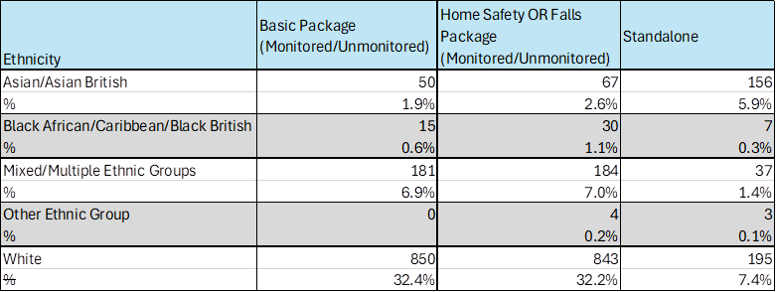

Overall ethnicity of existing people using the service.
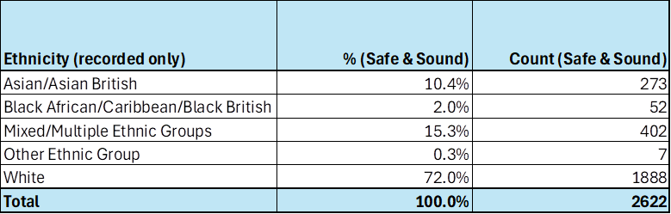

A representation of ethnicity by age profile, the most vulnerable of whom fall within the 65+ category.

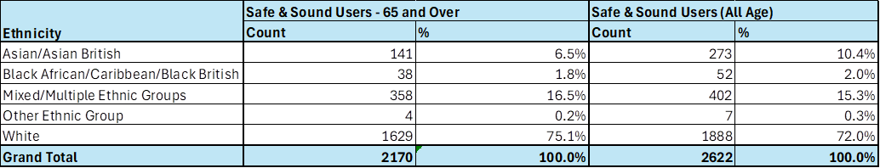

Cost Profile Analysis
This details the users mapped across to the new packages and a breakdown of package costs. The majority of existing users, representing 45%, if transferred across to the new charges would experience an uplift starting at £4.62 compared to the current £3.30. This reduces the impact of the change alongside with the recommended phased implementation.
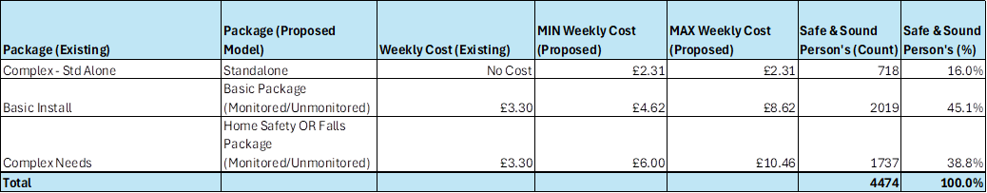

Gender
Over 60% of existing people who use the safe and sound service are female. Of those over 80% are presently paying a contribution to the service. Therefore, the impact of the change is expected to be minimal compared to if the majority were receiving the standalone service.
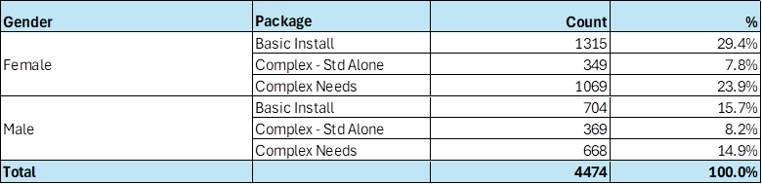

As part of the implementation of the new Digital ARC and through the consultation process we are aiming to capture additional details covering protected characteristics, this will help our understanding of the needs of the current service users.

2.5 How could the disproportionate negative impacts be mitigated or eliminated?
(Note: Legislation and best practice require mitigations to be considered, but need only be put in place if it is possible.)

We are proposing that subject to Executive approval the new charges are implemented from 1st April 2025 for all new service users. At this stage, we are seeking Executives approval to undertake a formal consultation exercise with key stakeholders and bring back the findings from this exercise to the Executive for their consideration. Following approval from Executive to go out to consultation, we will write to all existing service users who are receiving Safe and Sound service to inform them of the proposed changes and the implications for them, and to provide them with options for sharing their feedback.

Section 3: Dependencies from other proposals

3.1 Please consider which other services would need to know about your proposal and the impacts you have identified. Identify below which services you have consulted, and any consequent additional equality impacts that have been identified.

As this service is operated in conjunction with other organisations, the proposal is planned to be consulted with our partners which include, health and social care organisations, West Yorkshire Ambulance Service and the Yorkshire Fire and Rescue Service.

Section 4: What evidence you have used?

4.1 What evidence do you hold to back up this assessment?

From the data available via the following, we know that demand for ASC services will continue to increase in the coming years, so having access to robust and Care Act compliant case management system is a critical component for operational service delivery.

  - Poppi and Pansi data

  - ONS population projections.

  - Carers feedback

  - Feedback from people who receive support or their carers/advocats.

The evidence on the usage by groups with protected characteristics is included in the earlier sections of the EQIA.

4.2 Do you need further evidence?

There may be futher evidence from the consulation which will be considered once this is received.

Section 5: Consultation Feedback

5.1 Results from any previous consultations prior to the proposal development.

The plan is to seek approval at Council Executive on the 3rd September to go out to formally consult on the proposals outlined in this paper for a period of 3 months. This will cover not only people who use our services, but also families and carers, along with partners.

5.2 The departmental feedback you provided on the previous consultation (as at 5.1).

We undertake regular surveys with current service users who have provided positive feedback on their experience of using the service. Key messages include:
- 80.2% were either extremely or very satisfied with the equipment they received.
- 80.2% said that the TEC helped them have as much control over their daily life as they wanted.
- 80.2% said that the TEC helped them have as much control over their daily life as they wanted.
- 80.2% said that the TEC helped them have as much control over their daily life as they wanted.

5.3 Feedback from current consultation following the proposal development (e.g. following approval by Executive for budget consultation).

The consultion has started but not yet concluded.

5.4 Your departmental response to the feedback on the current consultation (as at 5.3) – include any changes made to the proposal as a result of the feedback.

This will be fed back when the consultation is completed.

Report of the Strategic Director for Adult Social Care and Health to the meeting of Executive Tuesday 3 September 2024

Resolved –

That the Executive:

(1) Recognised the developments in the Safe and Sound Service to implement a Technology Enabled Care offer.
(2) Agreed for a formal consultation to be undertaken with current service users and stakeholders on the proposal to change the charging model.
(3) Agreed for the Strategic Director for Adult Social Care and Health to bring a report back to the Executive setting out the feedback from the consultation and recommendations on the proposed way forward.

To be actioned by: Strategic Director for Adult Social Care

Click to return to contents page

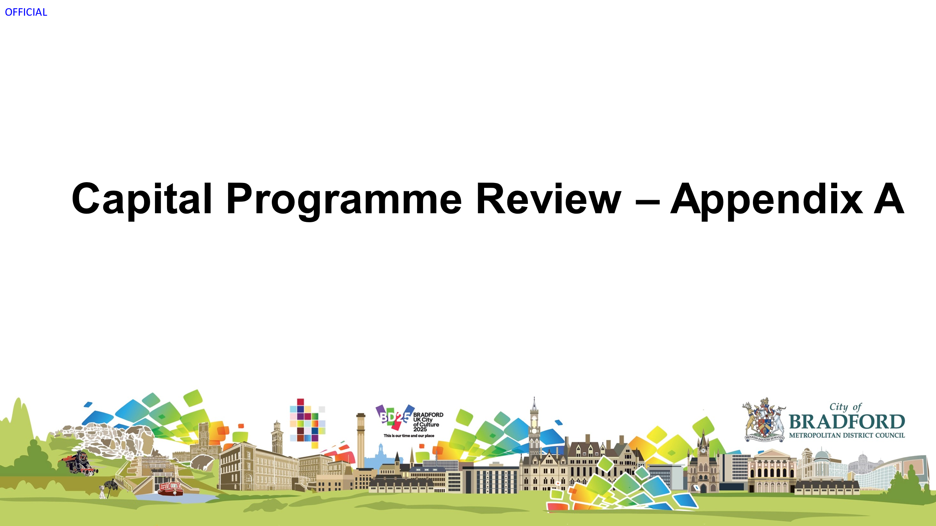

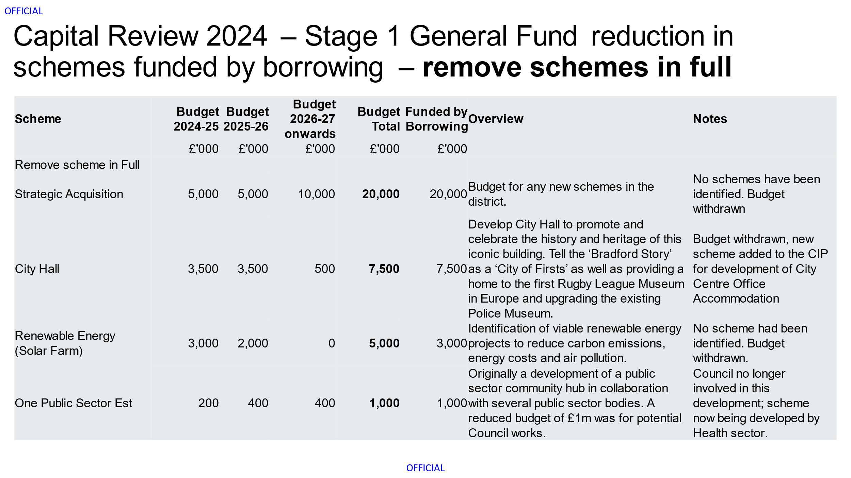
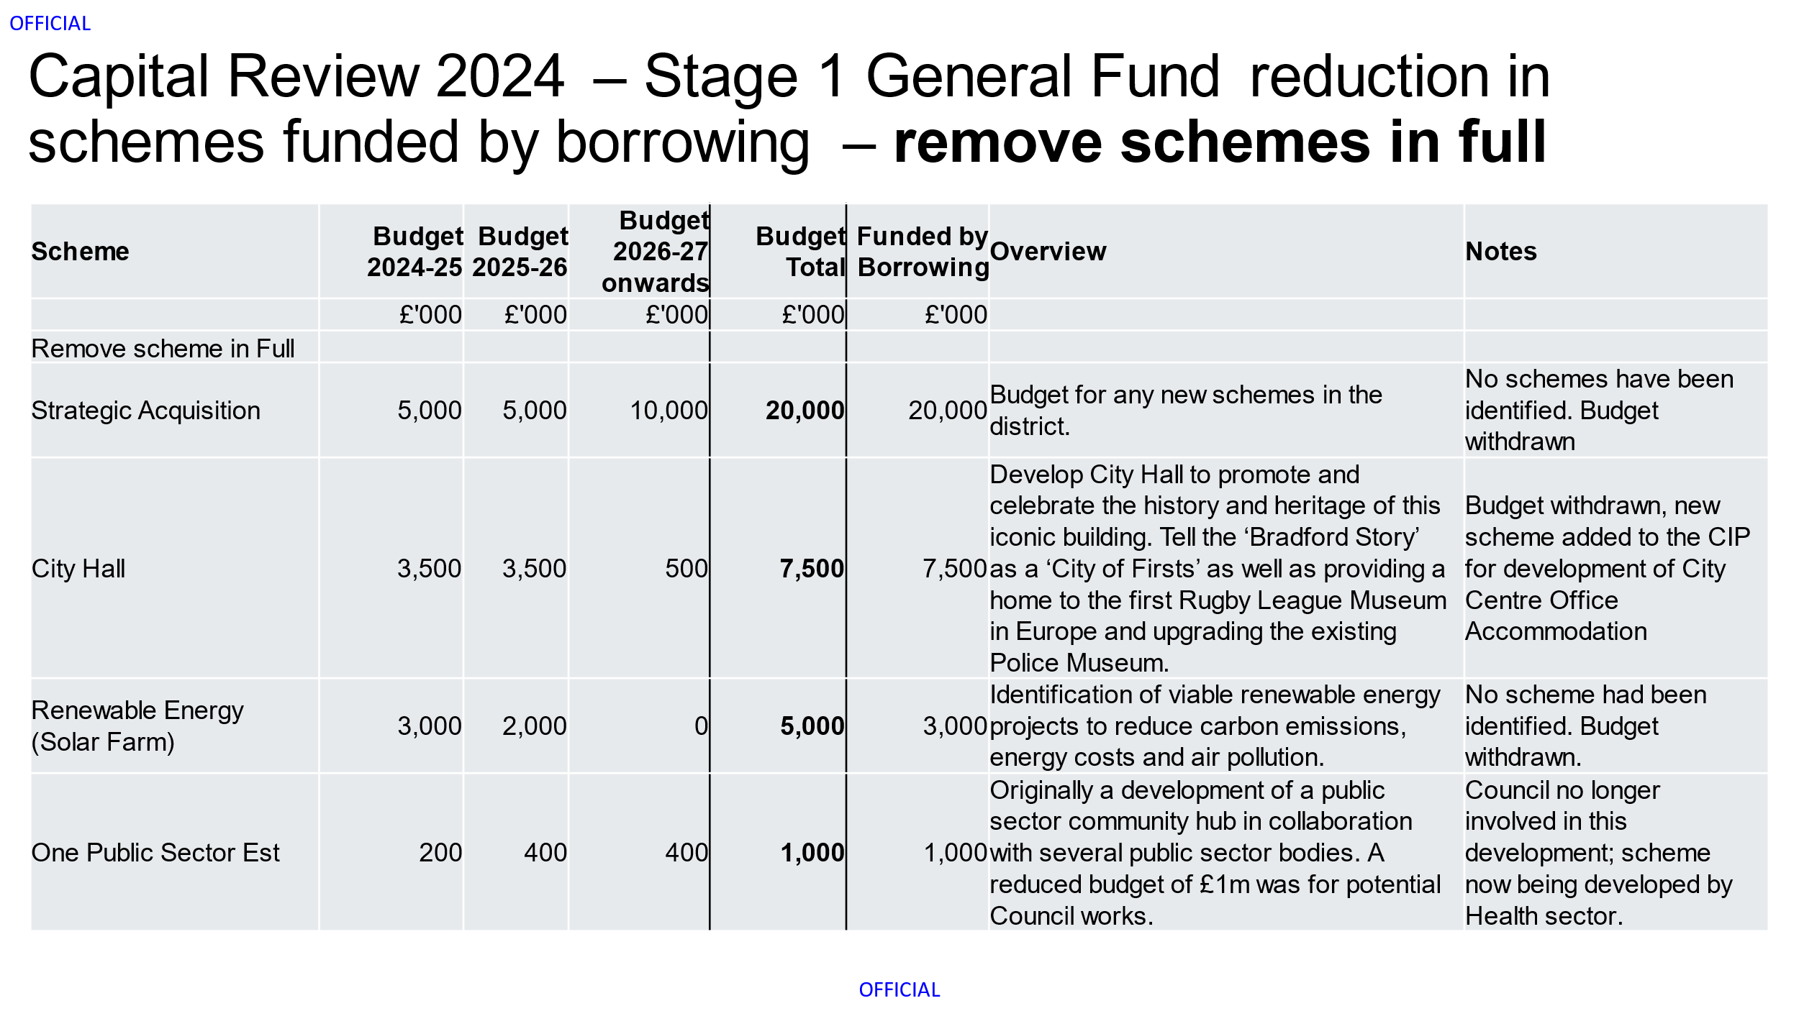

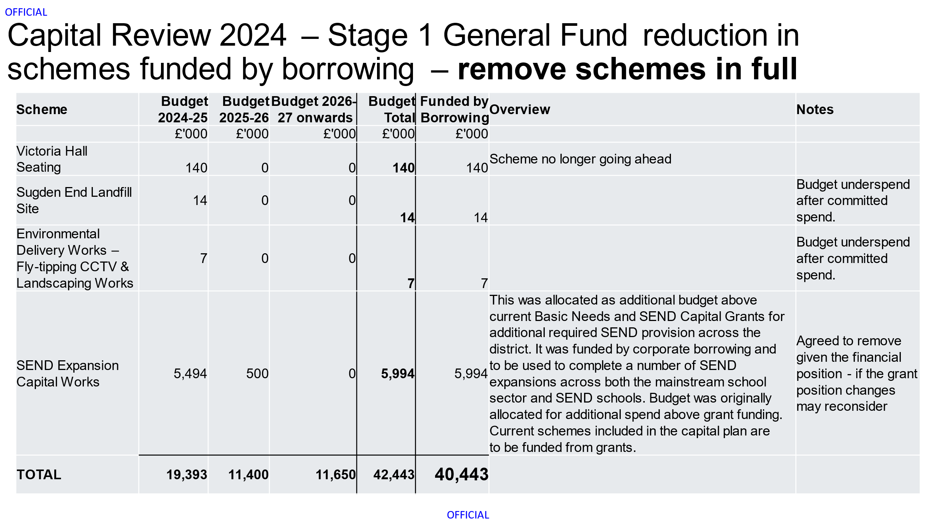

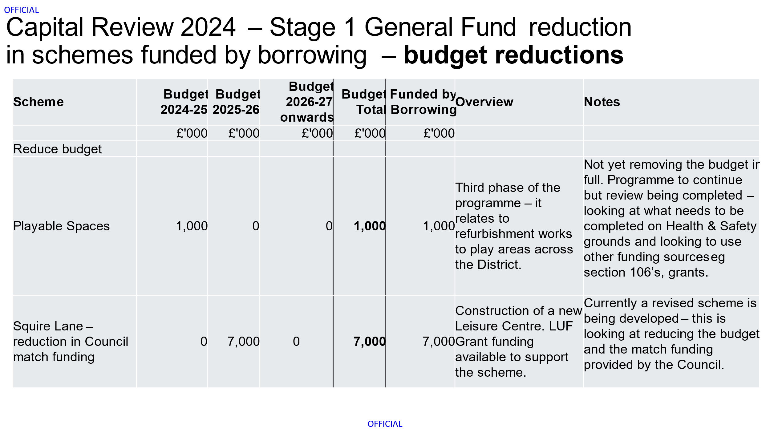

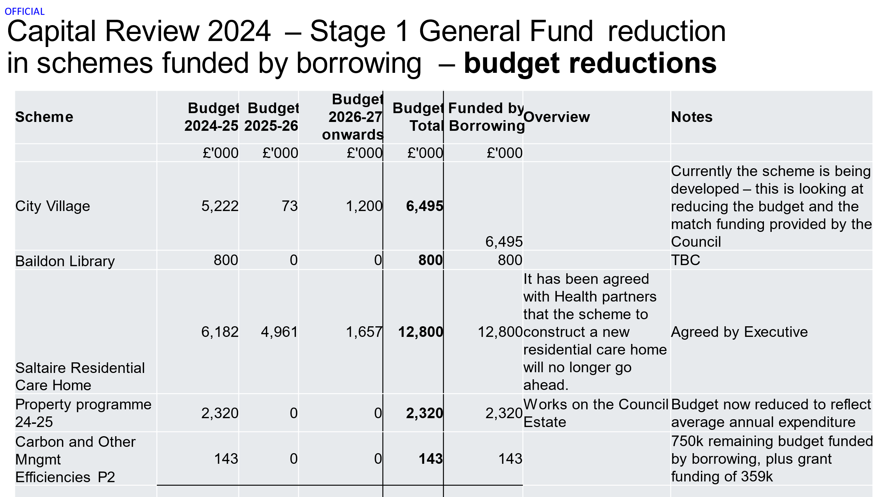

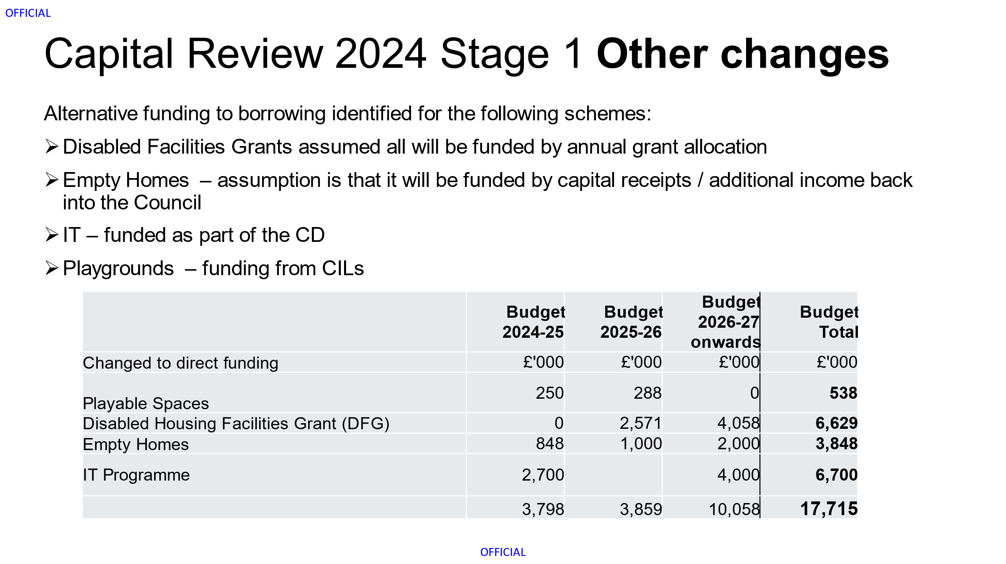

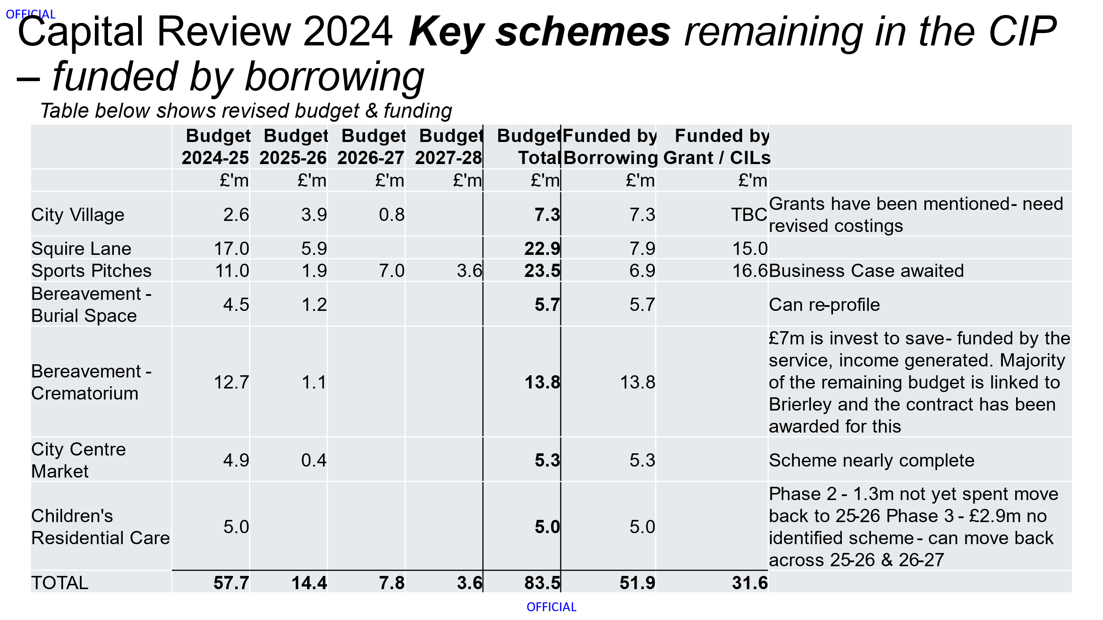

Click to return to contents page

Average salary payment including on-cost at 18/10/24 confirmed by finance as £30k.
NB this is likely to be higher as not all solutions will be delivered on 1st April 2025. This will be worked up in more detail during Q3 and Q4 2024/25.
PwC benchmarking exercise concluding December 2023.
Artificial intelligence use cases | Local Government Association
Average salary payment including on-cost at 18/10/24 confirmed by finance as £30k.
NB this is likely to be higher as not all solutions will be delivered on 1st April 2025. This will be worked up in more detail during Q3 and Q4 2024/25.
Based on an average salary payment including on-cost of £30k.
Based on an average salary payment including on-costs of £30k.
It should be noted that Leeds City Council’s structure is under review.

