The ‘Coal Road’.
The southern end of Bingley 219 is identified on the 1818 Townships Map and the 1850 Wilsden Tithe Map as ‘Coal Road’. The origin of this name is described in a paper on the history of the “Blue Bell Haworth and Toller Lane Turnpike Trust” published in the 1947 edition of The Bradford Antiquary.
An Act was obtained to improve the road from Toller Lane to Haworth in 1755 and in 1758 a toll bar was set up at Hewenden Brow. The price was fixed for waggons carrying coal from Denholme at a charge of 6d for those drawn by six horses or 1d per horse for others and ½d for single horses.
In 1796, the minutes of the Trust reported that the inhabitants of Wilsden had refused to pay their share of composition to repair the road and were using two side roads near Ling Bob to evade the toll. The Trustees ordered two ‘side gates’ to be erected on these roads to collect tolls from traffic entering the turnpike road.
By August 1818 despite the fact that the tolls on the road had doubled the Trustees were hard pressed for money and several Townships were not paying their composition. A notice was placed in the Leeds Mercury announcing that the Trust would be applying for a new Act of Parliament authorising them to increase the tolls.
Leeds Mercury 18th August 1818
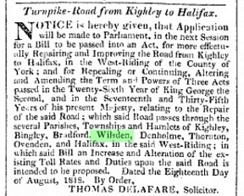

In September 1818 - The Bradford Antiquary account states that “a bar was set up across the highway leading to Birchen Ley Farm and Denholme coal pits. Thomas Horsfall had opened a road from his pits in Denholme to the turnpike at Hewenden Mill to avoid the tolls at Hewenden Brow Bar. Counsel’s opinion was taken but the decision does not appear”.
The ‘highway’ referred to is shown very clearly on the 1818 Map of the Township of Wilsden commissioned around the same time. It follows the line of Bingley 235 which joins the southern portion of Bingley 219 leading over the boundary to Denholme 40. There is also a branch to Birchen Ley Farm, although this is not on the modern line of Bingley 219.
If a bar or side gate was erected at that time, no notice of it has been found in the Leeds Mercury as required by the general act regulating turnpike roads (13 Geo III c.8 s 34). But it is possible that Thomas Horsfall had been taking advantage the fact that he could not be prevented from using the side road to merely cross the turnpike road to Hewenden Mill as s.34 also states that:
“…no person shall be liable to pay toll at any side gate erected on the side or across any turnpike road, or be subject to any penalty for carriage, horse, or beast, which shall only cross such road, and shall not pass above 100 yards thereon, except over some bridge erected at the considerable expence of the trustees of such turnpike road.”
It is unlikely that the Trustees of the Unitarian Chapel, who were the owners of the land over which the ‘coal road’ travelled, would have allowed Thomas Horsfall to ‘make’ a new road across their land to illegally gain access to the turnpike road. It is more likely that the ‘highway’ already existed and was an occupation road which they had an obligation to repair.
However if such a thing had happened, the laws preventing the evasion of tolls were considerably strengthened in 1822 when a new Act was passed to amend the general Laws for regulating Turnpike roads in England (3 Geo IV c 126 s. 41) which stated:

“That if any person with any horse, cattle, beast or carriage, go off or pass from any turnpike road, through or over any land or ground near or adjoining thereto, (not being a public highway, and such person not being the owner or occupier, or servant or family of the owner or occupier of such ground) with intent to evade payment of the tolls granted by any Act of Parliament; or if the owner or occupier of such land or ground shall knowingly or willingly permit or suffer such person (as aforesaid), with any horse, cattle, beast or carriage whatsoever, to go or pass through or over such land or ground to avoid tolls; ……….or if any person shall do any other act whatever in order to evade tolls, and whereby the same shall be evaded, every such person shall for every such offence forfeit and pay any sum not exceeding five pounds”.

The following year a new Act was obtained for more effectually repairing, widening and amending the Toller Lane turnpike road (4 Geo IV c xlviii). In June 1823, a notice in Leeds Mercury announced the erection of a Turnpike Bar at Hewenden Bridge at the junction with Bingley 235. From 1823 onwards Toll Bars were maintained at Hewenden Bridge and Hewenden Bar and at the two Side Gates at Ling Bob.
.

Leeds Mercury 18th June 1823
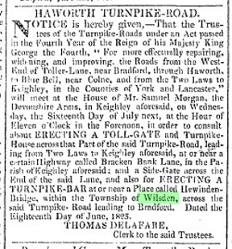
The road was dis-piked in 1860 and the toll bars were pulled down. The Trustees of the Turnpike road sold the site of the Hewenden Bridge Bar to the Trustees of the Unitarian Chapel with the proviso that they demolish the Bar House. The Plan in the margin of this Deed identifies the site beside a lane (Bingley 235) on which the destination is annotated ‘To Denholme’.
1860 Deed of Conveyance – Trustees of the Turnpike Road to the Trustees of the Unitarian Chapel
Bradford Archives Ref: 31D81/6
