

APPLICATION FOR A PAVEMENT LICENCE

Business and Planning Act 2020 - Levelling-up and Regeneration Act 2023 – Highways Act 1980

Please read the guidance document, standard and national conditions before completing this form

SECTION 1: APPLICANT DETAILS – INDIVIDUAL APPLICANTS (if you are personally responsible for the business premises)

Title: | First name(s): |  | Surname:
Address:

Post Code:
Phone (daytime): |  | Phone (mobile):
e-mail address:
NOTE: In the case of a partnership, please state all parties included

SECTION 2: BUSINESS PREMISES DETAILS

Trading Name:
Address:

Post Code:
USE OF THE BUSINESS PREMISES

Use as a public house, wine bar or other drinking establishment | Y | N
Other use for the sale of food or drink for consumption on or off the premises | Y | N

SECTION 3: CONTACT DETAILS FOR CORRESPONDENCE (leave blank if same as applicant)

Title: | First name(s): |  | Surname:
Address:

Post Code:
Phone (daytime): |  | Phone (mobile):
e-mail address:
SECTION 4: AREA OF HIGHWAY PROPOSED TO BE USED AND FOR WHAT PURPOSE.

Please provide a description of the area you wish to use on the highways and what reason, e.g. consuming food & drink, smoking. (NOTE you are also required to submit a plan with this application see Appendix 1 below)

SECTION 5: RELEVANT PURPOSE THE APPLICATION RELATES TO:

Part A: Which of the following relevant purposes do you wish to put furniture on the highway for?
- Does your business provide food or drinks? |  |  |  |  |  |  |  |  | Y |  |  | N
- If yes to above, is the food and drinks prepared within the business premises? |  |  |  |  |  |  |  |  | Y |  |  | N
- Does your premises hold a current food hygiene rating? |  |  |  |  |  |  |  |  | Y |  |  | N
- What is current rating for this premises? write current rating number
Part B: Facilities available
- Is alcohol being served on premises? |  |  |  |  |  |  |  | Y |  |  |  |  | N
- Is alcohol going to be consumed in area you propose to use? |  |  |  |  |  |  |  | Y |  |  |  |  | N
- Is food going to be consumed in the area you propose to use? |  |  |  |  |  |  |  | Y |  |  |  |  | N
- Will smoking be permitted in area proposed area? |  |  |  |  |  |  |  | Y |  |  |  |  | N
- Does the premises have adequate accessible toilet facilities? |  |  |  |  |  |  |  | Y |  |  |  |  | N
Section 6 Days and Times
Please confirm the times when you propose to place furniture on the highway, on each of the following days:
NOTE: Please use the 24hr clock, e.g. 10:00 to 20:00:

 | Monday | Tuesday | Wednesday | Thursday | Friday | Saturday |  |  |  | Sunday
Start
Finish
Section 7: Furniture to be placed on Highway.
Please provide a description of the furniture you propose to place on the highway – including dimensions, quantity, brand, type and materials (NOTE you are required to provide photographs/brochure images of the proposed furniture with your application)
What is not permitted?
- Items associated with the pavement licence outside of the designated area.
- Play music, live broadcasts or social commentary
- Use barbecues, fire pits or naked flames
- Sales of food or drink from within the pavement licensed area
- Structures other than the ones mentioned below
Type |  | Description (e.g. material/colour etc) |  | Dimensions |  | Quantity
Tables
Chairs
Parasols
A-Boards
Other
Where will the furniture be stored outside requested hours? E.G overnight.

SECTION 8: PAVEMENT LICENCE HISTORY
Is there currently or has there previously been a Pavement Licence located at the business premises? |  |  |  |  |  |  | Y |  |  |  | N
Has the applicant changed since the previous licence? |  |  |  |  |  |  | Y |  |  |  | N
Has the previous pavement licence area changed? |  |  |  |  |  |  | Y |  |  |  | N

SECTION 9: CHECKLIST FOR DOCUMENTS TO INCLUDE WITH APPLICATION
Furniture details - photographs or brochure images of the furniture proposed to be used
Site plan - showing see appendix 1
- property boundary and proposed boundary of area to be licensed (with a red line to confirm the area to be licensed).
- building and kerb lines (with measurements from area to be licensed to kerb edge)
- furniture layout
- points of access and egress
- position of any lighting columns, litter bins, road signs or other existing street furniture.
The plan must either be to a suitable scale or with clear measurements stated.
Public Notice of Application – a photograph to show this has been displayed to the public
Public Liability Insurance – proof of insurance for a minimum of £10 million
Proof of payment – if paid by bank transfer
SECTION 10: PAYMENT OPTIONS
- online payment form
- chip and pin (Bradford council car pound)
PLEASE NOTE ALL PAYMENTS ARE NON-REFUNDABLE.

SECTION 11: DECLARATION BY APPLICANT
I understand that I am required to display a notice of my application in accordance with the requirements of the Business and Planning Act 2020 (as amended) and that failing to do so and to maintain the notice throughout the consultation period may lead to the revocation of any licence granted.
I understand that I must hold and maintain public liability insurance for a minimum of £10 million.
I understand that my application will not be considered to be complete, and the consultation period will not start, until the day after all the required documents and information have been provided and the correct application fee of £112 has been paid.
I understand that the application fee paid is non-refundable if my application is refused or if any licence granted is subsequently surrendered or revoked.
I understand that the Authority is under a duty to protect the public funds it administers, and to this end may use the information I have provided on this form for the prevention and detection of fraud. I understand that it may also share this information with other bodies responsible for auditing or administering public funds for these purposes.
I declare that the information given above is true to the best of my knowledge and that I have not wilfully omitted any necessary information. I understand that if there are any wilful omissions, or incorrect statements made, my application may be refused without further consideration or, if a licence has been issued, it may be liable to revocation.
I understand that the Authority is collecting my data for the purposes described on this form and will not be used for any other purpose, or passed on to any other body, except as required by law, without my consent.
Signature:

Print Name:
Date:

Please email your completed application, with the above documents and payment option, to: he@Bradford.gov.uk and we will confirm receipt.

Appendix 1
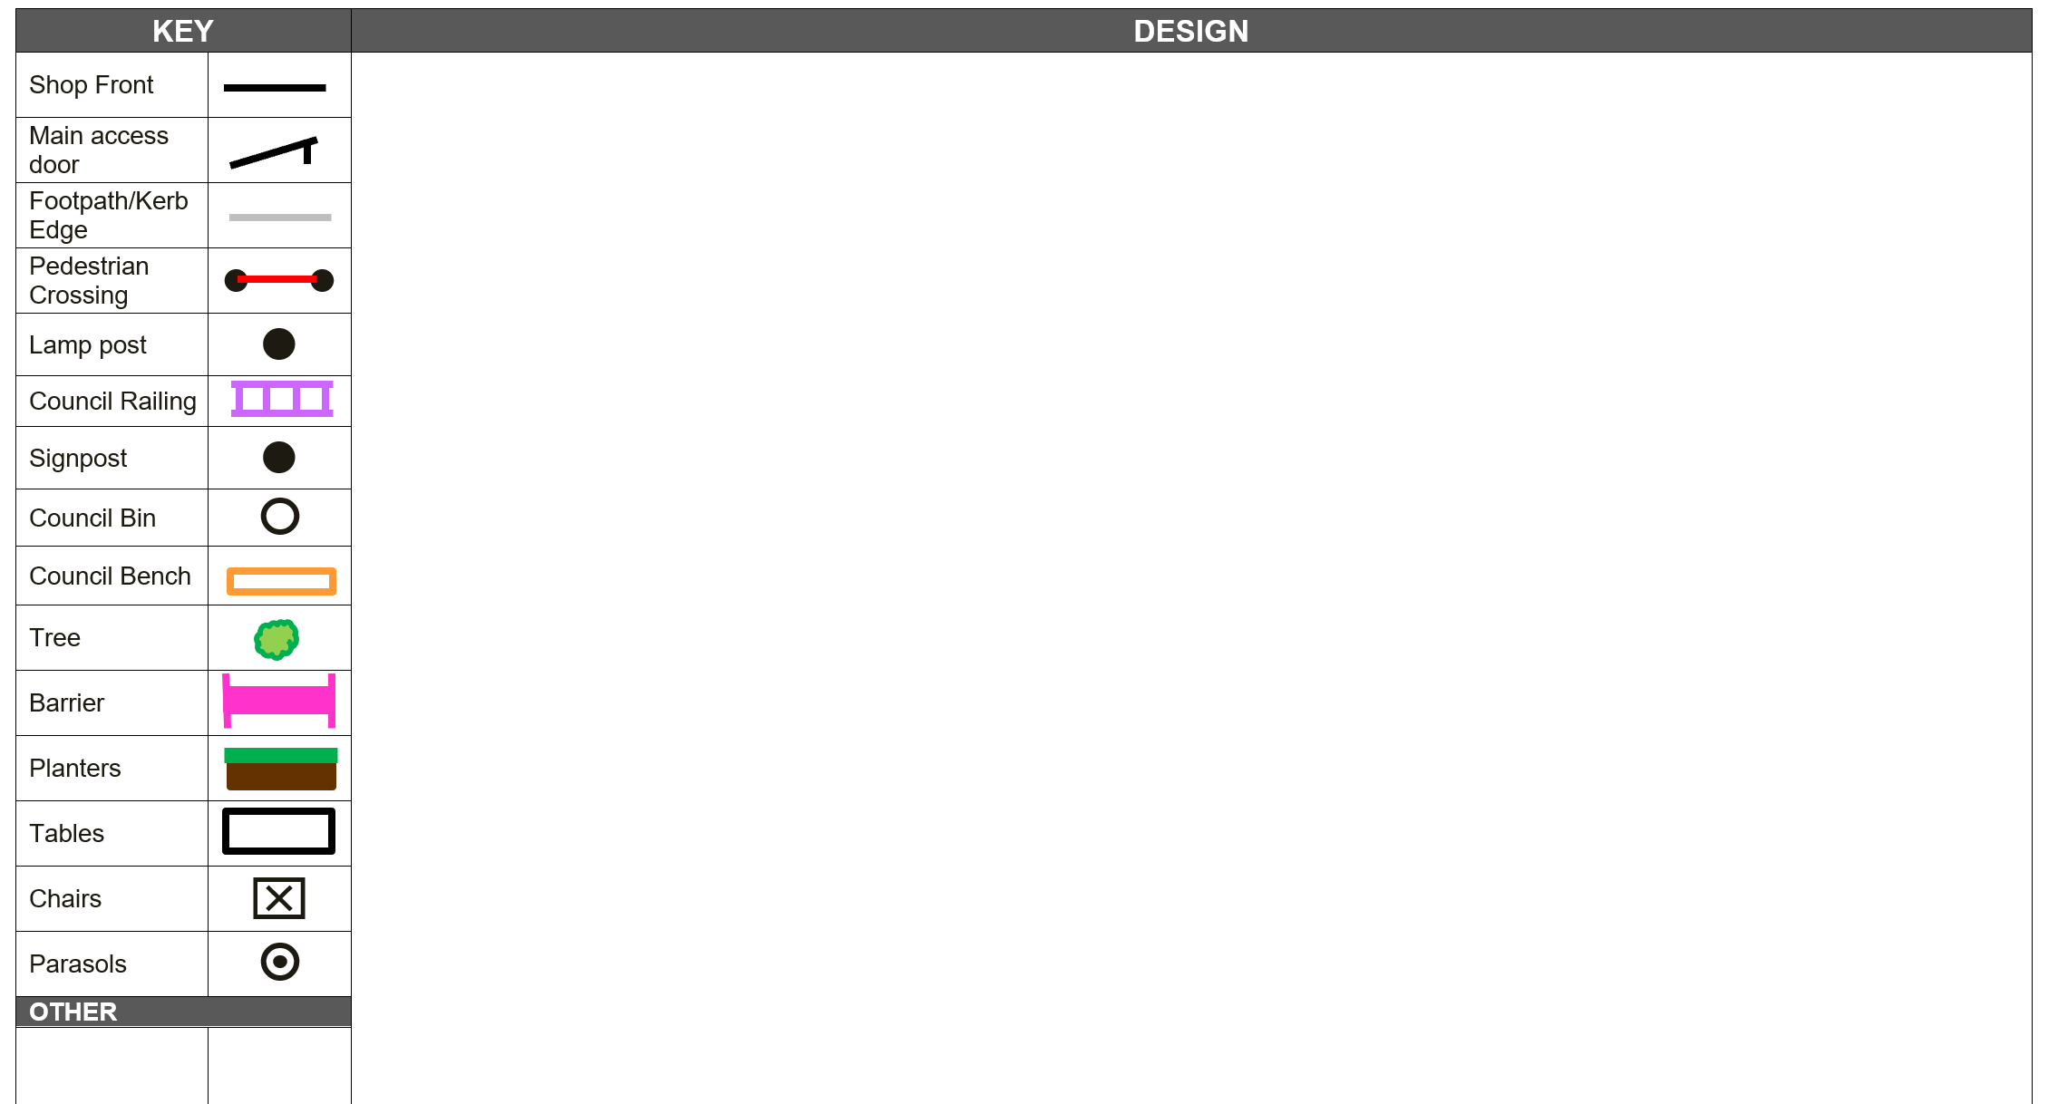

Appendix 2 | 
NOTICE FOR PAVEMENT LICENCE

Levelling-up and Regeneration Act 2023
Please fix this notice to the premises so that it is visible and easily read by all highway users
We _______________________________________________________ (name of applicant), give notice

that on _________________ (date the application is made/submitted) we applied to the City of Bradford

Metropolitan District Council for an ‘Pavement Licence’ located at

__________________________________________________ (address) known as

____________________________(business name)

This application is for (provide a brief description such as location, types of tables/chairs/other furniture, if serving food or alcohol, also please state times the outdoor area will be used, etc.):

Any person wishing to make representations regarding this application may do so by emailing he@bradford.gov.uk (if you do not have access email please call the Councils contact centre 01274 431000 and ask to speak to a member of the Traffic and Enforcement Team. This must be done within 14 working days of the date of this notice.

The application and information submitted is available to be viewed upon request from the premises direct or by emailing he@bradford.gov.uk

The last date of representation to contact the highways department will be:

Signed (Name of applicant):
Dated (Date displayed):
(N.B: this should be the same date the application is made/submitted)
For further information on pavement licences please visit:
https://www.bradford.gov.uk/business/licensing/outdoor-seating-licence/

